TYPES OF MUSEUMS
General - General museums hold collections of more than one subject. Some of these museums hold a number of important specialized collections that they could be groups in more than one category.
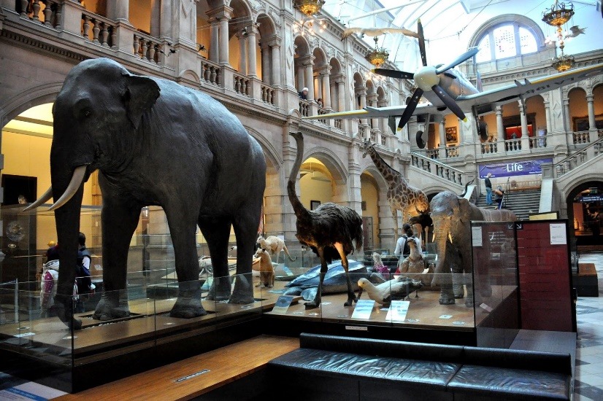
Osama Shukir Muhammed Amin FRCP(Glasg). (2013, November 4). General internal view. Kelvingrove Art Gallery and Museum, Glasgow, Scotland [Digital image]. Retrieved April 23, 2021, from https://commons.wikimedia.org/wiki/File:General_internal_view._Kelvingrove_Art_Gallery_and_Museum,_Glasgow,_Scotland..JPG
Natural History and Natural Science - Museums of natural history and natural science focus on the natural world. Their collections may contain birds, mammals, insects, plants, rocks, minerals, and fossils.
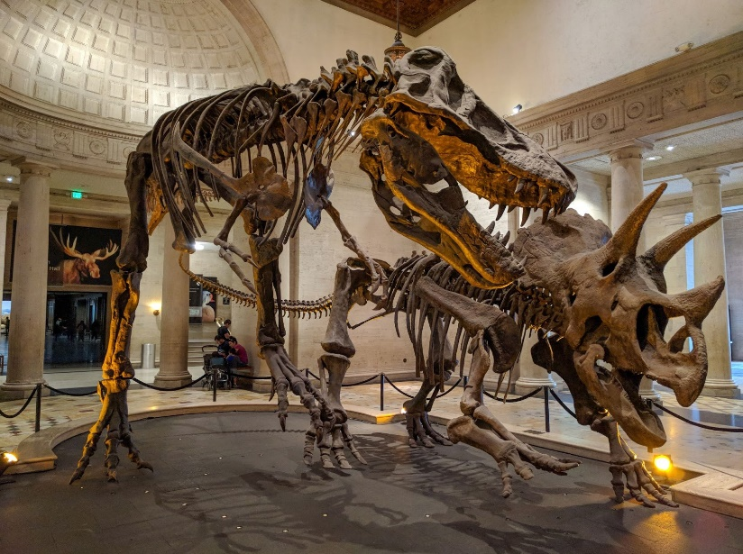
Dillon, M. (2018, March 20). Natural History Museum of Los Angeles County [Digital image]. Retrieved April 23, 2021, from https://www.flickr.com/photos/ruggybear/31904519747
Science and Technology - Museums of science and technology are concerned with the development and application of scientific ideas and instrumentation. Some science and technology museums focus on demonstrating science applications and give visitors an opportunity to participate in interactive displays.
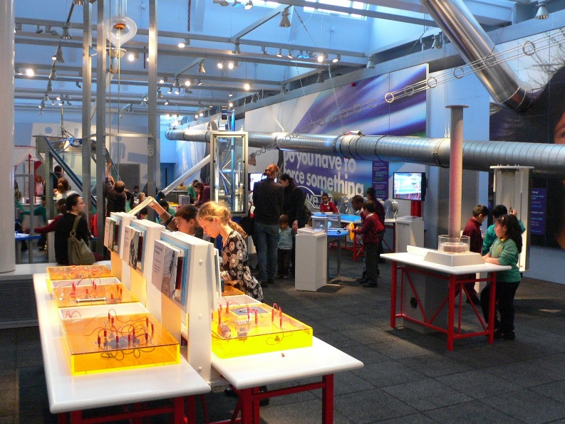
Cowper, H. (2009, January 8). Launchpad Centre at the Science Museum, London [Digital image]. Retrieved April 23, 2021, from https://www.flickr.com/photos/heatheronhertravels/3182439839
History - Museums that present information in a chronological perspective, or deal with a specialized time in history are considered History Museums. These will sometimes include archaeological materials, ethnographic (culture) viewpoints, items which attempt to preserve urban and rural traditions, historic houses, items that commemorate historical events, and portrait galleries.
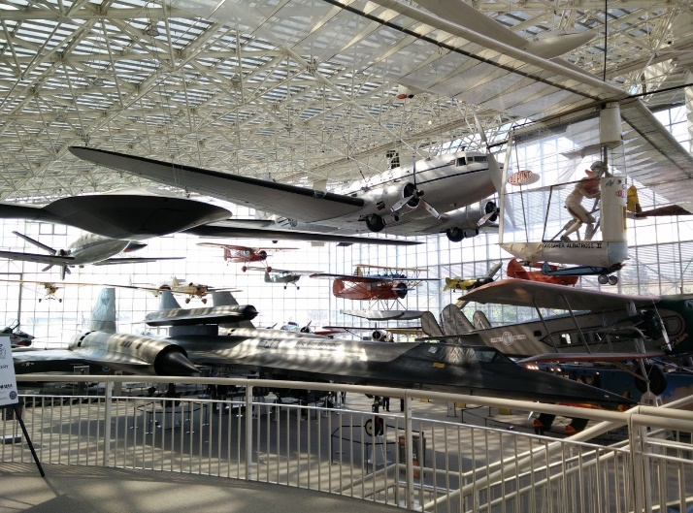
Marostegui. (2016, April 9). Seattle Museum of Flight [Digital image]. Retrieved April 23, 2021, from https://commons.wikimedia.org/wiki/File:Seattle_Museum_of_Flight_-_2.jpg

Art - A building or space that displays art, provides opportunities for cultural expression, exchanges, and host activities. Some of the art on display is owned by the museum, but oftentimes collectors will loan their art to a museum for others to view it.
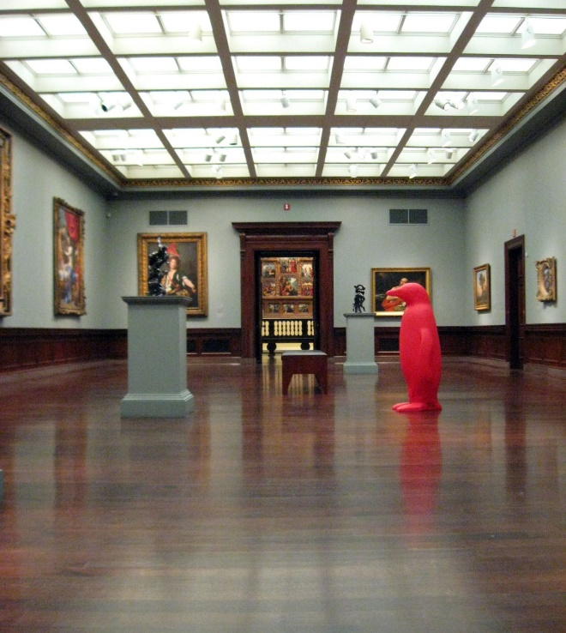
Elycefeliz. (2011, April 21). Cincinnati Art Museum [Digital image]. Retrieved April 23, 2021, from https://www.flickr.com/photos/elycefeliz/5659525004/

