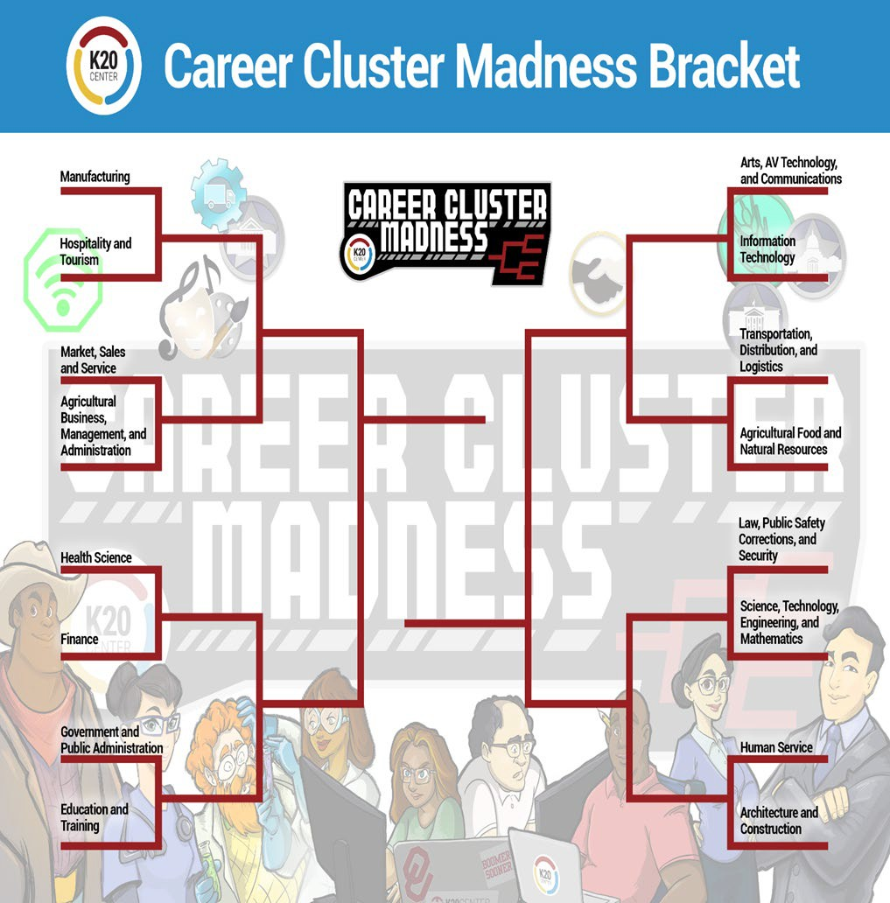



**CAREER CLUSTER MADNESS BRACKET**