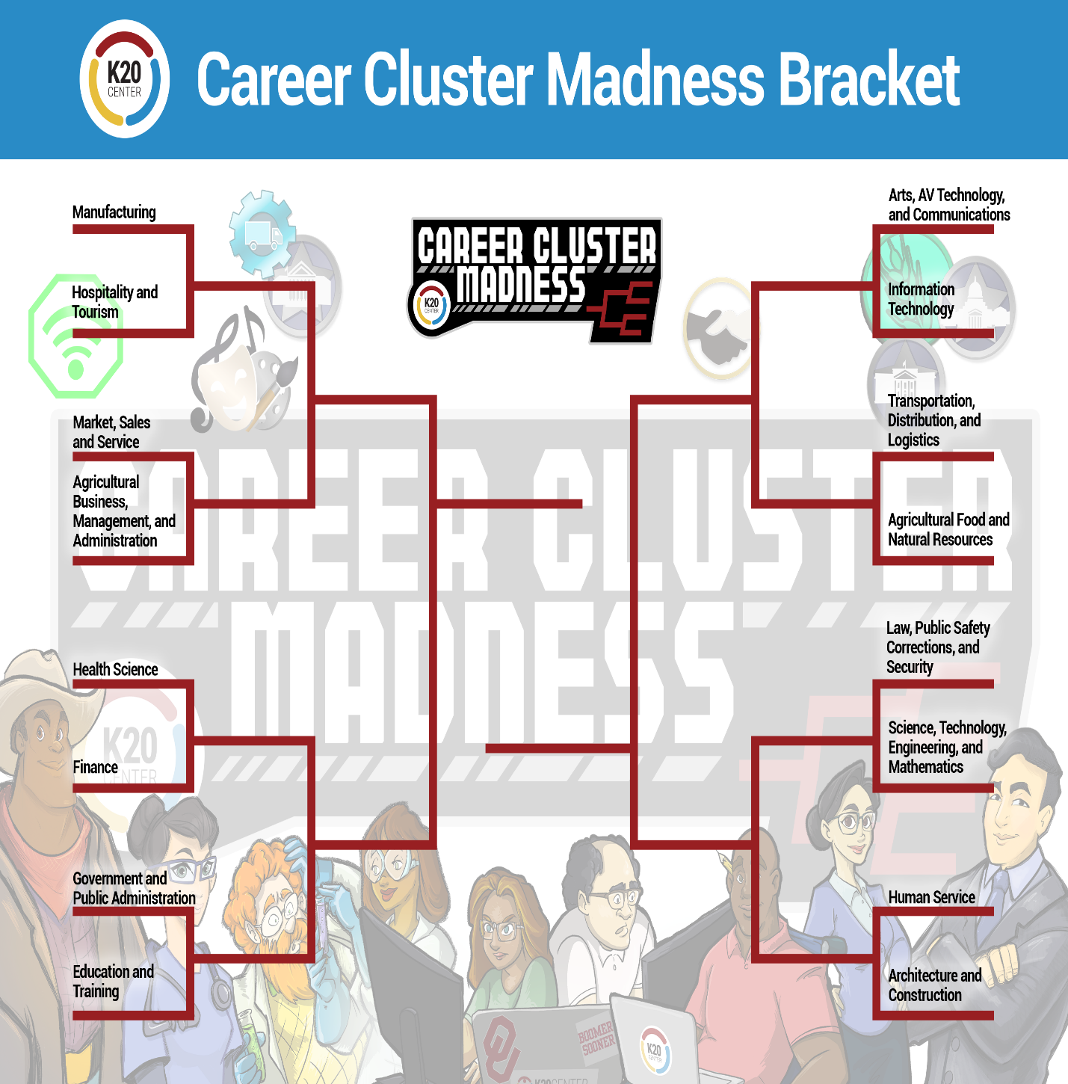

Table of Contents
Career Cluster Madness—Overview  - Materials  - Instructions | 3
Activity 1: Selection Process | 5
K.I.M.S. Chart Template | 6
K.I.M.S. T-Chart Template | 7
Activity 2: Bracket Challenge | 8
Career Cluster Madness Bracket | 10
Final Four Frayer Model Template | 11
Example-Two-Voice Poem | 12
Two-Voice Poem Template | 13
Activity 3: Design a Mascot | 14
Mascot Pennant Handout | 17
Extend | 18
Sources | 19

Overview
The K20 Center’s GEAR UP program wants to help you explore career options. This Career Cluster activity will help you examine your skills, personality, and interests to identify which clusters might be a good fit for you. While your interests will likely change over the years, the Career Cluster Madness activity is a great place to begin your exploration—but the journey won’t end there. You can apply what you learn in this activity to other career exploration and activities.

What is a career cluster?
A career cluster is a group of jobs that are similar. If you like one job in a cluster, you will probably find other jobs in that cluster that you will like as well. There are sixteen career clusters total. These clusters organize every career into groups with others that are similar.

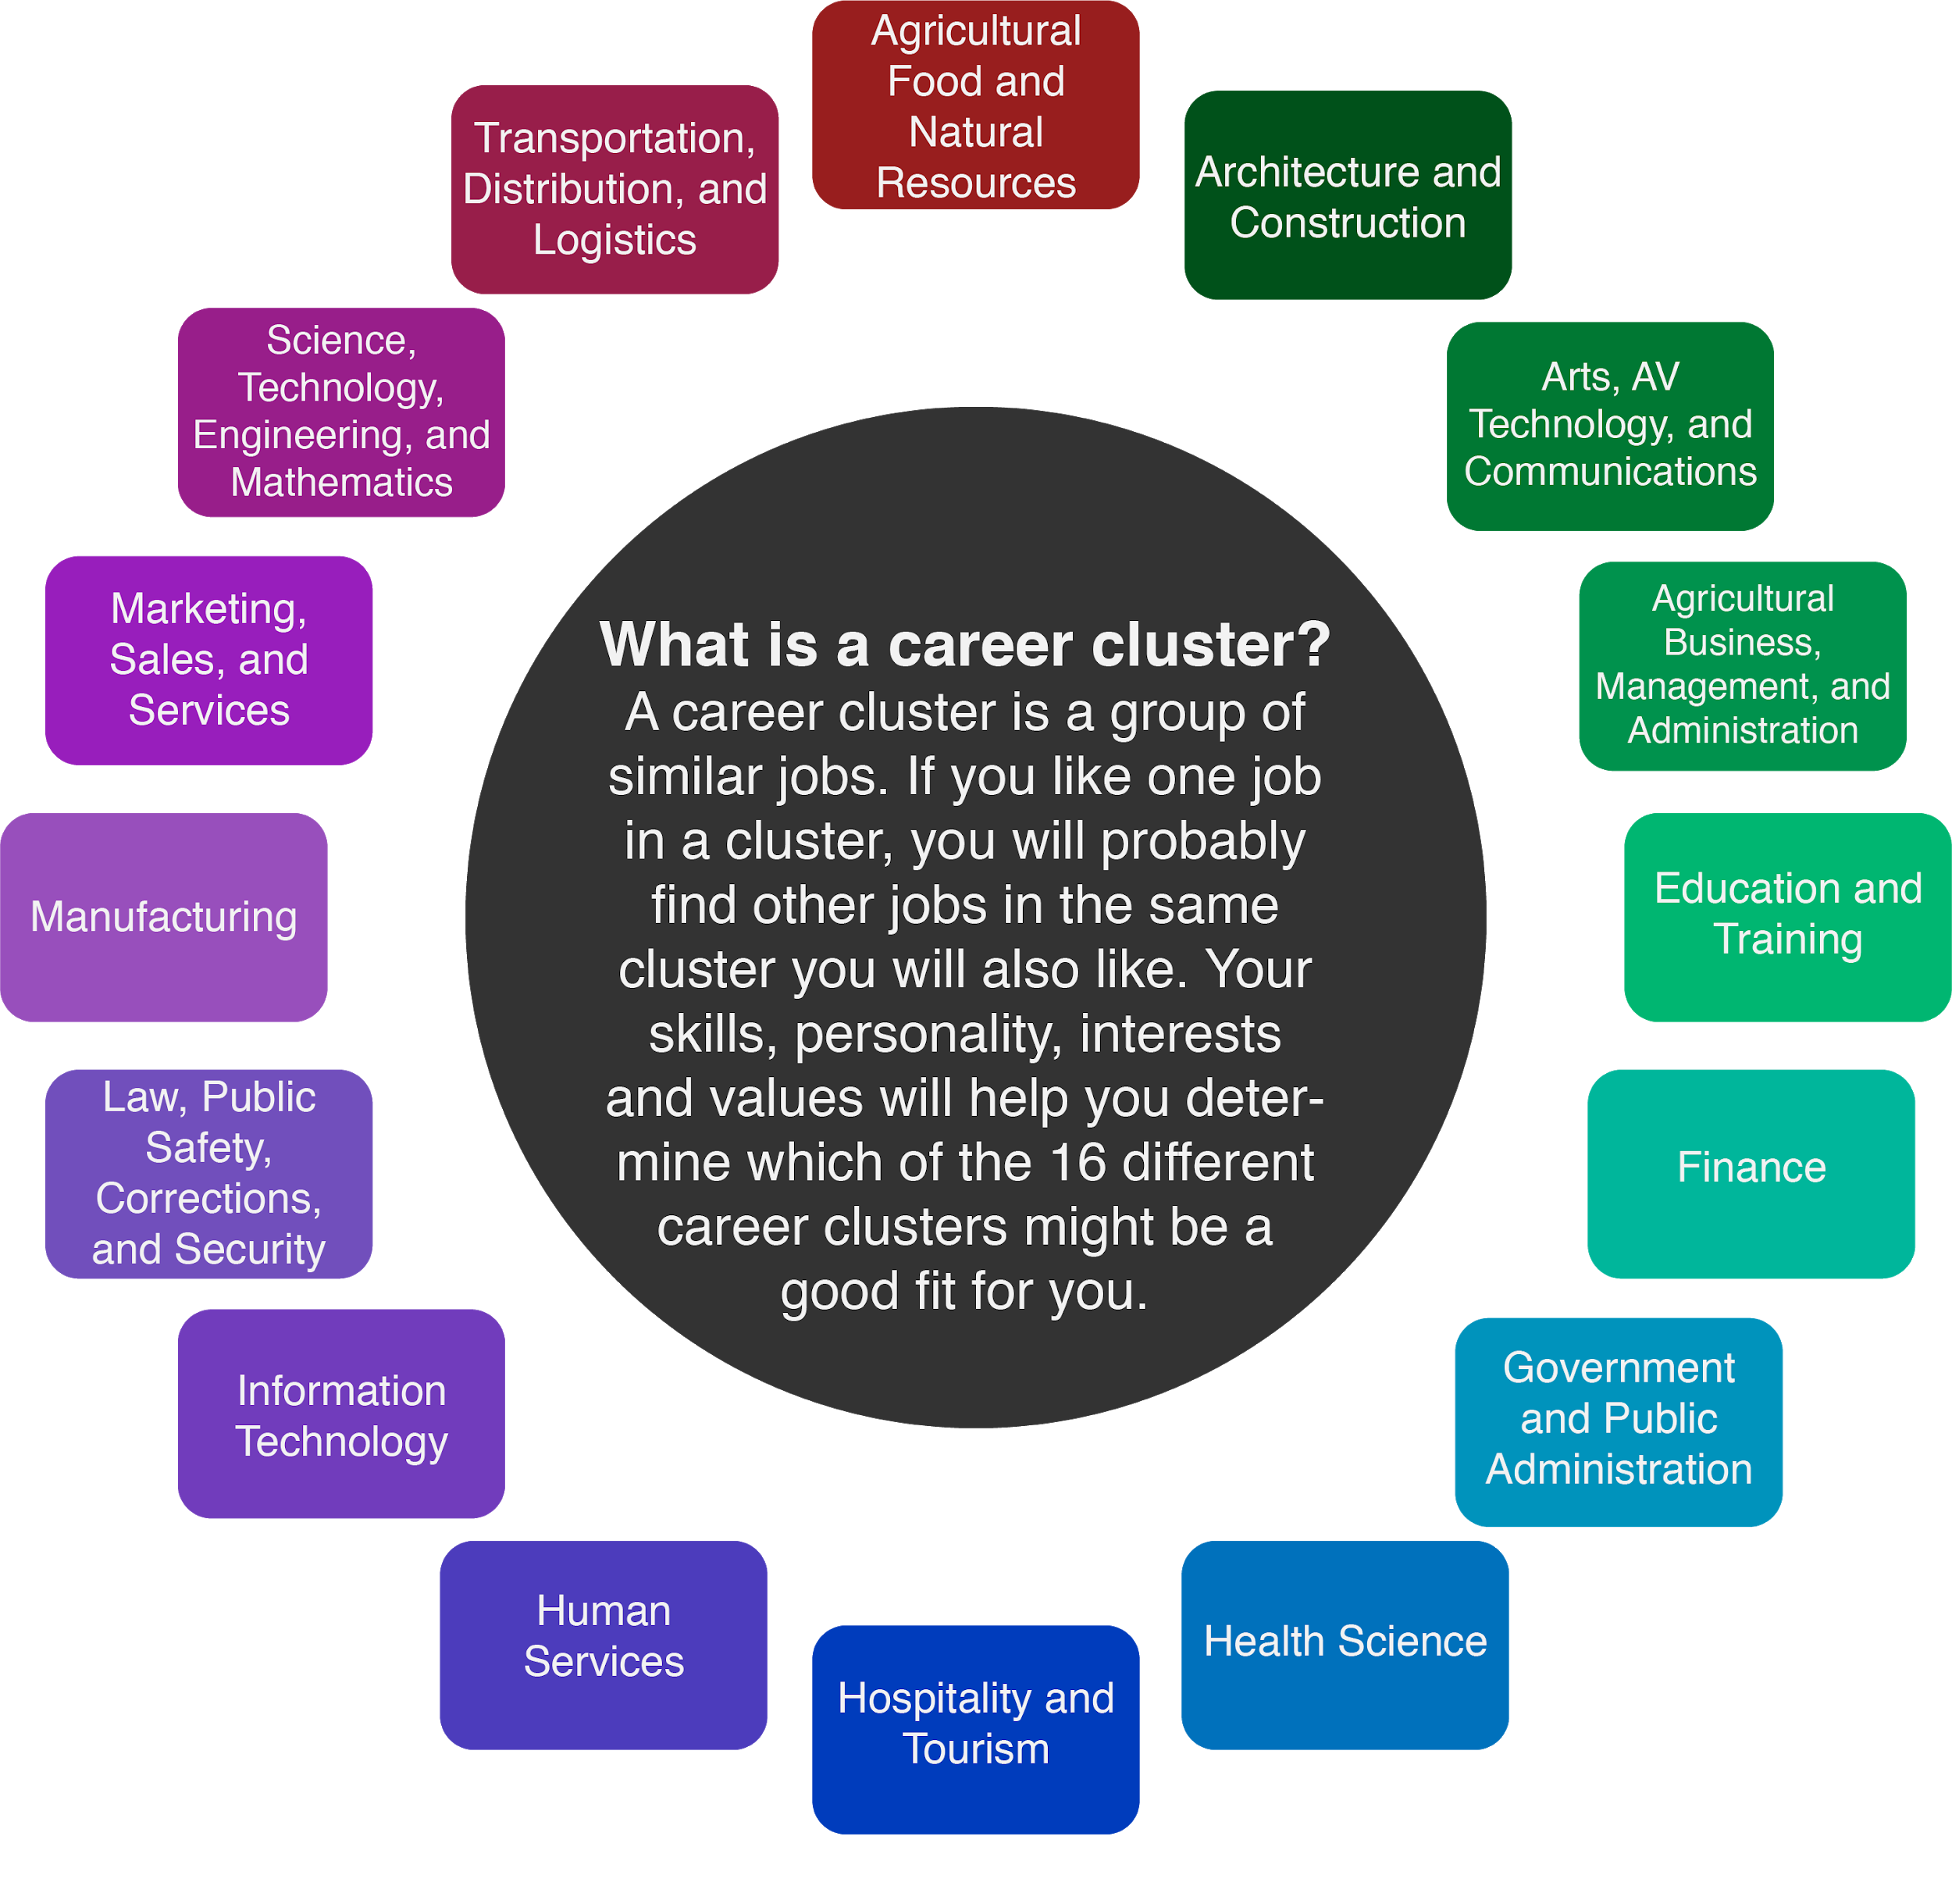

Why is Career Exploration Important for Your Future?
The following activities will guide you through career cluster exploration by examining your skills, personality, and interests and connecting them to possible careers. While you work on these activities, let your interests and passions guide you. Remember, career development is a cyclical process. This means that as you have different life and educational experiences and learn more about yourself, you may come back to your original thoughts about career exploration and find that they have changed. This is quite common, and this is okay.

Materials
- Device with Internet access
- Career Cluster Infogram
- K.I.M.S. Notes
- K.I.M.S. T-Chart (as a substitute for K.I.M.S. Notes)
- Career Cluster Madness Tournament Bracket handout
- Frayer Model Organizer
- Two-Voice Poem Template
- Two-Voice Poem Sample
- Mascot Pennant Handout
- Pencils and/or pen
- Blank paper (optional)
- Art materials (crayons, markers, colored pencils, etc.)

Instructions
- Begin by using the Career Cluster Infogram to explore the sixteen career clusters and create your own K.I.M.S. Notes.
- Move on to the Bracket Challenge activity to start your Career Cluster tournament, narrowing the clusters down to one final champion.
- Use what you have learned and create a mascot for the career cluster that finishes number one in your bracket.
- Check out more information about career exploration in the Extend section.

Activity 1: Selection Process
In this activity, use the Career Cluster Infogram to explore the sixteen different career clusters. Use the K.I.M.S. Notes handout, the KIMS T-Chart, or create your own system for taking notes on a separate piece of paper to keep track of your thoughts and ideas as you complete this activity. You will use the information from this activity to help guide you through the next task, so make sure you follow all the steps!
Materials:
- Device with Internet Access
- Career Cluster Infogram
- K.I.M.S. Notes
- T-Chart
- Blank sheets of paper
- Pencils or pens

Instructions:
- First, view the Career Cluster Infogram.
- Look through each page. Read the information for each cluster.
- Print eight copies of the K.I.M.S. Notes, print the K.I.M.S. T-Chart template, or create a T-Chart on a sheet of paper to take notes on important information about each career cluster. The templates for both K.I.M.S. Notes and KIMS T-Chart are available on pages 6 and 7 of this handout.

Include the following information in your K.I.M.S. Notes:

K.I.M.S. Notes
a. | K-Key Word | Based on the information on each page, select one word that represents each particular cluster.
b. | I-Important Information | What is important about this career cluster? Check the description section.
c. | M-Memory Clue | What image or particular job in the cluster helps you remember this career?
d. | S-Sentence | Summarize each career cluster in one sentence.

- Keep your K.I.M.S. Notes handy. You will need them to help you complete the next activity.

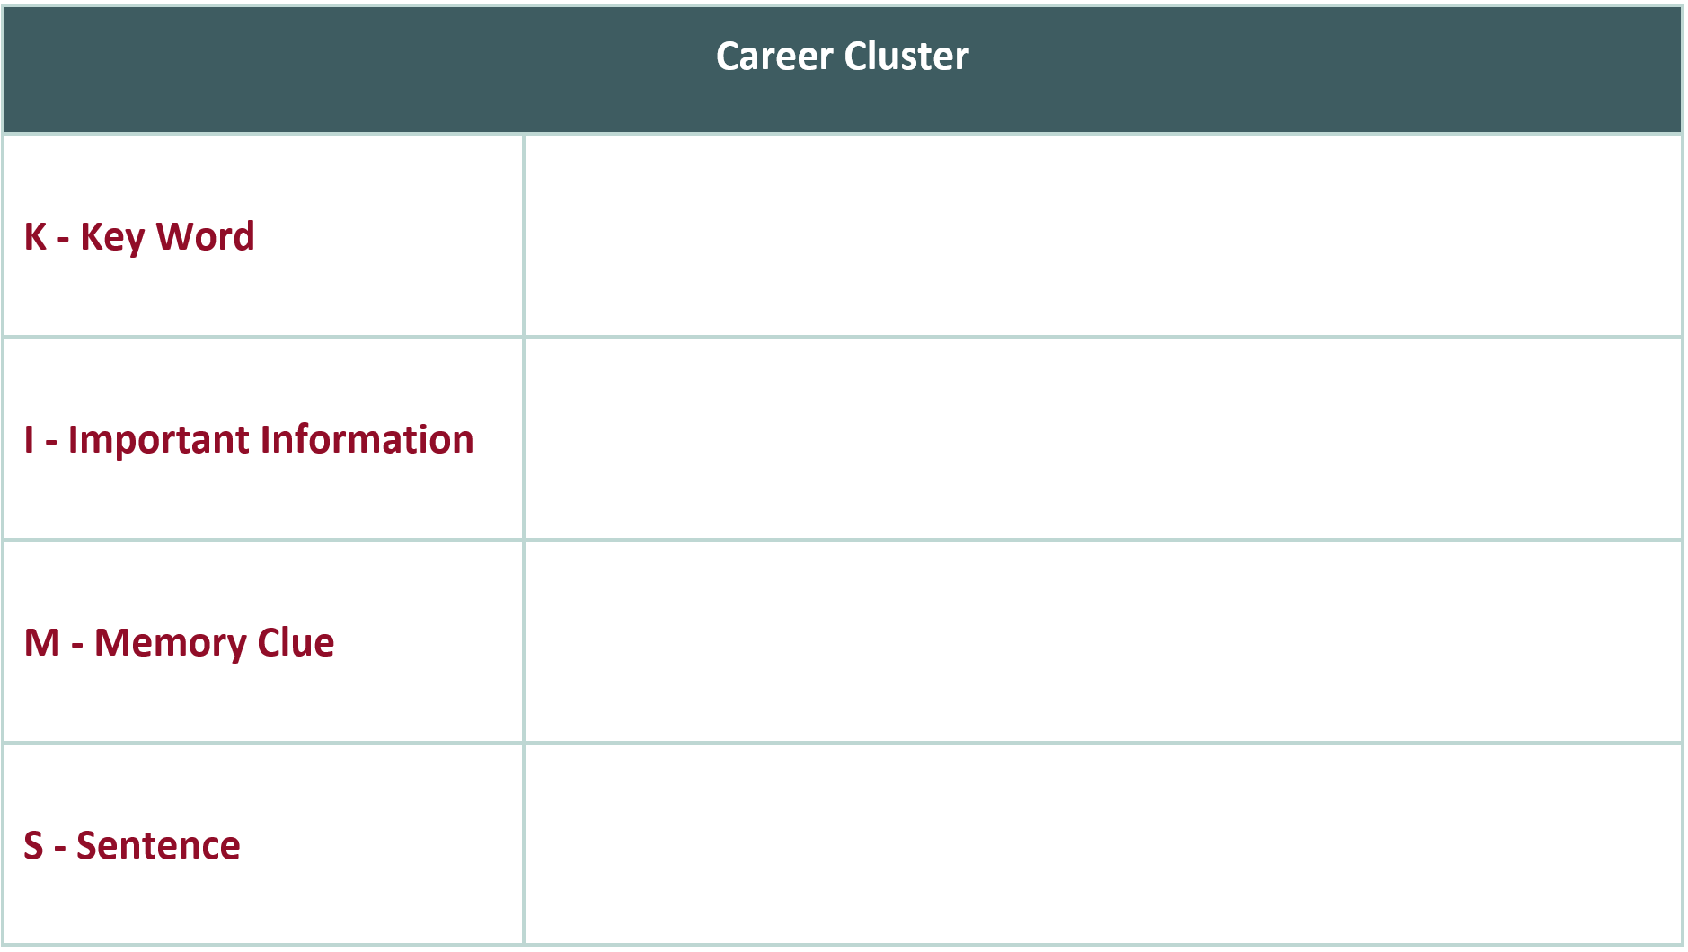
 | T-Chart
As your review the Career Cluster Infogram, write down on the T-Chart the KIMS information:
Key Word (K); Important Information (I); Memory Cue (M); Sentence (S) in the columns below.
 | Career |  | Career
 | K: | K:
I: |  |  | I:
 | M: | M:
 | S: | S:
 | Comments:
Activity 2: Bracket Challenge
Have you ever watched March Madness, the college basketball championship tournament?
During this activity, the sixteen career clusters will compete head-to-head in an epic battle to determine which cluster matches your skills, interests, personality, and career goals. Begin the first round using your K.I.M.S. Notes from the previous activity to eliminate the first group, so make sure those are handy. Complete the remaining rounds to get to your championship pair.
Materials:
- Device with Internet Access
- Career Cluster Madness Tournament Bracket handout
- K.I.M.S. Notes or K.I.M.S. T-Chart from Activity 1
- Frayer Model Organizer
- Two-Voice Poem Template
- Two-Voice Poem Sample
- Blank sheets of paper
- Pencils or pens

Instructions:
- First, take a look at the Tournament Bracket handout. This page has all of the sixteen career clusters listed on the outside spaces of the bracket. They are matched up in pairs.
- The instructions below will tell you how to eliminate clusters for your Career Cluster Madness tournament.

a. | Round 1-Sweet Sixteen | - Review your K.I.M.S. Notes.  - Eliminate one cluster from each pair based on your likes, interests, and information gathered from Activity 1.  - Write the career cluster that you want to move on to the Elite Eight Round in the winning bracket space to the side of each pair, moving towards the center.
b. | Round 2-Elite Eight | - Use the internet to go to O*NET Online.  - Use this website to learn more about jobs in the eight clusters left on your bracket.  - Eliminate one cluster from each pair once you have completed that review. This will get you to your Final Four.  - Write those four clusters in the spaces on the bracket moving towards the center.

c. | Round 3-Final Four | - Use O*NET Online to take a closer look at one job of interest in each of your four remaining clusters.  - Use the Frayer Model handout and fill in the information for each of the four careers you looked at.  - Include skills needed, education requirements, and salary information.  - Rate the career on a scale of one to five stars, one being the lowest and five being the highest.  - Eliminate two after you have completed the four Frayer Models. This will give you your final two clusters for the Championship round.  - Write those two clusters on the blank spaces in the center of your bracket.
d. | Championship Round | - Use the Two-Voice Poem strategy to determine the winner.  - Brainstorm similarities and differences found between the two remaining clusters.  - Use the Two-Voice Poem handout to help structure your poem. This poem is designed to be read by two voices. Think of it as a rap battle between two career clusters. Check out the sample of a Two-Voiced Poem linked here.
e. | Winner! | - Your original Two-Voice Poem will reveal your winner. Now that you have your winner, take some time to explore more about that career cluster and the job opportunities that might be available for you.

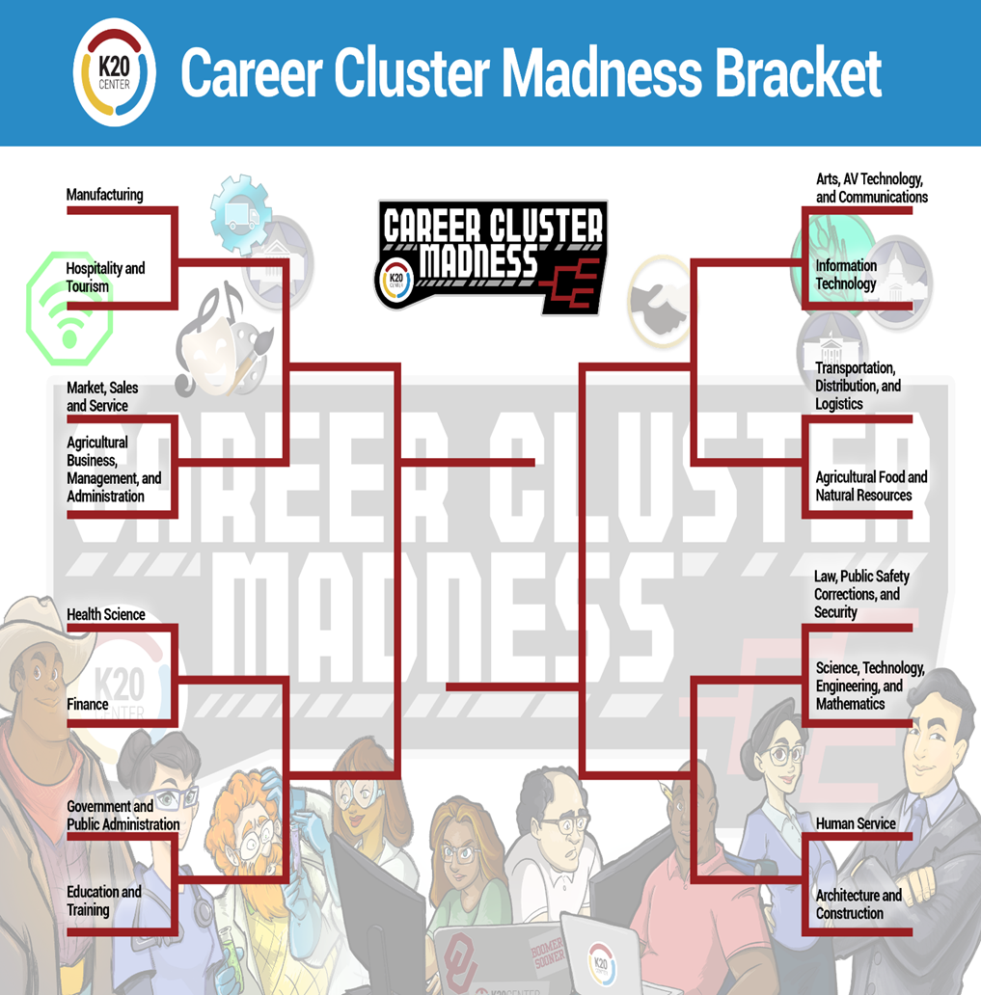

Final Four Frayer Model

Skills Needed
Education Requirements

Salary Information
Rate this Career
Cluster/Job

Example Two-Voice Poem
Batman | Both Say This | Joker

I am Batman.
 |  | I am Joker.

I am a hero.
 |  | I am a villain.
 | I have secrets.

Everyday I fight crime the Joker creates.
 |  | Every day I break the laws and encourage others as well, which are solved by Batman.
 | We are total opposites.

I am quiet and humble.
 |  | I crave the attention of others by acting out.

People admire me.
 |  | People fear me.

I have a loyal sidekick named Robin.
 |  | I have a sidekick named Harley Quinn, but I can’t always rely on her.

Without the Joker...
 |  | Without Batman...
 | I AM NOTHING!

Two-Voice Poem Template
Career Cluster | Both Are Similar | Career Cluster

I am...
 |  | I am...

Activity 3: Design A Mascot
Did you know?
The word ‘mascot’ actually comes from the French word, ‘mascotte,’ which means “lucky charm.” Sports organizations and schools use animals as mascots to provide extra entertainment for their audience. Some schools and teams even bring along live animals to the games!
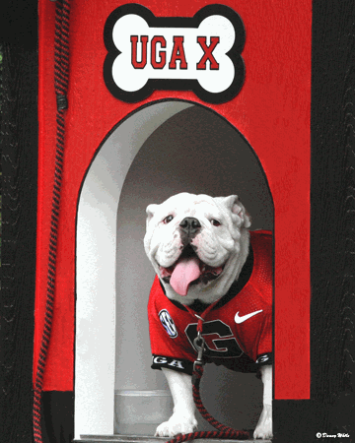
Uga is the University of Georgia’s mascot. In 2019, Sports Illustrated named Uga The Greatest Mascot in College Football History! “Georgia’s line of pure white English bulldogs, now on number 10, has been a staple of the mascot landscape since 1956. Though every new dog is added to the “Uga” line-Uga X is the latest. Each mascot also has its own unique name, is given a custom-made jersey and a varsity letter, and resides in an air-conditioned on-field doghouse. When his day comes, each Uga is buried in a marble vault alongside his fallen predecessors outside the football stadium.
Figure 1: Uga X. University of Georgia mascot
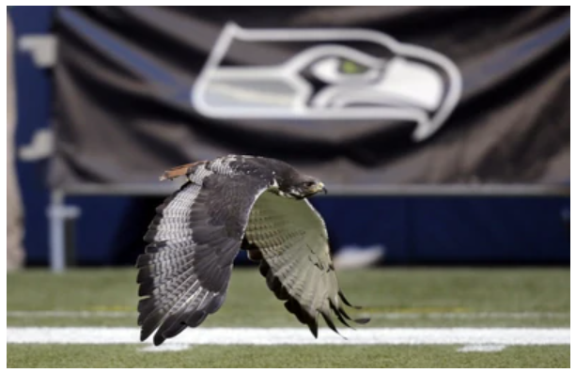
Taima the Hawk is the live mascot for the Seattle Seahawks and one of only three live mascots in the National Football League. According to the Seahawks, Taima has been a member of the team since 2007. He is always the first out of the tunnel before a game starts and is usually the last to leave. His name was chosen by the fans and means “Thunder.”
Figure 2: Taima the Hawk. Seattle Seahawks mascot.

Having live mascots is not something that every team can realistically include in their roster. Could you imagine going to a college football game and seeing a live alligator on the sidelines? In the late 1960s, with the invention of the Muppets came the rise of the ‘fantasy mascots.’ “These larger-than-life puppets represented a new medium in mascot development and utility: cute and touchable corporate ambassadors.”
~International University Sports Federation
Design Your Mascot
For this activity you will design a mascot of your very own that represents your career cluster. So, whether you design one that can show up to your career fair in person, or you design one that represents the career in a fantastical way, is up to you.
To begin, you want to think about what makes a good mascot. What career cluster will this mascot be representing? What images, information, key words, and symbols pop into your mind? Knowing your content and what your mascot represents is very important. Think of ways your mascot could be helpful to others who are trying to understand what it characterizes.
Use the handout provided to create a mascot for the final cluster that won your Tournament Bracket activity. You can look back at the images on the infogram to help you. Notice the images of the people and the icons on that page. You can also use your device with internet access to search for other visual ideas that help represent that career cluster. Have fun with this!
Materials:
- Device with Internet Access
- Activity 2 Handouts and Notes pages
- Career Cluster Infogram
- Mascot Pennant Handout
- Pencils/Pens
- Coloring tools (crayons, markers, colored pencils, etc.)
- Scratch paper for sketching (optional)

Instructions:
- Start this activity by reviewing information about your winning career cluster from Activity 2. You can use your K.I.M.S. Notes or KIMS T-Chart, Frayer Model Organizer, and Two-Voice Poem handouts (Template and Sample). Decide if you are going to create a mascot to represent the whole cluster or a specific job from the cluster. Using your observations and previous work, what image comes to mind that can visually represent your final career cluster/job?
- Look back at the Career Cluster Infogram to help you brainstorm your design. Notice the icons and images on the cluster slides that can be helpful in creating your mascot. Sketch your ideas on a scratch piece of paper if that is helpful.
- Create your final mascot design on the Mascot Pennant Handout. A pennant is a type of flag used to represent a team. Your pennant should include:
  - Your cluster or job name
  - The mascot
- Finalize your pennant by coloring it and decorating it in a way that best represents your cluster or job.
- Once you have finished your mascot, share it with a friend, family member, or teacher.

Extend
Want to learn more about the sixteen career clusters? Explore different career options using the activities developed on the K20 Center LEARN website https://learn.k20center.ou.edu/. For a shortcut directly to these activities use: https://tinyurl.com/k20studentresources. These activities take a deeper dive into a variety of careers across the sixteen career clusters.

Sources
All of the sources that were linked throughout the activity are listed below. Providing a list of sources enables us to give credit for the work someone else made.
- Annaswan18. (2018). Uga X. [Digital image]. https://commons.wikimedia.org/wiki/File:Uga-uga-x-dog-house-print-3.gif
- Burtnett, F. (2021). In Bound-for-career guidebook: a student guide to career exploration, decision making, and the job search (2nd Edition, pp. 13). [Essay]. Rowman & Littlefield.
- Career Technical Education. (2021). Career Clusters. https://careertech.org/career-clusters.
- Iconic Digital Marketing Agency. (2020). What it takes to create an iconic mascot. https://iconicdigitalagency.com/
- K20 Center. (n.d.). K.I.M.S. Strategies. https://learn.k20center.ou.edu/strategy/780
- K20 Center. (n.d.). Two-Voice Poem. Strategies. https://learn.k20center.ou.edu/strategy/133
- National Bobblehead Hall of Fame. (n.d.) What is a mascot? https://www.bobbleheadhall.com/whatisamascot/
- Sportsmascots Fandom. (n.d.). Taima the Hawk. [Digital image]. https://sportsmascots.fandom.com/wiki/Taima_the_hawk_(Seattle_Seahawks)
- U.S. Department of Labor. (2021). O*NET OnLine. [Job website]. https://www.onetonline.org/
- Vrabel, J. (2017). Lions and tigers and bears (and zips and banana slugs and purple cows) -- Oh, My!: An NCAA champion feature. NCAA. https://www.ncaa.org/static/champion/mascots/

You may prefer using the KIMS T-Chart instead of KIMS Notes. Either will work well.
Figure 1: Uga X. https://commons.wikimedia.org/wiki/File:Uga-uga-x-dog-house-print-3.gif
Figure 2: Taima the Hawk. https://sportsmascots.fandom.com/wiki/Taima_the_hawk_(Seattle_Seahawks)

