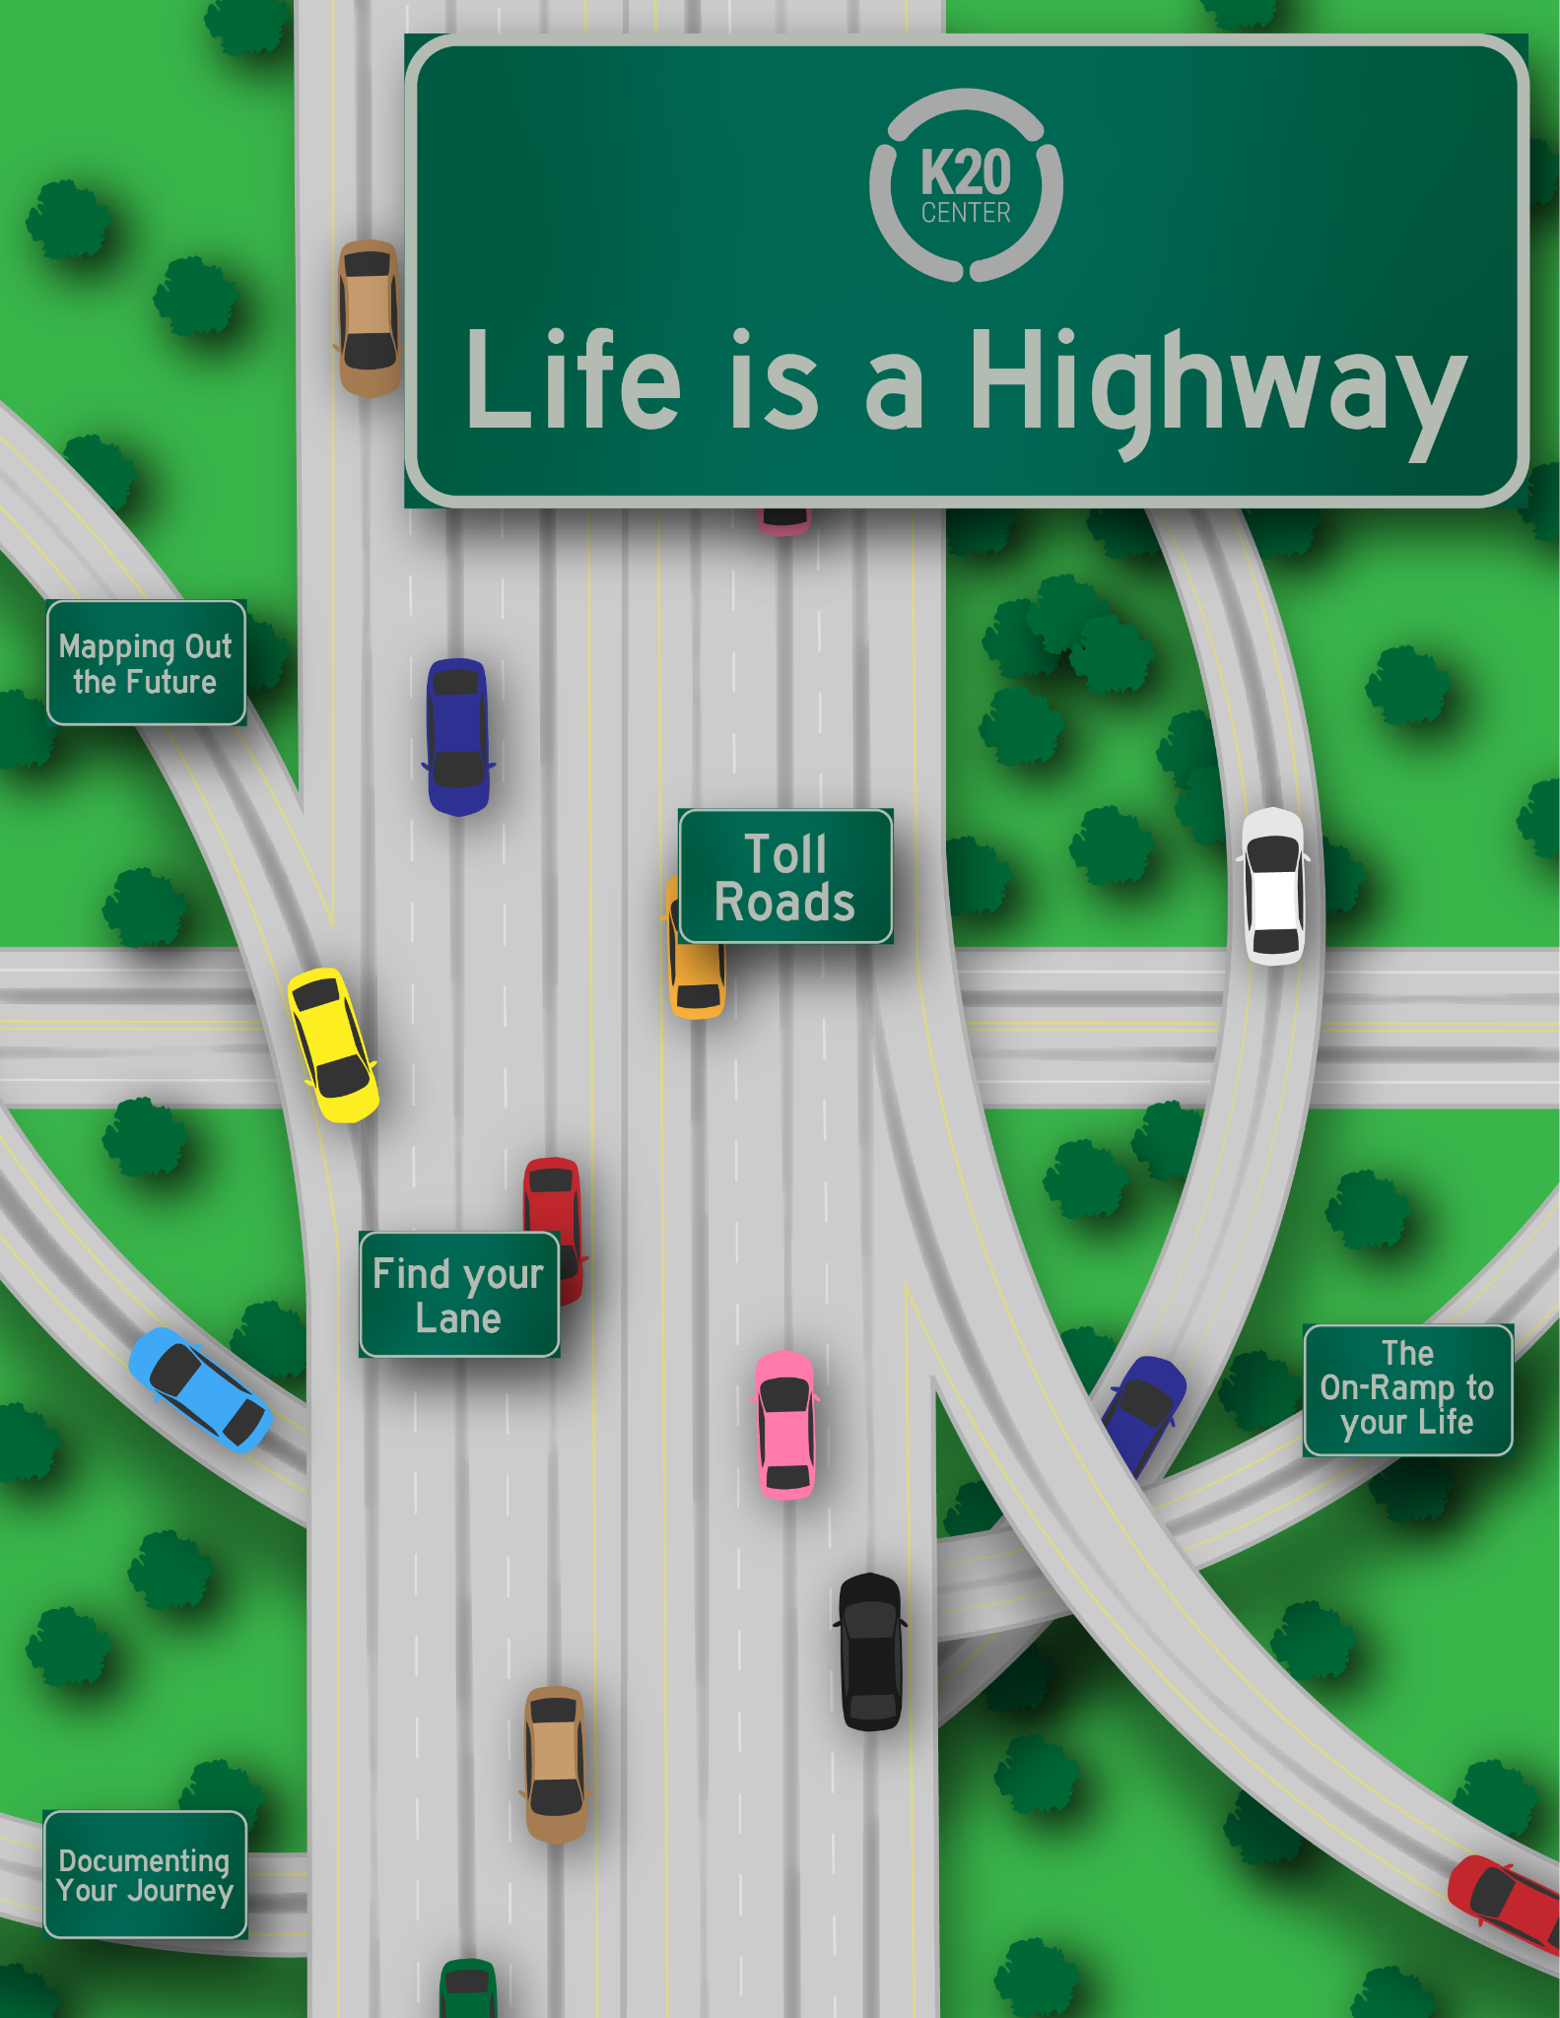

Contents
Life is a Highway: Overview _________________________________________________ | 3
Materials
Instructions
Getting Started - The On-Ramp of Your Life _____________________________________ | 4
Activity 1 - Finding Your Lane ________________________________________________ | 6
Activity 2 - Documenting Your Journey _________________________________________ | 10
Activity 3 - Toll Roads ______________________________________________________ | 22
Extend __________________________________________________________________ | 23
Sources _________________________________________________________________ | 25

LIFE IS A HIGHWAY: OVERVIEW
Just like the Game of Life, you have to make pit stops along the way. Making important life decisions like, what career do you want when you’re older, what colleges, tech schools, or certification programs will help you achieve those career goals, and how are you going to make sure you get there, are all important questions to ask as you continue along your journey.

Materials
- Tablet or personal device
- Internet access
- Pen or pencil
- 3-Column Chart
- Three-Ringed Binder, file box, or similar organizer
- Section Dividers with the following headings
  - Volunteer
  - Awards
  - Leadership
  - Extracurricular
  - Academics Beyond the Classroom
- Sheet protectors (optional to keep awards and documents safe)
- High School Resume Tracker
- Scholarship Tracker
- Poster-board
- Markers/pens
- Old magazines
- Glue
- Vision Board Templates (optional)
- My Vision Board (optional)
- How to Create a Vision Board (optional)

Instructions
- Begin by getting yourself organized in “The On-Ramp of Your Life” where you will research basic information for the career that you are interested in having.
- Next, you will “Find Your Lane” and determine which “exit” is right for you, college, technical institutes, certification programs, or an apprenticeship?
- Begin “Documenting Your Journey” through high school now, so writing those essarys and resumes your senior year are easier!
- Start applying for scholarships to help get you through those “Toll Roads”
- Finally, begin “Mapping Out the Future” by creating a vision board that displays your goals!

GETTING STARTED - THE ON-RAMP OF YOUR LIFE

You may already have a strong idea of what you want to do when you’re out of high school, what your future career will be, and where you want to go to school. But, are you fully prepared? This brief activity has you looking for specific information about your chosen career to help guide you towards the appropriate program you need in order to make it here. Knowing what skills, education, and average salary will help you determine where you need to build yourself up in terms of skill development, narrow down your focus of choice of colleges, and help you determine how much you’re willing to spend on a program based on how much you’ll be making and if you’ll be able to pay off any potential student loans.
Materials:
- Tablet or personal device
- Internet access
- Pen or pencil

Instructions:
- Visit the website My Next Move by clicking on the link- https://www.mynextmove.org/
- Type in your career
  - ex. Teacher
  - 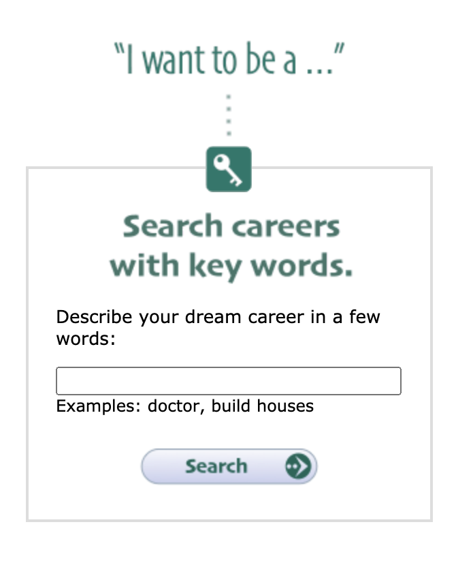
- A list of top careers for what you entered will appear. Find a match that is closest to your search and what you want to be
  - ex. Elementary School Teachers
  - 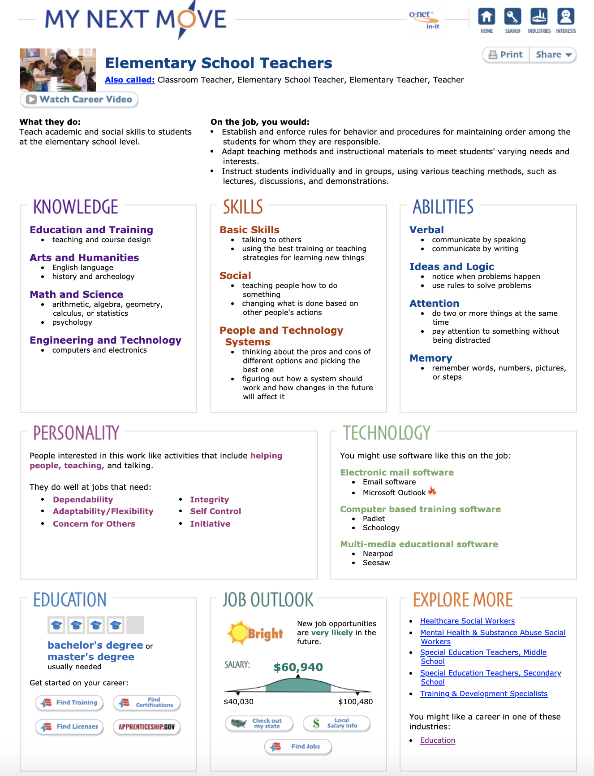
  - Here, you will find all of the important information you will need to help you get started!
- Use the information on this search page to help you fill in the following information, but make sure you don’t close out of the website, you’ll need it for the next activity!

Career Title:

What career cluster does this fall under?

What do they do?

What skills do they need to have?

What type of education do you need to enter this career field?

What is the average salary for this career field?
ACTIVITY 1 - FINDING YOUR LANE
So you already know what you want to be when you grow up, but how do you get there?

Materials:
- Tablet or personal device
- Internet access
- Pen or pencil
- 3-Column Chart
Instructions:
- Starting back on the screen that has all of the important information for your chosen career you will be a block marked “Education.”
- Under the “Education” block there are links for you to select:
  - Find Training
  - Find Certifications
  - Find Licenses
  - Apprenticeship.gov
- Select “Find Training”
  - 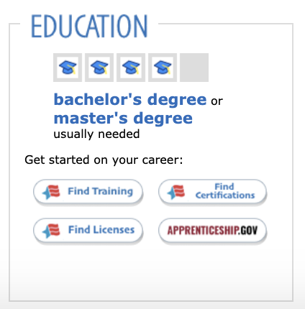
- You will be prompted to select the state you want to search through.
  - ex. Oklahoma
  - 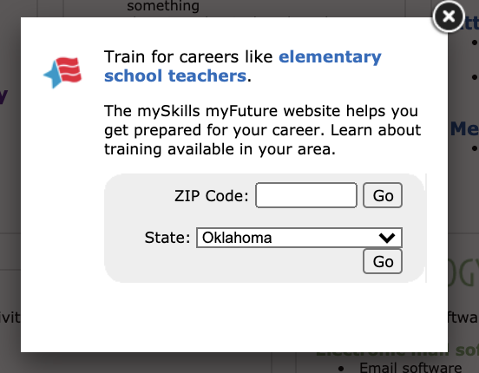
- A list of appropriate programs will come up for you to search based on your location.
  - 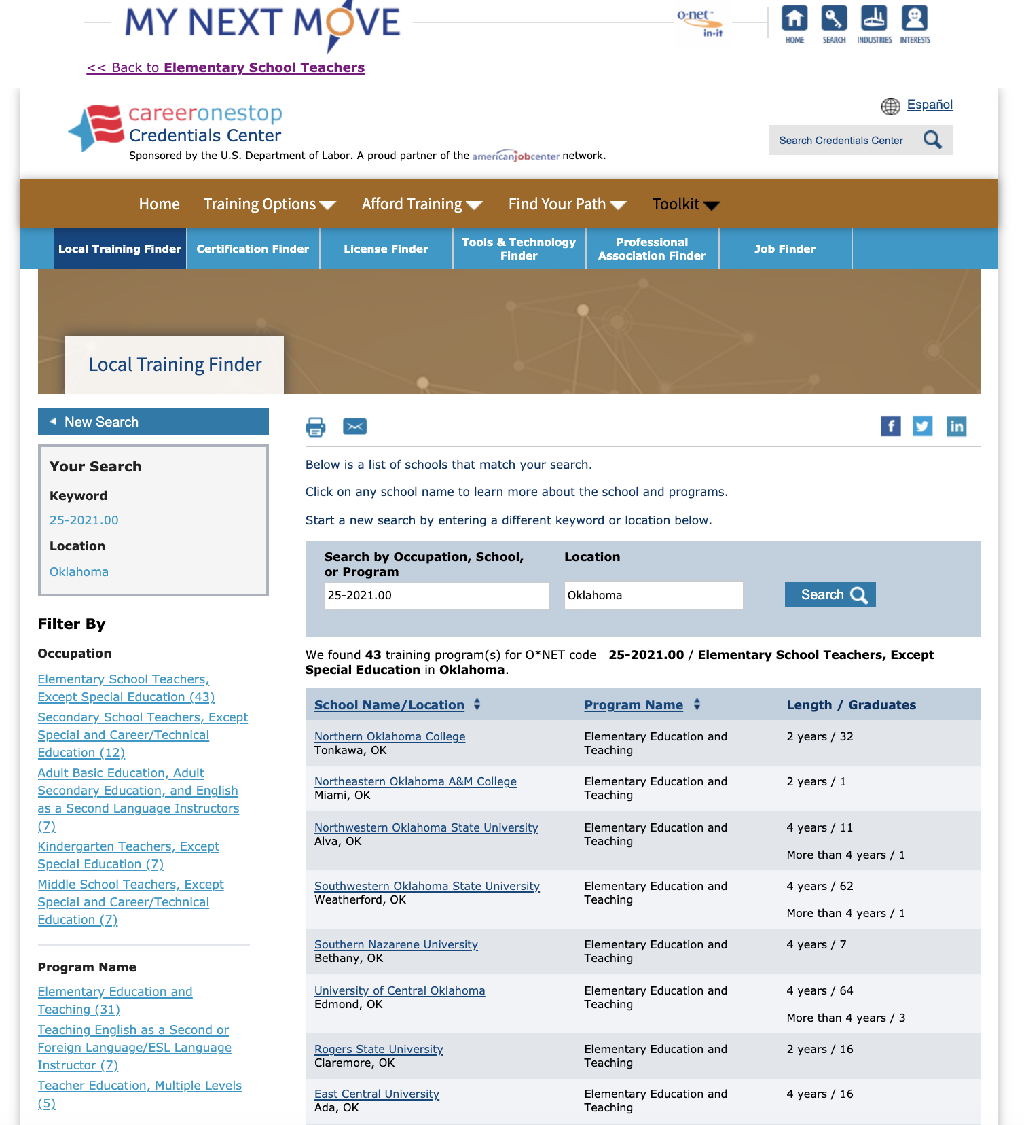
- Take some time to review at least five (5) of the schools you think you might be interested in.
- For each of the programs you “visit” create a Pro/Con/Requirements 3-Column Chart. You can choose to print the chart on the next page five (5) times or simply create your own on a separate sheet of paper.
  - Pros
    - What draws you to that program?
    - What are the benefits of choosing that school?
  - Cons
    - What turns you off about the school?
    - What are the reasons you don’t want to attend that program?
  - Requirements
    - Entrance requirements
    - GPA
    - SAT/ACT required scores
    - Required prerequisites

THREE-COLUMN NOTES
PROS | CONS | REQUIREMENTS

ACTIVITY 2 - DOCUMENTING YOUR JOURNEY
Fast forward...it’s your senior year in high school and it’s time to start writing college application essays and highlighting accomplishments. Remembering everything you did three or four years ago is challenging. Now is a great time to sit down and set up a system to keep track of their activities and accomplishments.
Do you have what you need to get into the school or program of your choice? What if you are entering straight into the job force, how do you make sure you’re sharing all of the wonderful things about you that you’ve done and can do based on your life experience?
Materials:
- Three-Ringed Binder, file box, or similar organizer
- Section Dividers with the following headings
  - Volunteer
  - Awards
  - Leadership
  - Extracurricular
  - Academics Beyond the Classroom
- Sheet protectors (optional to keep awards and documents safe)
- Pen or Pencil
- High School Resume Tracker
Instructions:
- Set up a three-ring binder, file box, or similar organizer with dividers
- Label your dividers with the following (you may include others as well):
  - Volunteer
  - Awards
  - Leadership (for example, secretary of class, attended leadership retreat)
  - Extracurricular (may have more than one section for Extracurricular, such as Band, Football, Art Club, Technology Club, etc.)
  - Academics--beyond the classroom (study groups, lessons to build skills such as music lessons or art lessons, practices and performances, competitions such as bridge building, robotics performances, etc.
- Your organizer is now ready to hold your records. If you chose a three ring binder as your organizer, you can use sheet protectors to save certificates and other documents that you don’t want to hole punch. Take photos of trophies and plaques to place in your organizer.
- In the following pages, you will find useful logs and forms for you to print and use in your organizer.
Note: as you continue through your high school journey you will want to revisit and update this information to include everything!

VOLUNTEER LOG SHEET
Name: _____________________________________________________________________
Date | Project/Task/Event/Activity Description | Hours

VOLUNTEER VERIFICATION FORMS
Name of Volunteer:
Date: Number of hours served:
Volunteer Organization:
Description of Volunteer Service:

Print name of Organization Contact:
Signature of Organization Contact:

Name of Volunteer:
Date: Number of hours served:
Volunteer Organization:
Description of Volunteer Service:

Print name of Organization Contact:
Signature of Organization Contact:

AWARDS LOG SHEET
Date: | Title of Award: | Rank:
Description: (should be short and specific)

Date: | Title of Award: | Rank:
Description: (should be short and specific)

Date: | Title of Award: | Rank:
Description: (should be short and specific)

Date: | Title of Award: | Rank:
Description: (should be short and specific)

Date: | Title of Award: | Rank:
Description: (should be short and specific)

LEADERSHIP OPPORTUNITIES
Date: | Grade level:
Description:

Date: | Grade level:
Description:

Date: | Grade level:
Description:

Date: | Grade level:
Description:

EXTRACURRICULAR ACTIVITIES
Date: | Grade level: | Activity:
Description: (position played, offices held, personal stats, accomplishments, etc.)

Date: | Grade level: | Activity:
Description: (position played, offices held, personal stats, accomplishments, etc.)

Date: | Grade level: | Activity:
Description: (position played, offices held, personal stats, accomplishments, etc.)

ACADEMICS - BEYOND THE CLASSROOM
Date: | Grade level:
Description:

Date: | Grade level:
Description:

Date: | Grade level:
Description:

Date: | Grade level:
Description:

ACTIVITY 3 - TOLL ROADS
As you can see, based on a review of the schools and programs, post-secondary education does not come cheap! But just because it costs a lot doesn’t mean there aren’t great resources and scholarship opportunities out there for you! What’s important to keep in mind is that you don’t have to wait to apply for scholarships, you can begin the process as early as 9th grade. Set up and keep track of all the scholarship awards you receive and the important information they require.
Materials:
- Personal device
- Access to the internet
- Scholarship Tracker
Instructions:
- Take some time to get familiar with the Scholarship Tracking document.
- Set up a file folder on your computer or personal device to keep digital copies of information that you may need to upload for applications, such as:
  - Essays you write
  - Letters of recommendations from teachers, coaches, employees, etc.
  - Most up-to-date transcripts
- Begin by visiting one of the following websites and reviewing some of the scholarships they have available for you to apply for now!
  - www.finaid.org
  - www.fastweb.com
  - www.collegeboard.com
  - www.scholarships.com
  - www.unigo.com/scholarships
- As you apply for a scholarship, fill in the information on your Scholarship Tracking document.
Note: as you continue through your high school journey you will want to revisit and update this information to include everything!

EXTEND
Now that you know where you want to go and how you want to get there, it is important to put it on a vision board so that you can walk by and see it every day! Creating a vision board will give you an opportunity to envision your professional and personal goals and aspirations, it creates an emotional connection that will motivate you, it will allow you to see what steps you need to take in order to make your DREAMS a REALITY, it helps to keep you focused on your goals, and it allows your support system to see and assist you in achieving your goals and aspirations!
Materials:
- Poster-board
- Markers/pens
- Old magazines
- Glue
- My Vision Board (optional)
Instructions for the Poster Vision Board:
- Create category names that you can use to help brainstorm what you want to include on your vision board! Some examples that may help you are:
  - Career - what career is your focus?
  - Education
    - What type of education do you need for this career?
    - What are some clubs or activities that you can focus on to help you accomplish your goals?
    - Have you selected a few schools that you want to apply for? Include them in your vision board!
  - Support Systems - who will help you get where you want to be?
  - Self Care - what are some things that you can do along the way to take care of your mind, body, and soul and ensure the best and happiest version of you meets these goals?
- Look through old magazines or on the internet for images that can represent your goals and each of the keywords that came up during your brainstorming session.
- Cut the images out and paste them onto your poster board. They can be organized a specific way, or they can be glued on randomly! The choice is up to you!!
- Once you have completed your vision board, share it with those in your support system and hang it up where you will see it often.
Instructions for the Digital Vision Board:
- Create category names- Each slide will represent a particular category. The categories that will be on our vision board today are Career, Education, Self-Care, and Support systems, but you can create and/or personalize your own category names.
- You should surf the web for visual representations of your goals. You can use online images, illustrations, words, or even songs to communicate your particular goals for that slide.
- Once you have decided on pictures, you will place them on the appropriate slides and create a layout that is pleasing to you.
- Once you have your vision board decorated and completed, you will share your boards with your support systems

Sources
All of the sources that were linked throughout the activity are listed below. Providing a list of resources allows us to give credit for the work someone else made.
Best Colleges - Rankings, Statistics & Data. RSS. (2016, February 8). https://collegestats.org/.
College Board - SAT, AP, and College Planning Tools. The College Board. (2021, June 3). http://www.collegeboard.com/.
FinAid. (n.d.). http://www.finaid.org/.
Find Scholarships for College for FREE. Fastweb. (n.d.). http://www.fastweb.com/.
My Next Move. (n.d.). https://www.mynextmove.org/.
Scholarships & Grants for College: Search $23 Billion on Unigo for FREE. Unigo.com. (2021, June 2). http://www.unigo.com/scholarships.
Scholarships.com. (n.d.). Get Matched to Scholarships Today. Scholarships for College Free College Scholarship Search 2020-2021. http://www.scholarships.com/.

