OPERATION: PRE-MED

Contents

Operation: Pre-Med Overview ________________________________________________ | 3
Materials
Instructions
Tip of the Iceberg Activity ____________________________________________________ | 4
Two Stars and a Wish Reflection Activity ________________________________________ | 6
Extend ___________________________________________________________________ | 7
Connect with Us! __________________________________________________________ | 8
Sources __________________________________________________________________ | 9
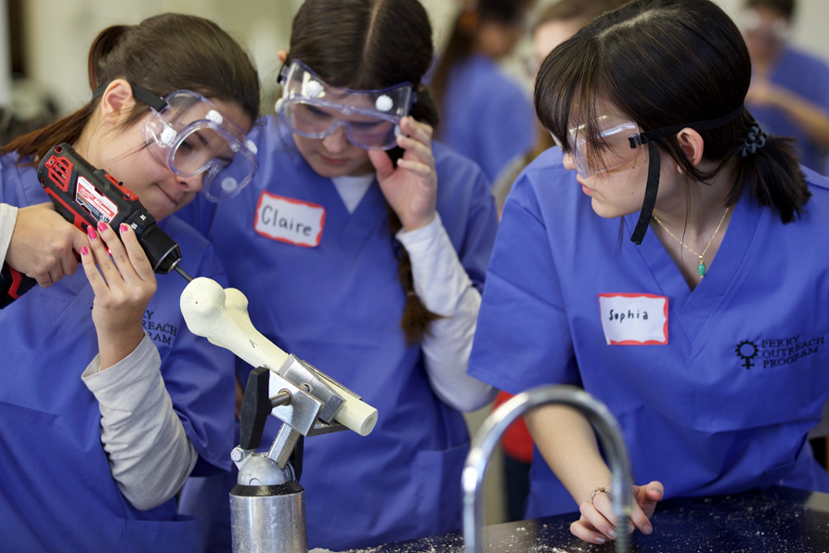
Club Scrubs [Photograph]. (n.d.). Excellence in Clinical Care-Teaching-Research, The University of Oklahoma College of Medicine Office of Diversity, Inclusion, and Community Engagement, Oklahoma City In R. C. Salinas, MD. (Comp.).

OPERATION: PRE-MED
Have you ever wondered what it takes to be a student of medicine? It may seem difficult to think about something as far in the future as medical school or even a “pre-med” program (the classes you take in college that prepare you for medical school). This activity will help you learn more about pre-med programs and how to set yourself up for success on your pre-med journey, including what high school classes to focus on, how you can get admitted to a pre-med program, what to expect in pre-med classes, as well as other related postsecondary (that is, beyond high school) opportunities that exist!

Materials
- Pen or pencil
- Internet access
- Quizlet link (below)
- Tip of the Iceberg graphic organizer (page 5)
- 2 Stars and a Wish sheet (page 6)

Instructions
- Work through the Tip of the Iceberg activity on pages 4-5.
- Complete “Below the Waterline” with this Quizlet link: https://tinyurl.com/OPpremed. Click “Flashcards” to access all of the cards. Use the new information you learn from the Quizlet cards to help you complete your graphic organizer.
- Once you have completed steps 1 and 2, reflect on the new information you have learned by completing the Two Stars and a Wish activity on page 6.

TIP OF THE ICEBERG
Notice that in the picture below very little of the iceberg is above water, while the rest is below the surface. The same principle applies to learning. There are a few things that are easily seen (above the waterline) and many more things under the surface, which you learn as your depth of understanding grows (below the waterline). In other words, the part of a subject that we can see is only a small part of a much larger whole.

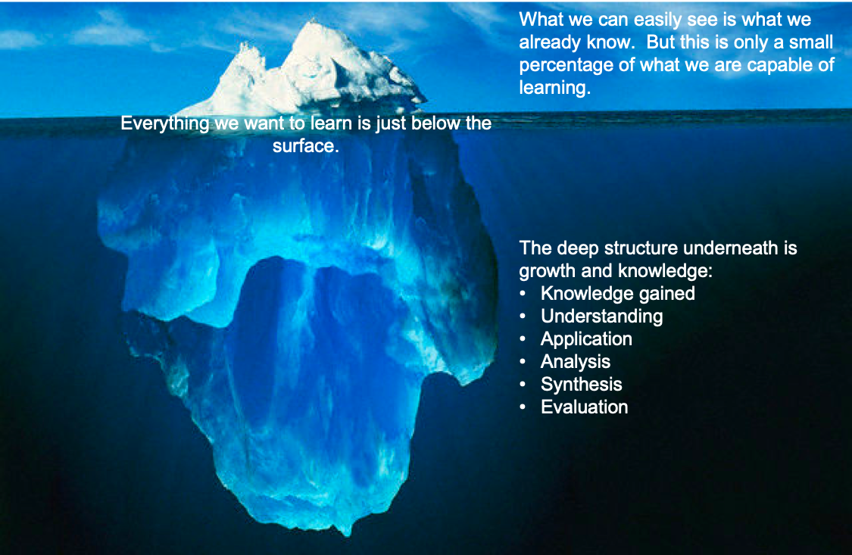
Materials
- Something to write with

Tip of the Iceberg graphic organizer, printed (page 5)

Note: If you are unable to print, you can divide a blank piece of paper into thirds. Label each third “Tip of the Iceberg,” “Waterline,” and “Below the Waterline” respectively.

Instructions
- Tip of the Iceberg. Print the graphic organizer on page 5 (or create your own). Consider everything you know about preparing for a medical career. What would you do in high school to get ready for college? Write down as many thoughts as possible in the “Tip of the Iceberg” section of the graphic organizer.
- Waterline. At the “Waterline” section, write down the information you want to learn about medical school.
- Below the Waterline. Click on the Quizlet link on page 3. Look through the Quizlet card set. Whenever you learn something new, write it down in the “Below the Waterline” section of your iceberg.
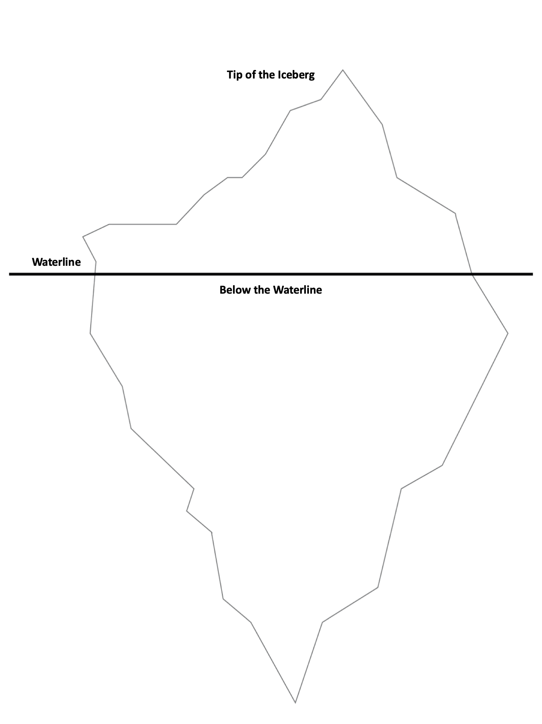

TWO STARS AND A WISH
Materials
- Something to write with

Two Stars and a Wish (printed) or a blank sheet of paper

Instructions

Consider the positive things you have learned, as well as the things you wish you had learned, while participating so far in Operation: Pre-Med.

Two Stars
What are some positive takeaways? Write one in each of the stars below.

A Wish
What is something you wish you could have learned more about? Write it in the thought bubble below.

EXTEND
The University of Oklahoma Health Sciences Center has several online resources for high school students interested in learning more about health science. Two such programs offered by the OU School of Community Medicine in Tulsa are Club Scrubs and MASH Camp. OU’s College of Medicine OKC campus offers the SPARK Summer Program for high school sophomores and juniors. Additional information is available for high school students interested in medical school, the physician assistant program, and other healthcare fields like hospital administration, nursing, and pharmacy.
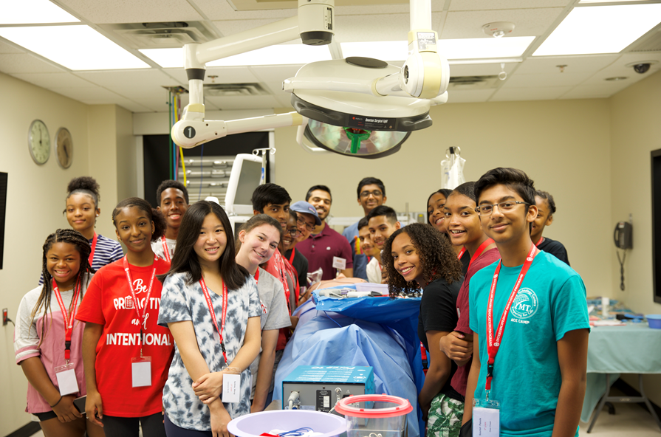
Club Scrubs [Photograph]. (n.d.). Excellence in Clinical Care-Teaching-Research, The University of Oklahoma College of Medicine Office of Diversity, Inclusion, and Community Engagement, Oklahoma City In R. C. Salinas, MD. (Comp.).

CONNECT WITH US
This activity is part of the Career Exploration section of the K20 Online Resources. Find more postsecondary and career exploration activities here: https://tinyurl.com/k20resources.

Do you have questions that weren’t answered in the activity above? Contact us! We would love to connect and share our resources with you.

K20 Center Mentoring Email: gearupmentor@groups.ou.edu
OU College of Medicine Email: odice@ouhsc.edu or diversity-inclusion@ouhsc.edu

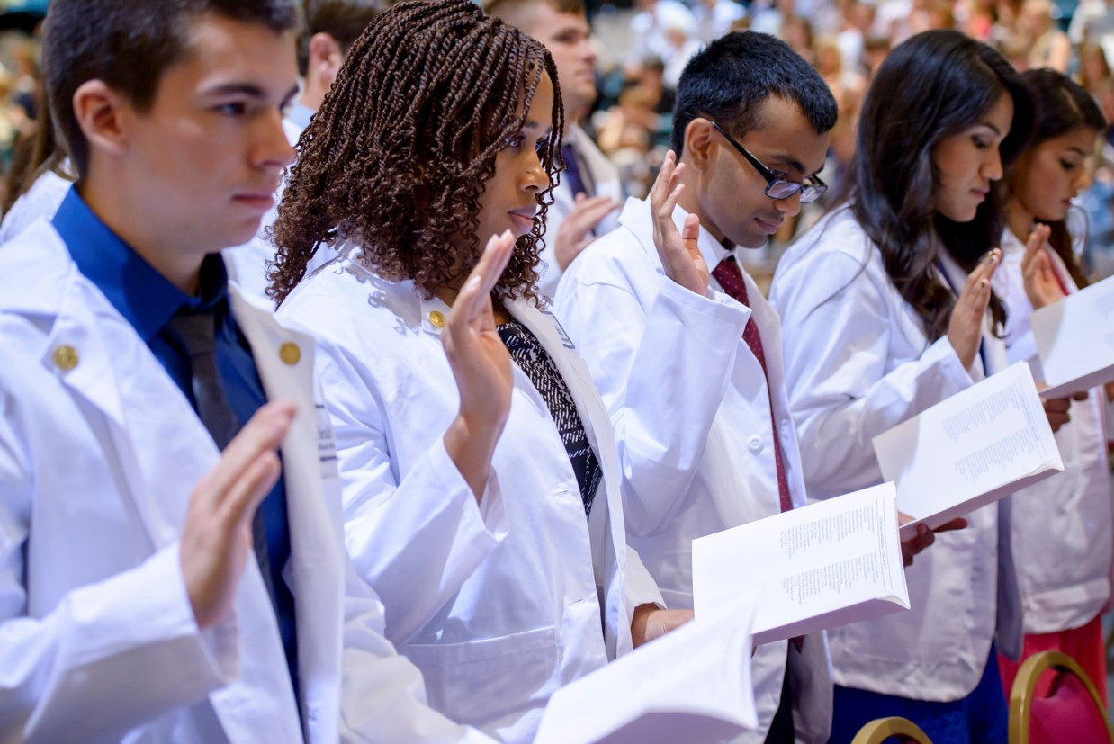OUCOM ODICE Zoom [Photograph]. (n.d.). The College of Medicine. The University of Oklahoma, Oklahoma City In R. C. Salinas, MD. (Comp.).

SOURCES
The sources linked in this activity are listed below. Providing a list of resources allows us to give credit for the work of others.

K20 Center. (n.d.). Tip of the iceberg. Strategies. https://learn.k20center.ou.edu/strategy/6f19b778b73e4c339d1a7d9653008def

OU College of Medicine. (n.d.). SPARK Summer Program. The University of Oklahoma. https://medicine.ouhsc.edu/Prospective-Students/Admissions/SPARK-Summer-Program

OU School of Community Medicine. (n.d.). Information for High School Students: Club Scrubs. The University of Oklahoma. http://www.ou.edu/tulsa/community_medicine/currrent-students/student-services/highschool

OU School of Community Medicine. (n.d.) Info for High School Students Interested in Medical School. The University of Oklahoma. http://www.ou.edu/content/dam/Tulsa/scm/rsa/High%20School/HSMD.pdf

OU School of Community Medicine. (n.d.) Info for High School Students Interested in PA School. The University of Oklahoma. http://www.ou.edu/content/dam/Tulsa/scm/rsa/High%20School/HSMD.pdf

Q&A

Classes, Coursework, and Grades
- What courses are important for me to take to attend a pre-medical program?
  - It is important to do well in all of your core classes. It is also recommended that you continue taking a math and science class through your senior year. However, other classes matter too. Consider taking foreign language classes, elective classes that engage you creatively, and activities that encourage you to build relationships with others.
- To attend medical school, do I have to take all Advanced Placement courses for my math and science credits?
  - No. While math and science are both important subjects, they are not the only ones that matter, and AP classes in general are not required to get into a pre-medical program.
- Will my research projects and science projects in middle and high school help prepare me for a pre-medical program?
  - Yes. Working on research projects helps you think critically and develop skills needed for pre-medical programs.
- Can speaking another language help me in the medical field?
  - Yes. Learning a different language can help you communicate with patients, as well as helping you learn about other cultures.
- Can other activities like art, music, or sports help me get into a pre-medical program?
  - Yes. Extracurricular activities are helpful because they show you have interests outside of schoolwork. Plus, having other interests can help your application stand out.
- Do my grades in high school affect my chances of being accepted into a college or university that will help prepare me for a pre-medical program?
  - Yes. Your grades in high school matter because the topics and ideas you learn will contribute to your college courses. Doing well in high school will help you do well in college, which better prepares you for medical school.

Volunteer Work and Projects Outside of School
- Will volunteering in the medical field (nursing homes, hospitals, doctor’s offices, etc.) before and during college help me prepare for medical school?
  - Absolutely! Volunteering in the medical field demonstrates that you are passionate about taking care of others. It also gives you good learning experiences and helps you know whether or not you really want to have a career in the medical field.
- What if I do volunteer work for projects or organizations that aren’t related to the medical field? Will that help me get into a pre-medical program?
  - Yes. Volunteering in general shows that you are willing to help others and give back to the community.
- Will volunteering regularly with an organization help my chances more than volunteering at a one-time event?
  - Although all volunteer hours matter and help the community, building relationships with people over a period of time shows dedication and deeper human connection.
- Can I participate in summer programs or internships that let me complete hands-on activities with medical staff while I’m still in high school?
  - Yes. For example, the University of Oklahoma Health Sciences Center offers the SPARK Summer program for high school sophomores and juniors interested in pursuing a medical career. This is a week-long program and is free to participants. You can find more information about Club Scrubs here: https://tinyurl.com/OUClubscrubs.

Admissions, Applying to Medical School, and Who Can Attend
- Do I have to take a medical college admissions test to attend medical school?
  - Yes. You will have to take the Medical College Admissions Test, also called the MCAT, before applying to a medical school.
- Can I just apply to go to medical school after high school?
  - No. You have to also take the MCAT and earn a Bachelor’s Degree before you can apply to medical school.
- Are my grades and test scores the only things schools take into account when I am applying to a pre-medical program?
  - No—leadership skills, critical thinking, problem-solving skills, and many other things are all taken into account.
- Do my reading, writing, and critical-reasoning abilities factor into my admissions?
  - Yes. These skills help when taking the MCAT. They also help you stand out as a candidate for medical school. Reading, writing, and grammatical skills are very important when considering a career in the medical field.
- Is it true that only rich students can afford to go to medical school?
  - No. Medical school is certainly expensive due to the years you will spend in school—a minimum of four years of undergrad and four years of medical school. However, there are things you can do to bring down the cost, such as applying for FAFSA, exploring options for scholarships, and going to school in-state.

Building Relationships with School Staff
- Is it true that building strong relationships with teachers and counselors at my school can help me prepare for, and get into, a pre-medical program?
  - Yes. If you start building relationships with your teachers and guidance counselors now, they can help you by providing reference letters and advice for navigating the college admissions process down the road.
- Is it a good idea for me to wait until my senior year to seek advice from an advisor or guidance counselor about going to medical school or going into the health science field?
  - No. It's a good idea to seek advice from an advisor or guidance counselor early on. Your advisors can help you understand and plan for the classes you should take to prepare for a pre-med education.

Bachelor’s Degree
- If I attend college and major in something other than science, can I still become a doctor?
  - Yes, you can have a degree in other areas (such as English or dance) as long as you have also taken prerequisite classes—that is, the classes you’re required to take before getting into a medical school program. As long as you have met the requirements for the program, you can apply no matter your major.

