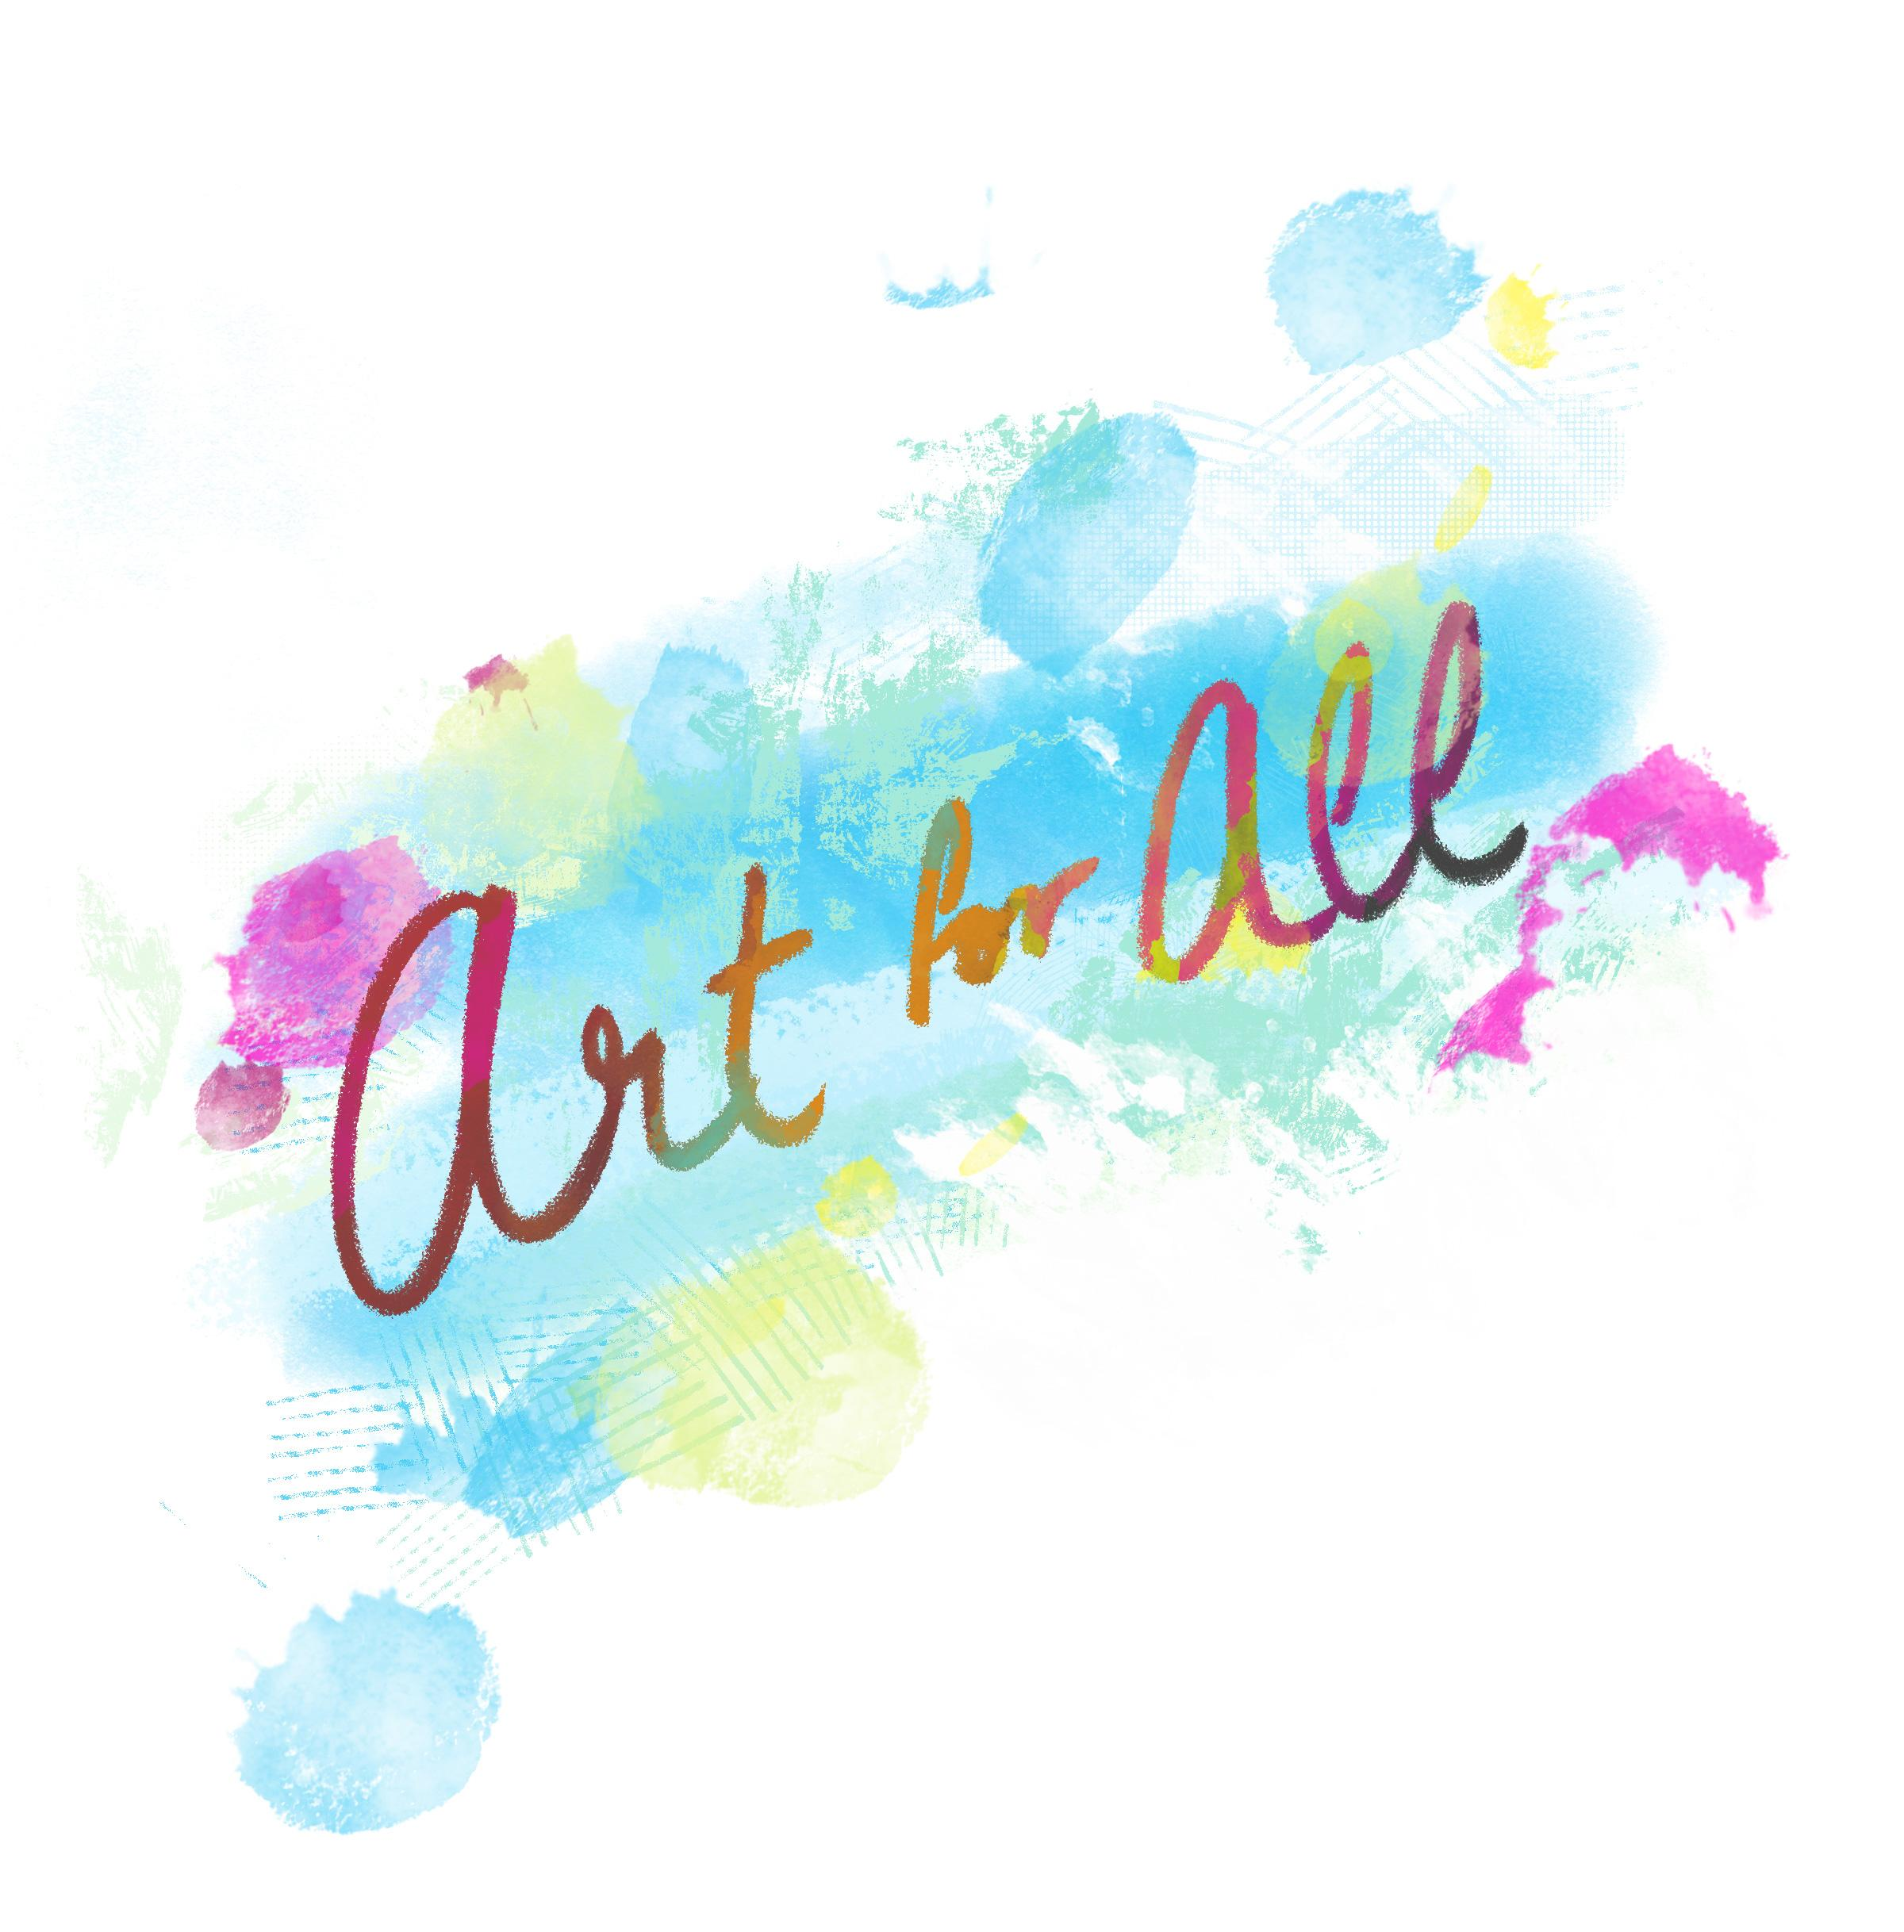

Contents
Art For All Overview ______________________________________________________ | 3
Materials
Activity Instructions
Activity 1: Virtual Tour _____________________________________________________ | 4
Activity 2: Art Creation ____________________________________________________ | 13
Activity 3: Career Talk _____________________________________________________ | 15
Extend _________________________________________________________________ | 16
Sources ________________________________________________________________ | 17

ART FOR ALL
Do you enjoy painting, chalking, drawing cartoons, or creating digital artwork but are unsure what careers these interests can lead to? If so, you’re not alone! It’s a common myth that art is only a hobby. In reality, there are many career opportunities that people with creative skills can pursue, including painting, graphic art, set design, animation, and illustration.

Professional artwork can be found everywhere. Consider the murals that you might see on buildings in your community, the animations on the video games you play, the pages of your favorite comic books, and even the billboard advertisements posted on streets and highways. This activity will allow you to explore artwork from different cultures, recreate a piece of artwork, and hear from an Oklahoma-based graphic artist.

Materials
- A device with access to the Internet (computer, smartphone, tablet, etc.)
- Paper (optional)
- Camera phone (optional)
- Something to color, paint, chalk, or draw with
- Assorted items from home (optional)

Activity Instructions
- Start with Activity 1: Virtual Art Tour.
- Move to Activity 2: Art Creation.
- Finish with Activity 3: Career Talk and complete the 3-2-1 writing reflection.
- Check out more careers from the Art, A/V Technology, and Communications cluster in the Extend section.

ACTIVITY 1: VIRTUAL ART TOUR
First, let’s take a virtual tour to view art from around the country and the world. There are eight different art options provided for you to explore on pages 5-12. Click the link below each picture to see more images from that art category.

- Take your time and note the pieces that you connect with the most and why. What message do you think the artists wanted to send with their work?

- Use the table below to keep track of the websites for your favorite artwork. You can copy and paste or write down each website and take notes about the artwork that you find interesting. You can also list the websites on a separate piece of paper and take notes there if you prefer.

- After viewing artwork from at least three of the websites, select one piece that you would like to recreate before moving on to Activity 2.

Art Tour
Website | Notes

- Murals: TravelOK
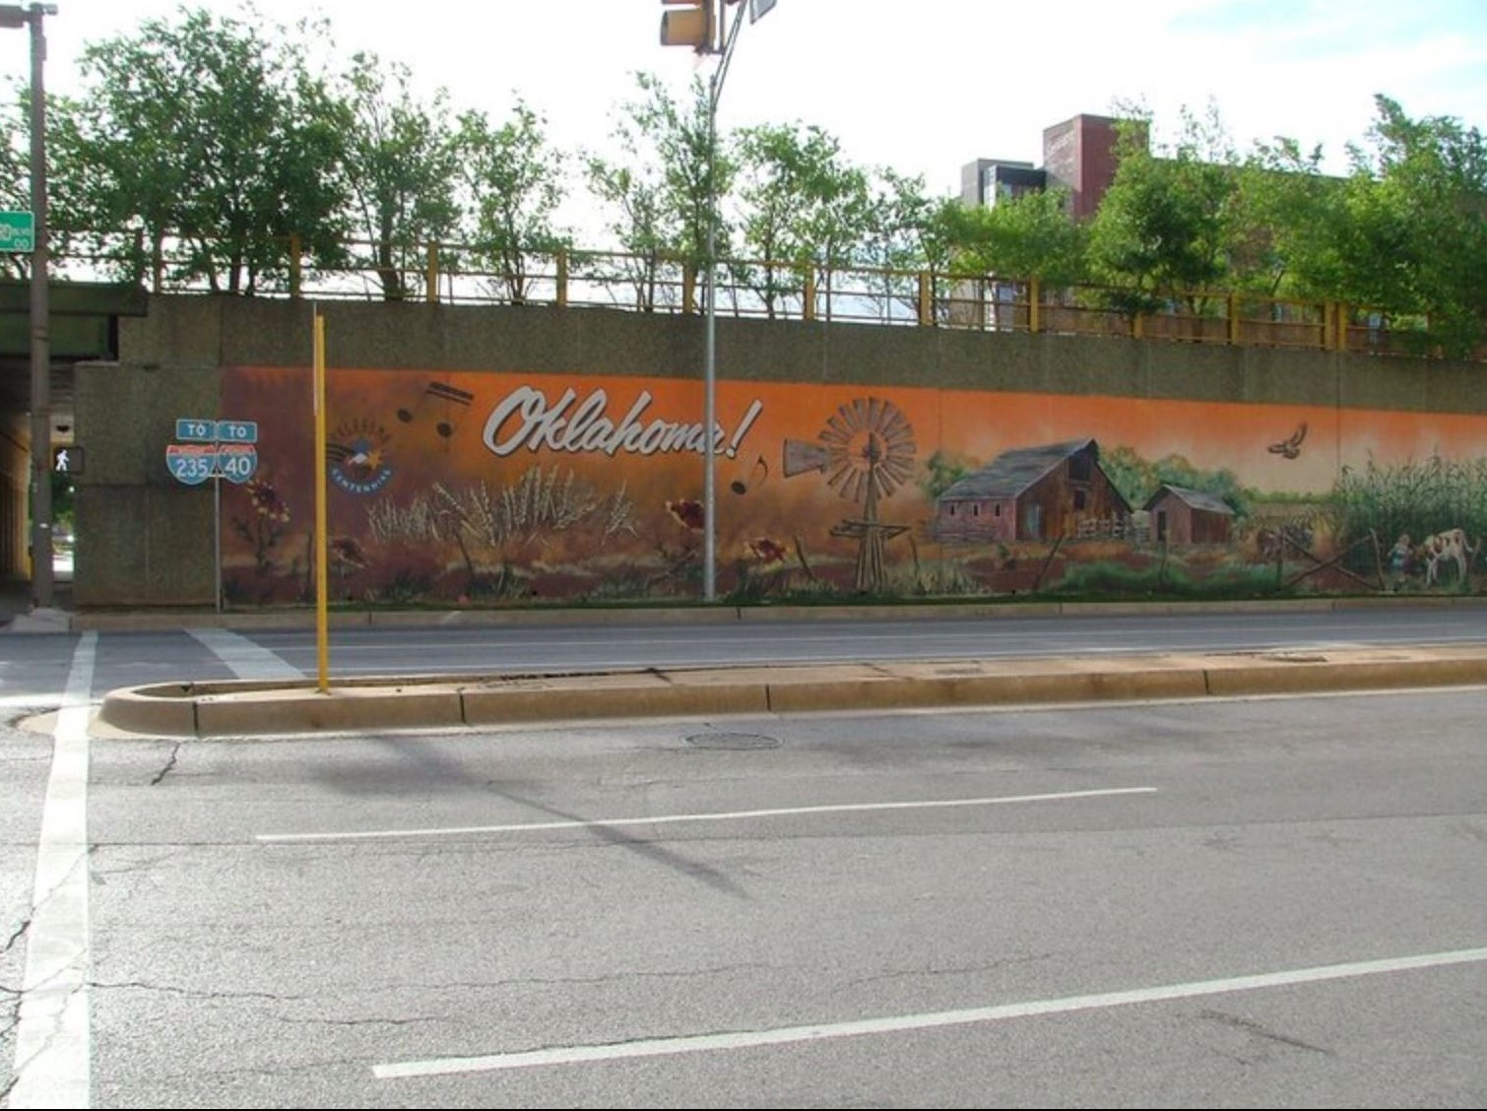
TravelOK. (n.d.). Oklahoma! Bricktown mural. https://www.travelok.com/listings/view.profile/id.23425
To view murals located throughout the state of Oklahoma, click HERE or go to https://tinyurl.com/okmurals.

- Portraits: Kehinde Wiley
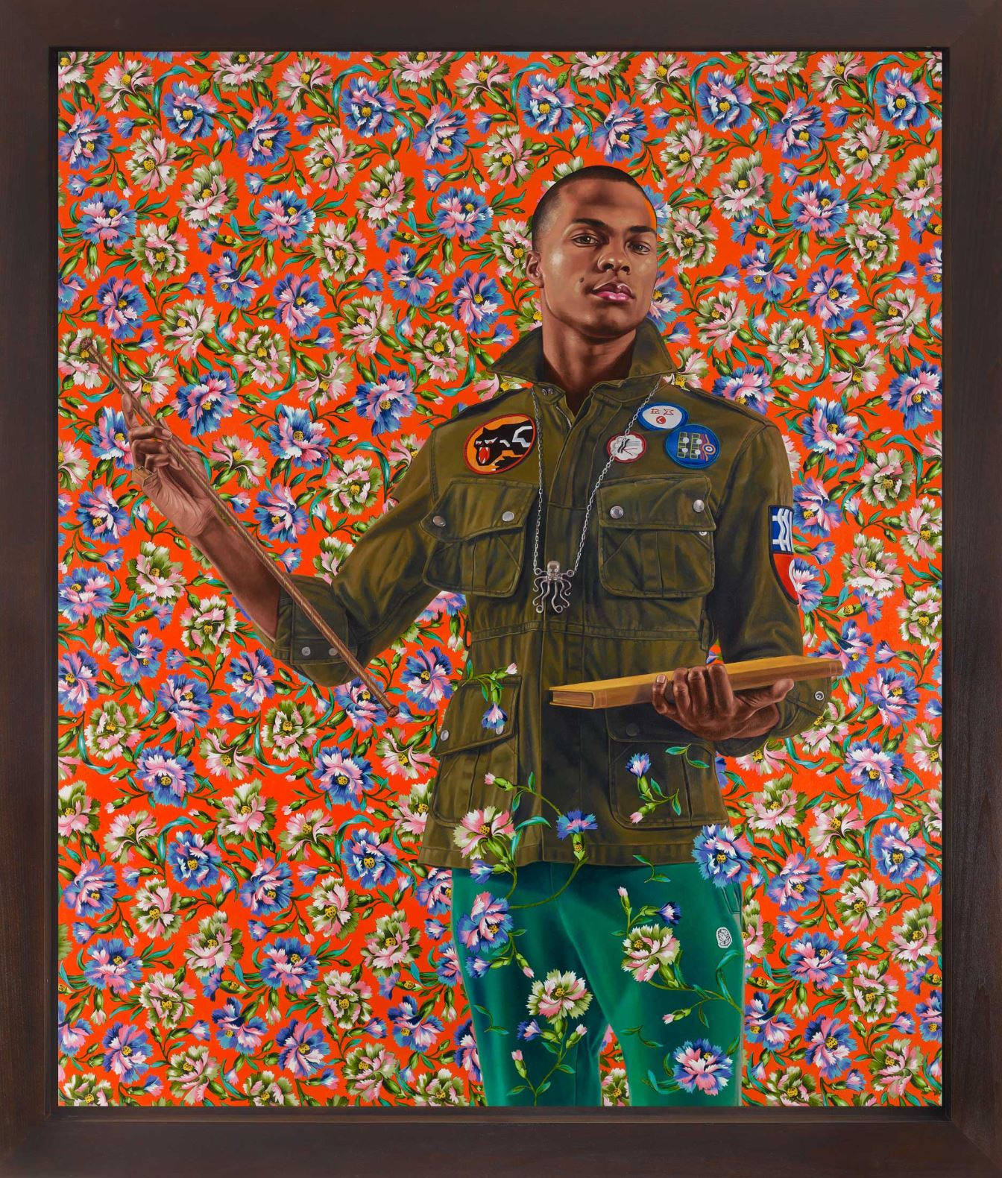
Wiley, K. (2013). Jean de Carondelet III. http://kehindewiley.com/works/selected-work-2013/
To view portrait paintings created by Kehinde Wiley, click HERE or go to https://tinyurl.com/portrait-kw.

- Artwork: Smithsonian Institution Latino Art Collection
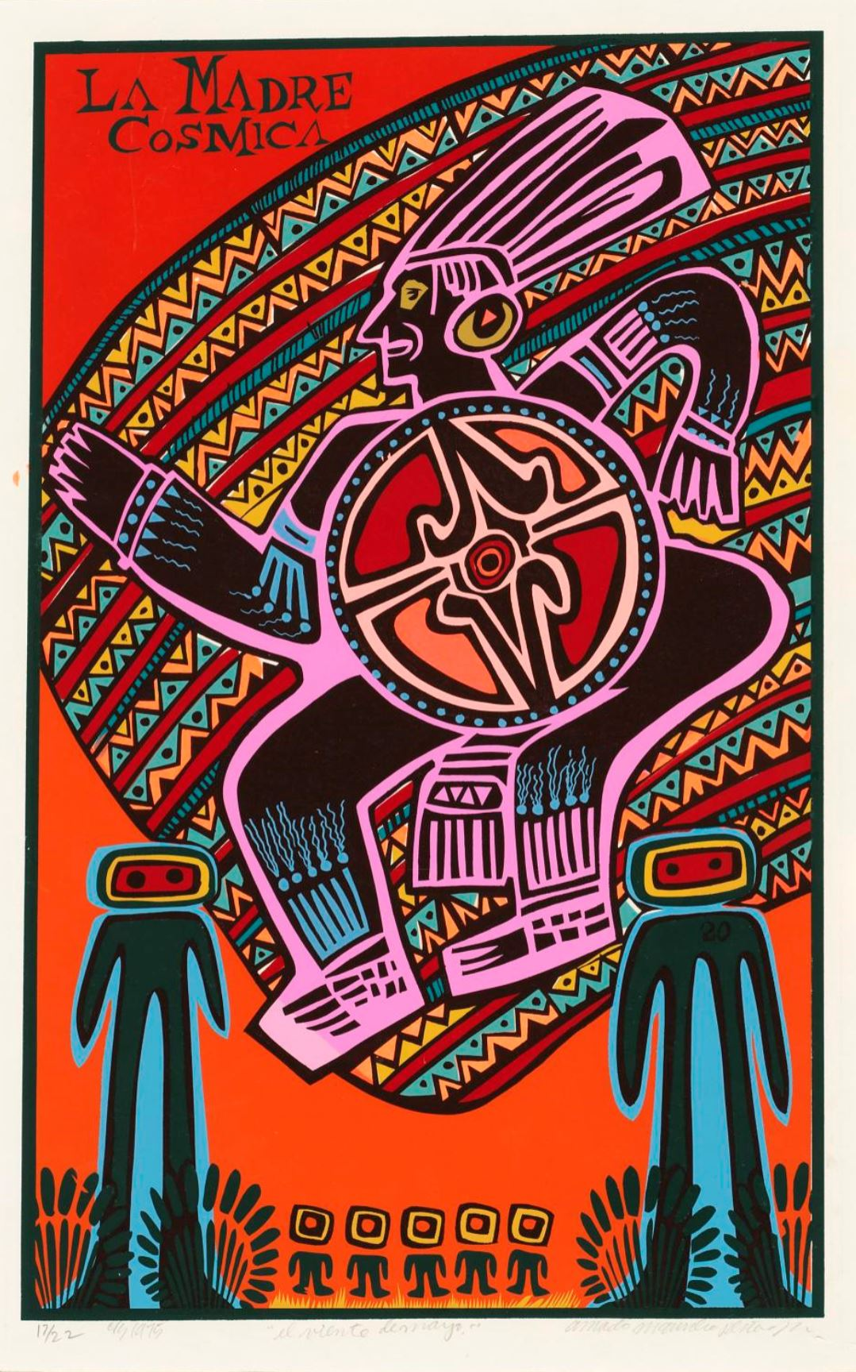
Peña, A.M. (1975.). El Veinte de Mayo. Smithsonian American Art Museum and its Renwick Gallery. https://www.si.edu/object/el-veinte-de-mayo:saam_1996.47.3
To view the Smithsonian’s collection of Latino art and artists, click HERE or go to https://tinyurl.com/art-smi.

- Paintings: Sacred Arts Research Foundation
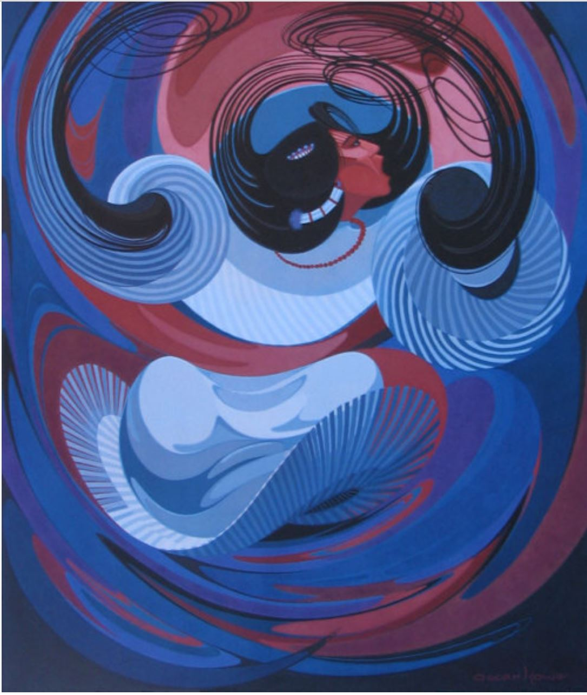
Block, A. J. (2018, Feb. 23). Oscar Howe (Dakota). 10 Native American painters, schools, and styles you should know. https://www.sacredartsresearch.org/blog/2018/2/23/10-native-american-painters-schools-and-styles-you-should-know
To view Native American paintings, click HERE or go to https://tinyurl.com/paint-sarf.

- Paintings & Drawings: Van Gogh Museum
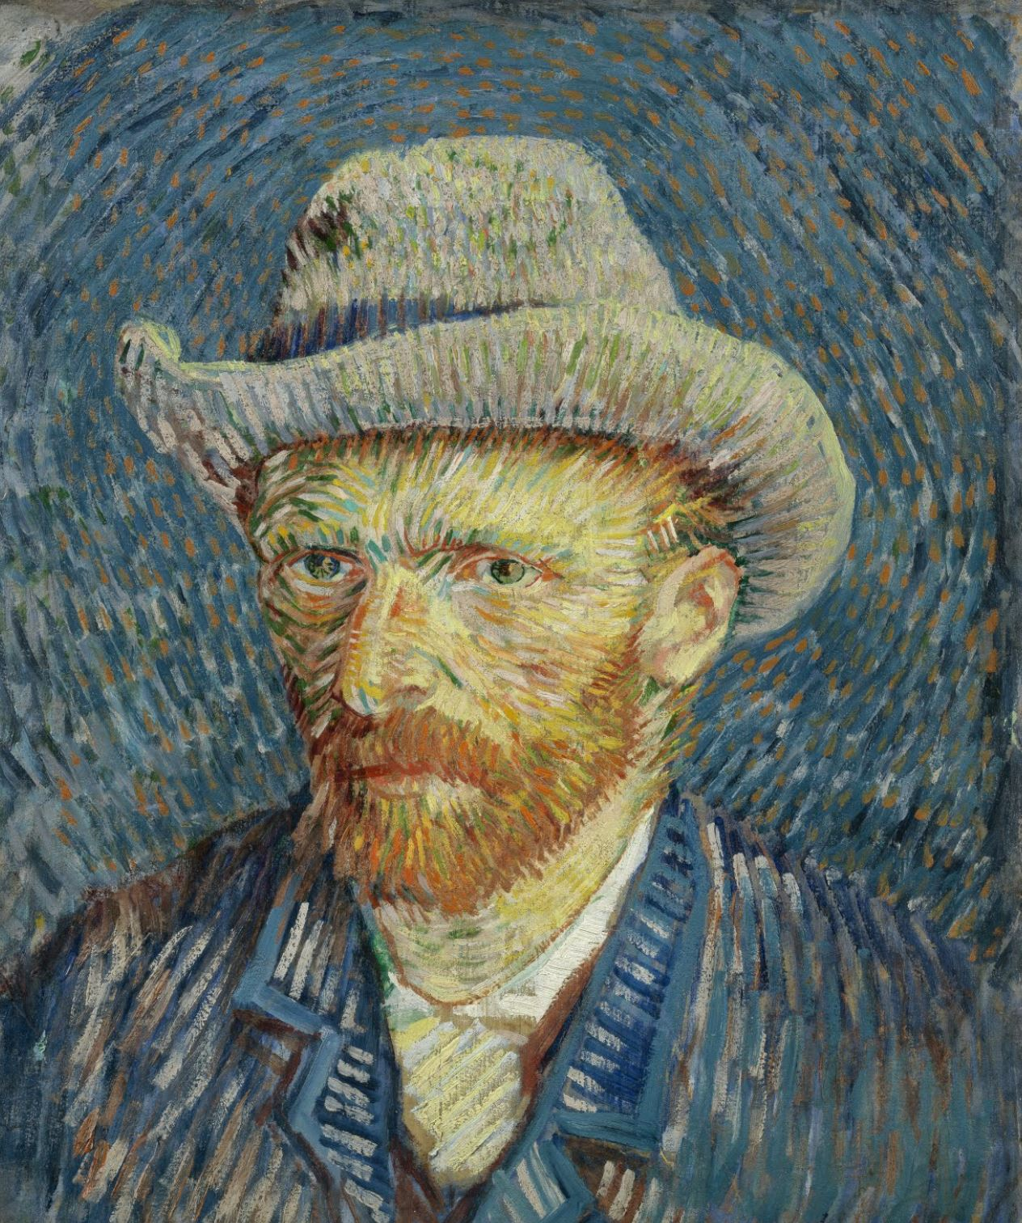
Google Arts & Culture. (n.d.). Vincent Van Gogh Self-portrait with grey felt hat. https://artsandculture.google.com/asset/self-portrait-with-grey-felt-hat-vincent-van-gogh/PgEJ1hPIzqsM2w?hl=en
To view the Van Gogh Museum’s collection of paintings and drawings, click HERE or go to https://tinyurl.com/paint-vg.

- Graffiti Art: Banksy
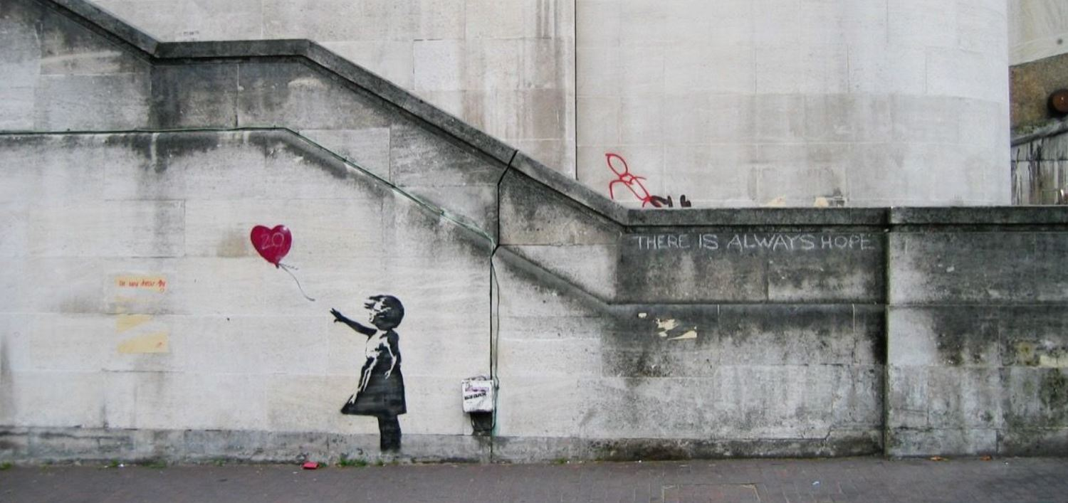
Indrisek, S. (2019). The 6 most iconic works by Banksy. https://www.artsy.net/article/artsy-editorial-6-iconic-works-banksy
To view graffiti art created by Banksy, click HERE or go to https://tinyurl.com/graffiti-ba.

- Street Art: Kurt Wenner
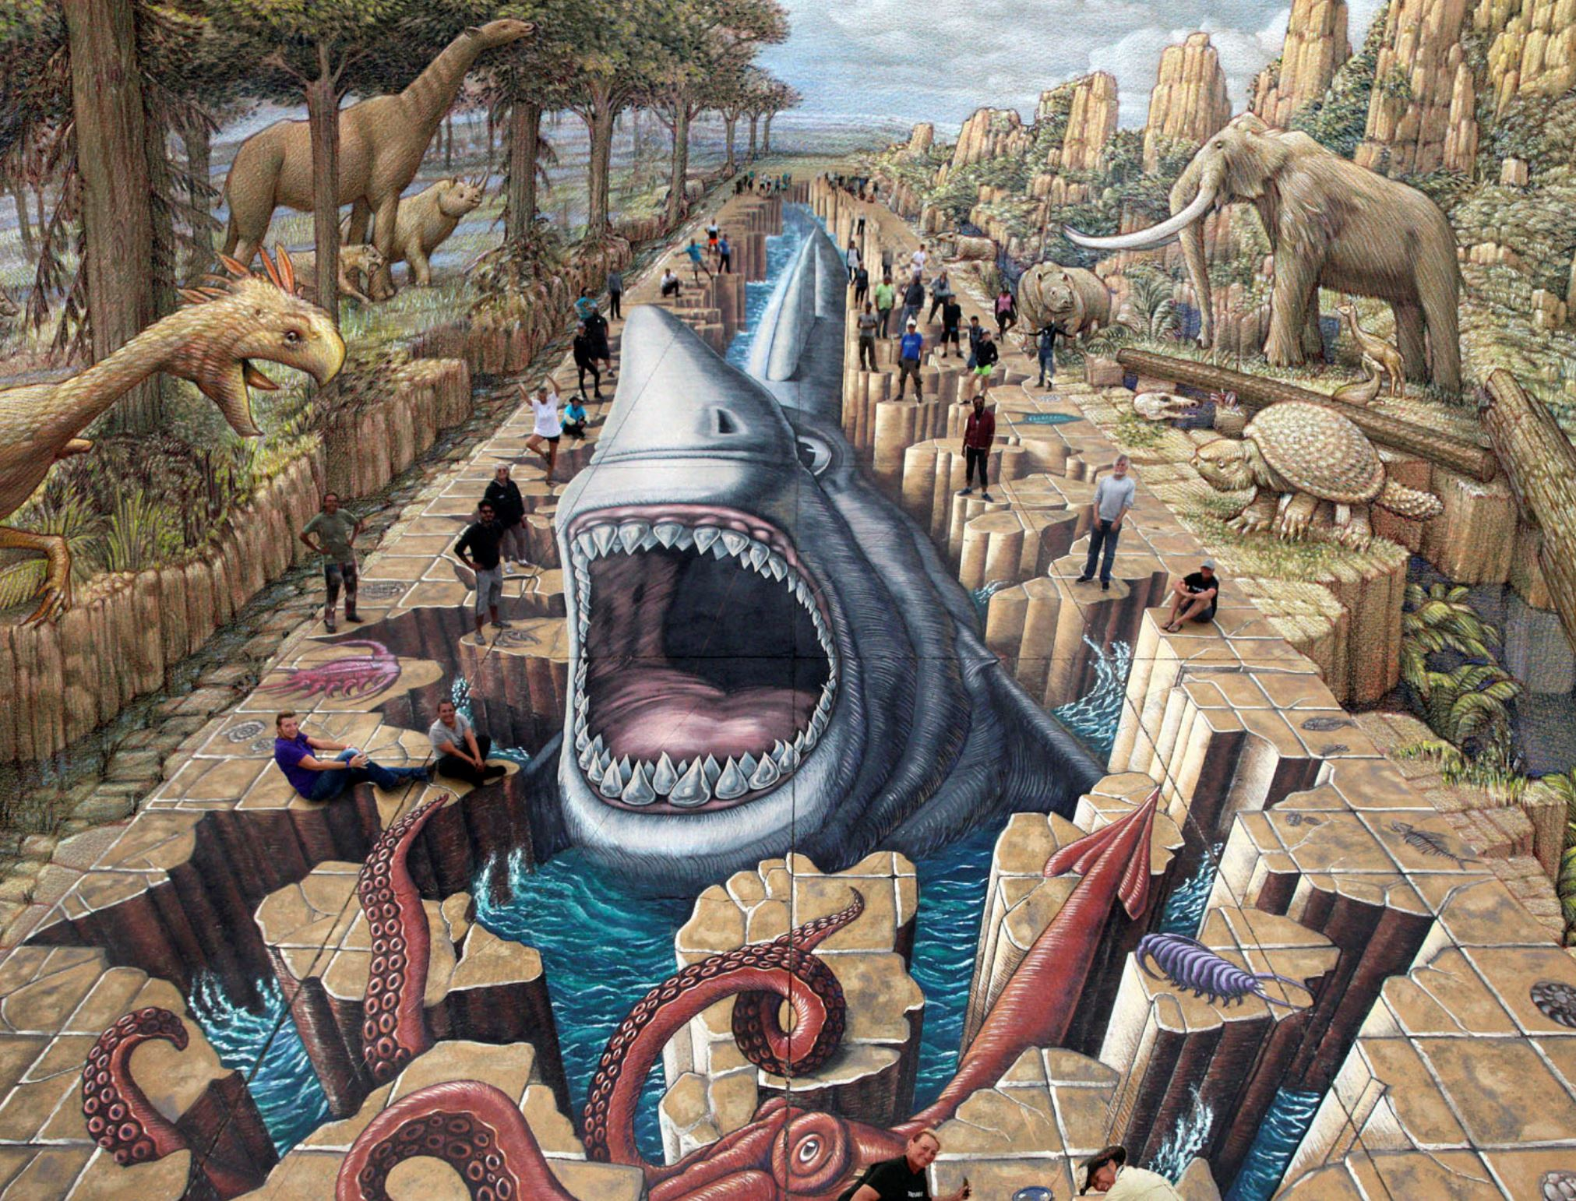
Wenner, K. (n.d.). 3D street art. https://kurtwenner.com/3d-street-art/
To view street art created by Kurt Wenner, click HERE or go to https://tinyurl.com/streetart-kw.

- Portraits: National Portrait Gallery
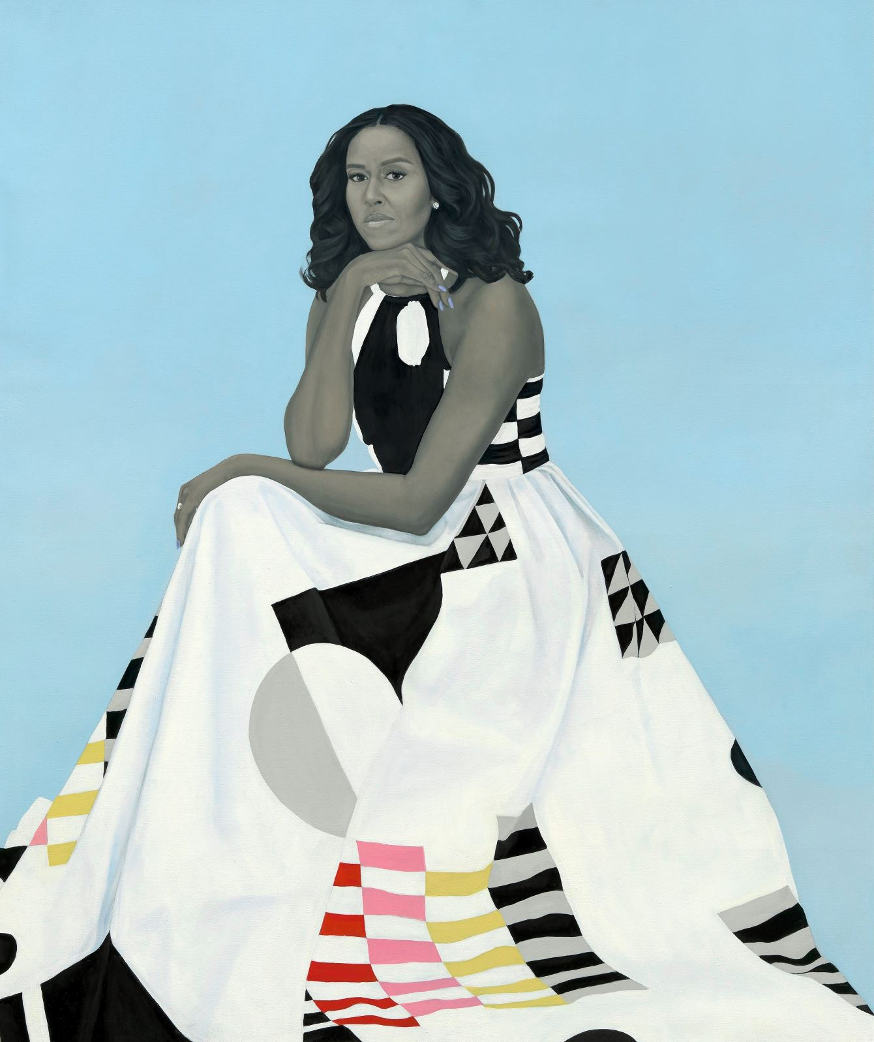
Google Arts and Culture. (n.d.). First ladies. From the National Portrait Gallery. https://artsandculture.google.com/exhibit/first-ladies/OAJS1lr5txbLJQ?mc_cid=a1b64e28dd&mc_eid=0d44a7c872
To view portraits located in the National Portrait Gallery, click HERE or go to https://tinyurl.com/portrait-npg.

ACTIVITY 2: ART CREATION
For this second activity, you will use the artwork that you selected from Step 1 to help you create your own masterpiece. Before you start creating, examine the chart below to learn more about the different types of art that you have viewed.

Visual Art Categories
Type | Description
Mural | A work of art that is usually large and created directly on the surface of a wall, ceiling, or other permanent surface.
Painting | A type of art created using paint. Some examples of styles of painting include still life, landscape, seascape, abstract, and pop art.
Drawing | A hand representation of any form or object made using items like pencils, pens, or charcoal.
Portrait | A painting, drawing or photograph of a person that usually includes only their head and shoulders.
Graffiti Art | Pictures or words that are painted or drawn directly on walls, buildings, or trains. Artists often use spray paint to create their work.
Street Art | Pictures or words that are painted or drawn directly on walls, highway overpasses, or sidewalks. Street artists often use their art to address societal issues and promote discussion. Artists often use chalk, LEDs, stickers, yarn bombing, or woodblocking.

To create your own art piece, select one of the four options included below. Be creative and don’t forget to give your art piece a title!

- Option 1: Paint using watercolors on paper or canvas.
- Option 2: Use chalk on dark paper or a sidewalk near your home with permission from a parent or guardian.
- Option 3: Draw on paper using markers, crayons, stencil pencils, etc.
- Option 4: Use items from around your home to recreate a portrait and take a selfie or photo.
Below is one example of how others have used different materials from their home as props for their portrait photo. To see other examples, click HERE or go to https://tinyurl.com/artrecreations.

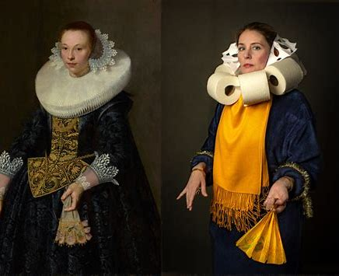
Barajas, J. (2020, April 15). Famous paintings come to life in these quarantine works of art. PBS. https://www.pbs.org/newshour/tag/getty-museum-challenge

Don’t keep all this fun to yourself! Invite your family to participate with you and create a family exhibit.

ACTIVITY 3: CAREER TALK
Now that you’ve had the opportunity to take a virtual art tour and recreate your own masterpiece, it’s time to hear from a professional artist. Calli Morris is an award-winning graphic designer and illustrator based in Oklahoma. She graduated from the University of Oklahoma with a degree in visual communication.

Click HERE or go to https://tinyurl.com/cmcareertalk2 to learn more about Calli’s development as an artist and how she turned her childhood passion into a full-time career.

After viewing Calli’s career talk, reflect on the video by completing a 3-2-1 writing activity.

3-2-1 Reflection
3 Things You Have Learned:

2 Questions You Still Have:

1 Thing You Found Interesting:

Extend

Do you want to take more virtual art tours but you’re not sure where to find them online? The Guardian, an online newspaper, has compiled a list of 10 virtual museum and art gallery tours that you can check out by clicking HERE or going to https://tinyurl.com/guardiantours.

Want to learn more about other careers in the arts? Check out My Next Move to see additional information about what people in these careers do and the knowledge, skills, and abilities needed. Click HERE or go to https://tinyurl.com/mnm-arts. Visual art is just one component of the Arts, A/V Technology, and Communications career cluster. You can find out more about the other career fields by clicking HERE or going to https://tinyurl.com/mnm-careers .

If you’re interested in design careers, check out AIGA’s website by clicking HERE or going to https://tinyurl.com/gd-aiga.

Don’t stop at exploring just careers in the arts. GEAR UP at the K20 Center Center has a full playlist of career talks from numerous fields online. To check out more career talks, click HERE or go to https://tinyurl.com/k20careerexpo.

Sources
All sources that were linked throughout the activity are listed below. Providing a list of resources allows us to give credit for the work someone else made.

AIGA. (n.d.). Types of design practice. https://www.aiga.org/aiga/content/tools-and-resources/student-resources/types-of-design-practice/
Art Hearty. (n.d.). The different forms of art that are surprisingly versatile. https://arthearty.com/different-forms-of-art
Barajas, J. (2020, April 15). Famous paintings come to life in these quarantine works of art. PBS NewsHour. https://www.pbs.org/newshour/tag/getty-museum-challenge
Block, A. J. (2018, Feb. 23). 10 Native American painters, schools and styles you should know. https://www.sacredartsresearch.org/blog/2018/2/23/10-native-american-painters-schools-and-styles-you-should-know
Block, A. J. (2018, Feb. 23). Oscar Howe (Dakota). 10 Native American painters, schools, and styles you should know. https://www.sacredartsresearch.org/blog/2018/2/23/10-native-american-painters-schools-and-styles-you-should-know
Forbes. (2020). Twitter crushes museum challenge with genius recreations of famous artworks. https://www.forbes.com/sites/suzannerowankelleher/2020/03/31/twitter-crushes-museum-challenge-with-genius-recreations-of-famous-artworks/#63d113d429f8
Google Arts and Culture. (n.d.). First ladies. From the National Portrait Gallery. https://artsandculture.google.com/exhibit/first-ladies/OAJS1lr5txbLJQ?mc_cid=a1b64e28dd&mc_eid=0d44a7c872
Google Arts & Culture. (n.d.) Van Gogh Museum. https://artsandculture.google.com/partner/van-gogh-museum?hl=en
Google Arts & Culture. (n.d.). Vincent Van Gogh Self-portrait with grey felt hat. https://artsandculture.google.com/asset/self-portrait-with-grey-felt-hat-vincent-van-gogh/PgEJ1hPIzqsM2w?hl=en
Indrisek, S. (2019). The 6 most iconic works by Banksy. https://www.artsy.net/article/artsy-editorial-6-iconic-works-banksy
K20 Center. (2020, March 31). Graphic designer- Calli Morris- Zoom into your career. https://www.youtube.com/watch?v=cuj8UYWdslc&list=PL-aUhEQeaZXIhi-ivvrQTrrEAlWvFWisR&index=27&t=48s
Merriam-Webster. (n.d.). Mural. In Merriam-Webster.com dictionary. Retrieved September 17, 2020, from https://www.merriam-webster.com/dictionary/mural?src=search-dict-box
Merriam-Webster. (n.d.). Painting. In Merriam-Webster.com dictionary.
https://www.merriam-webster.com/dictionary/painting
Merriam-Webster. (n.d.). Drawing. In Merriam-Webster.com dictionary.
https://www.merriam-webster.com/dictionary/drawing
Merriam-Webster. (n.d.). Portrait. In Merriam-Webster.com dictionary.
https://www.merriam-webster.com/dictionary/portrait
My Next Move. (n.d.). Fine artists, including painters, sculptors, & illustrators. https://www.mynextmove.org/profile/summary/27-1013.00
Peña, A.M. (1975.). El Veinte de Mayo. Smithsonian American Art Museum and its Renwick Gallery. https://www.si.edu/object/el-veinte-de-mayo:saam_1996.47.3
Smithsonian Institution. (n.d.). Online exhibitions. National Portrait Gallery. https://npg.si.edu/online-exhibitions
Smithsonian Institution. (n.d.). Latino art and artists. https://www.si.edu/spotlight/latino-artists
Study.com. (n.d.). Street art: Definition & history. https://study.com/academy/lesson/street-art-definition-history.html
TravelOK. (n.d). Murals [Search results]. https://www.travelok.com/listings/search/2?tags[]=957
TravelOK. (n.d.). Oklahoma! Bricktown mural. https://www.travelok.com/listings/view.profile/id.23425
Wilson, A. (2020, March 23). 10 of the world’s best virtual museum and art gallery tours. The Guardian. https://www.theguardian.com/travel/2020/mar/23/10-of-the-worlds-best-virtual-museum-and-art-gallery-tours
Wiley, K. (2013). Jean de Carondelet III. http://kehindewiley.com/works/selected-work-2013/
Wiley, K. (n.d.). Work. http://kehindewiley.com/works/
Wenner, K. (n.d.). 3D street art. https://kurtwenner.com/3d-street-art/

