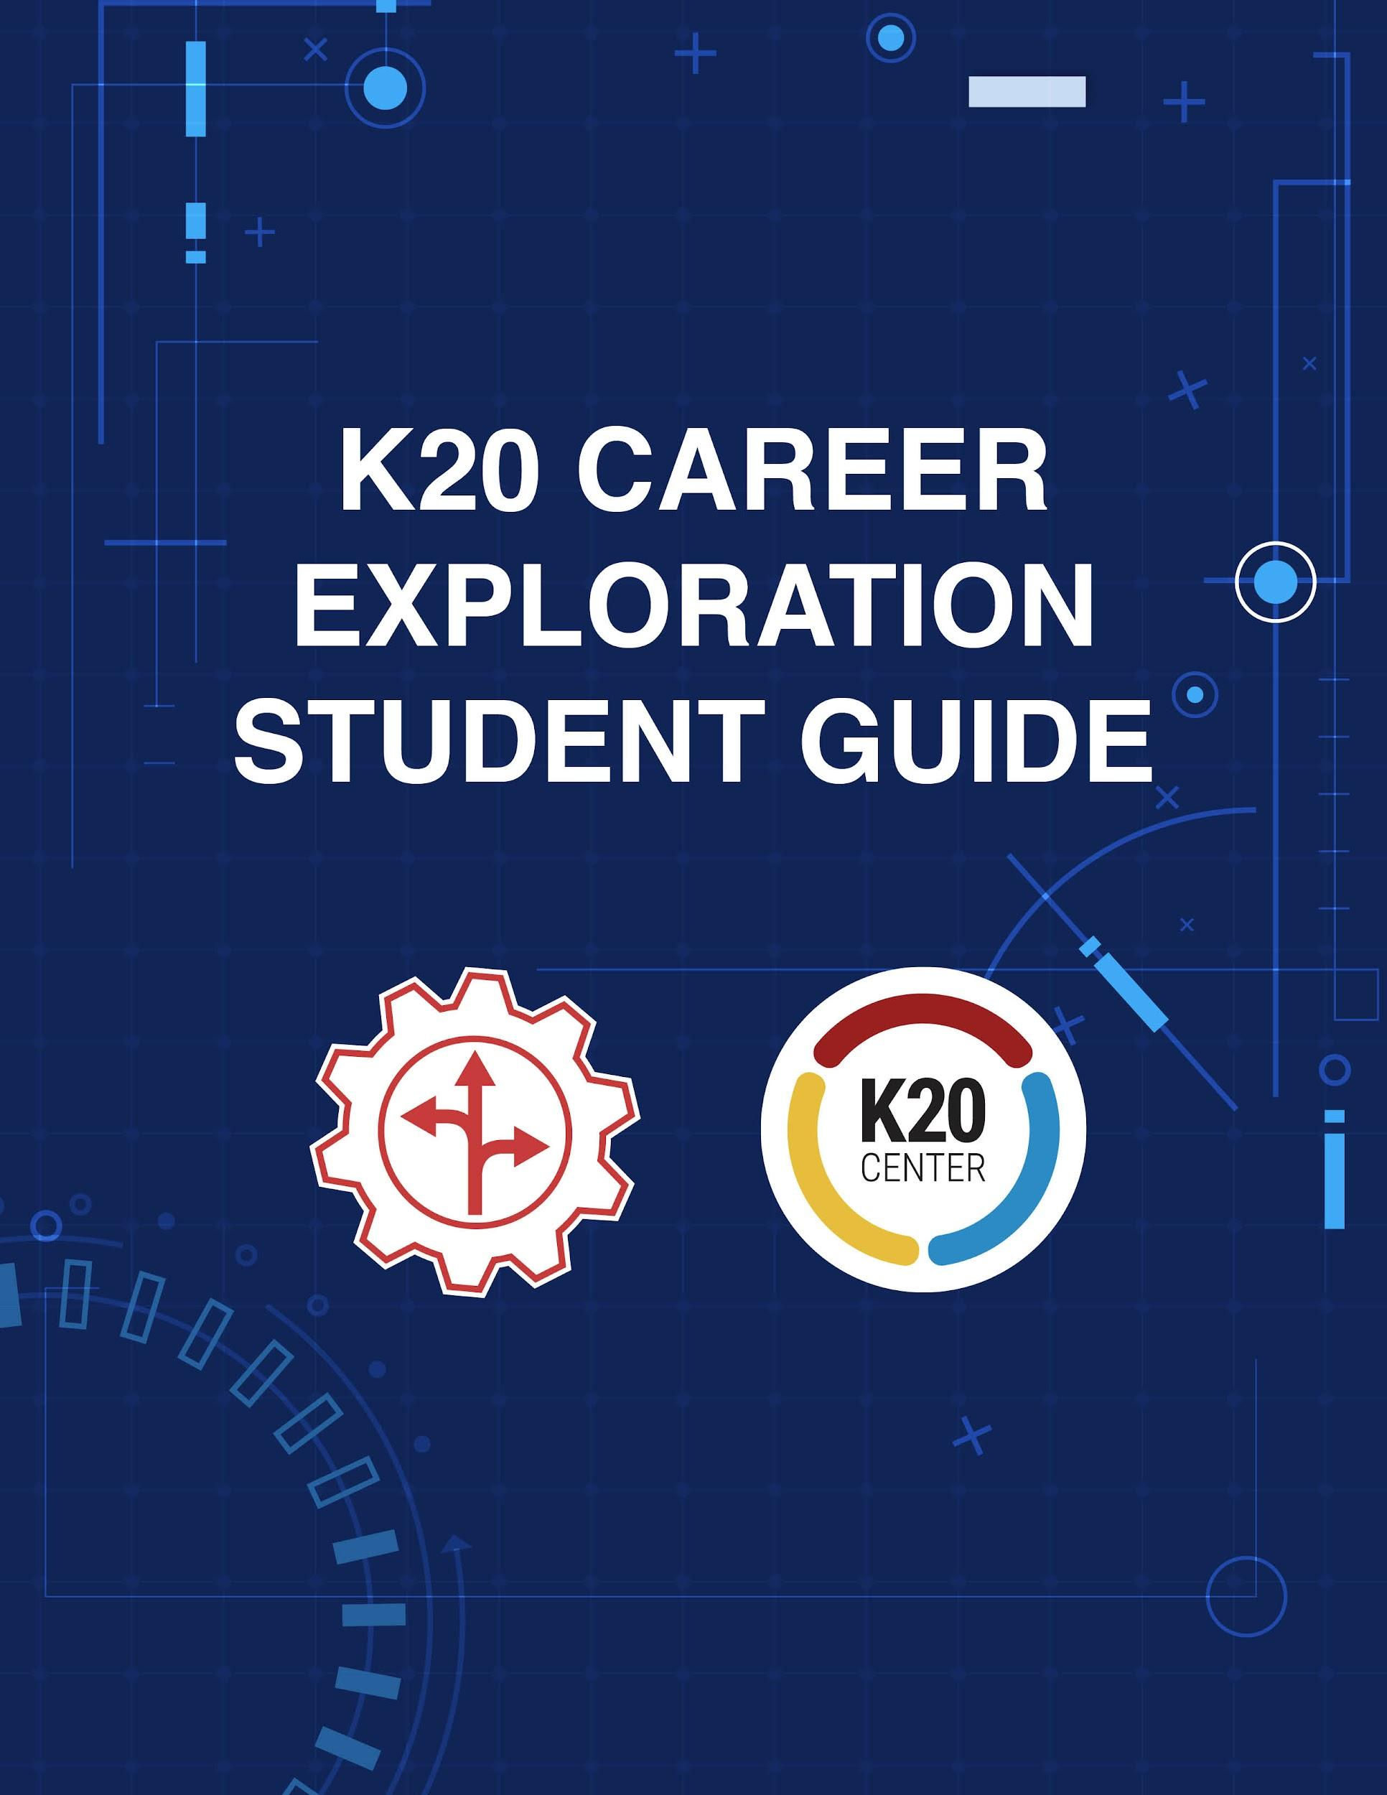

Contents
Overview ______________________________________________________________ | 2
Your Role as a Student ____________________________________________________ | 3
Activities ______________________________________________________________ | 6
Zoom Into Your Career Reflection Strategies ____________________________ | 6
BINGO! I’ve Found My Career _______________________________________ | 8
16 Ways to Survey Your Career ______________________________________ | 9

Overview
You may not know what you want to do when you grow up, and that's okay! No one expects you to have your future mapped out yet. The K20 Center’s Mentoring Team has created activities to help you explore different career options and opportunities. After you finish the activities, you will have a better understanding of what kind of career might interest you. This guide will walk you through the activities in more detail. After you finish each activity, discuss any questions you have with a parent or guardian. They can help you explore careers beyond the information provided.

These activities are also part of the Career Exploration section of the K20 Online Resources found at https://tinyurl.com/k20resources.

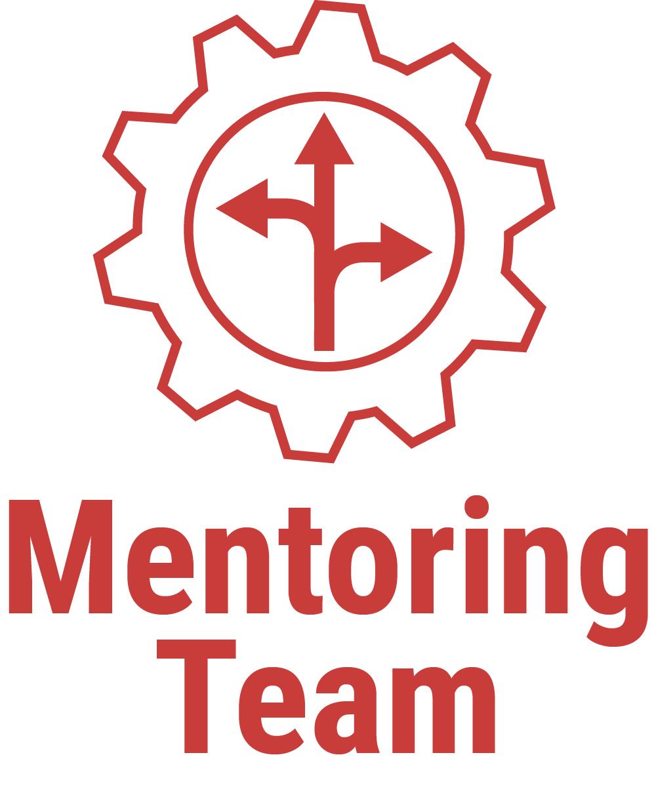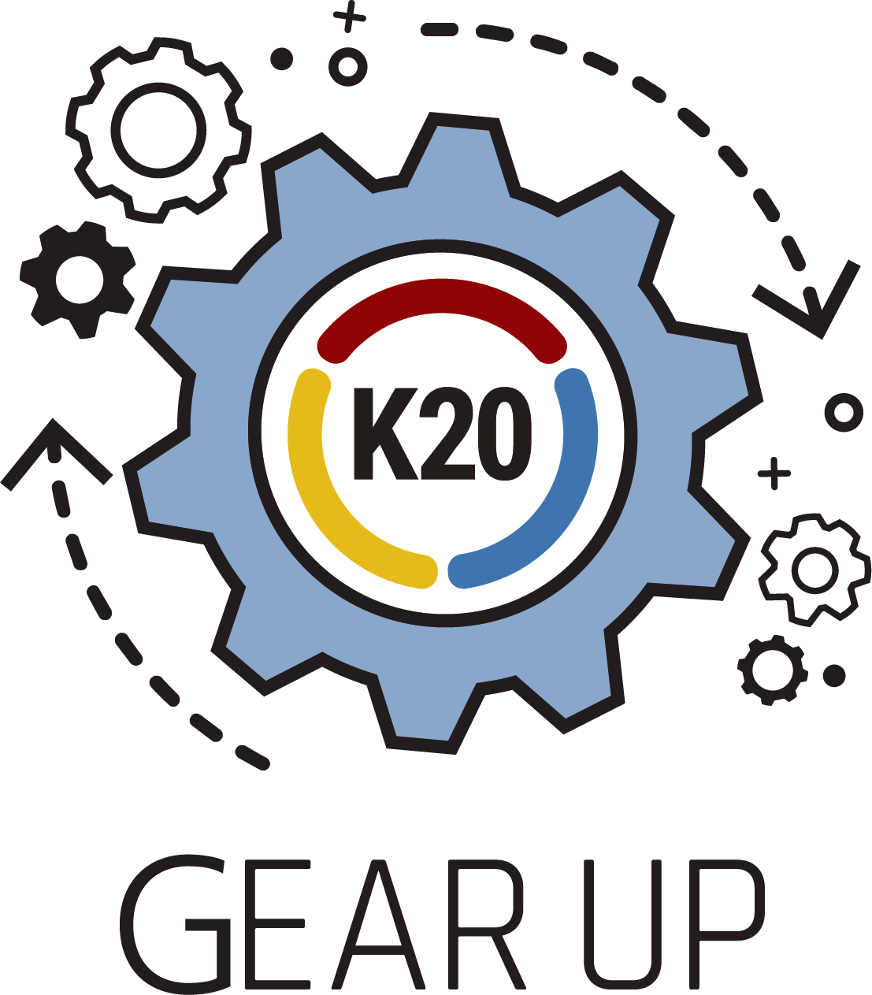

Your Role as a Student
Your role as a student is to have fun, think about what career you might want to pursue, and have a conversation with your family about it. Start exploring through these activities by selecting one of the reflection strategies and watching the Career Expo videos. Start by reading this section to learn more about career clusters. Then, follow this guide as it takes you through a number of activities to help you explore careers relevant to your interests. The first activity, "Zoom Into Your Career Reflection Strategies," begins on page 5.

Your career will be a big part of your life, so it is important to spend time exploring your options. There are so many great career possibilities that it can be hard to know where to start. Begin by looking for something that interests and excites you. Think about your personal interests, skills, and even your values and consider careers that will help you further develop those parts of your life. While your interests will likely change over time, it is never too early to begin exploring career opportunities. This exploration might lead you to notice careers you didn’t think you would like. You may be surprised at what you learn about yourself. And your future self might find different careers more interesting and fitting than you do right now.

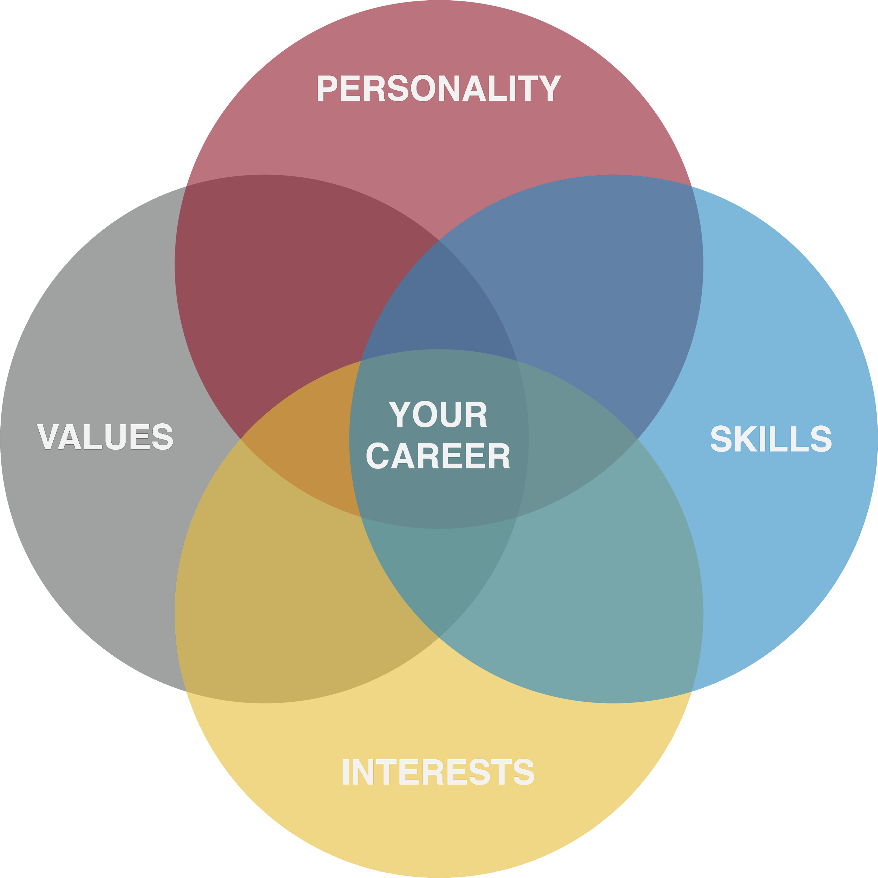

Through this exploration, you will become an expert on all 16 “career clusters”—that is, groups of similar jobs. The jobs in these career clusters are sorted so that when you find one job that you like, you’ll also probably find other jobs that interest you in the same cluster. Your skills, personality, values, and interests will help you determine which career clusters might be a good fit for you.

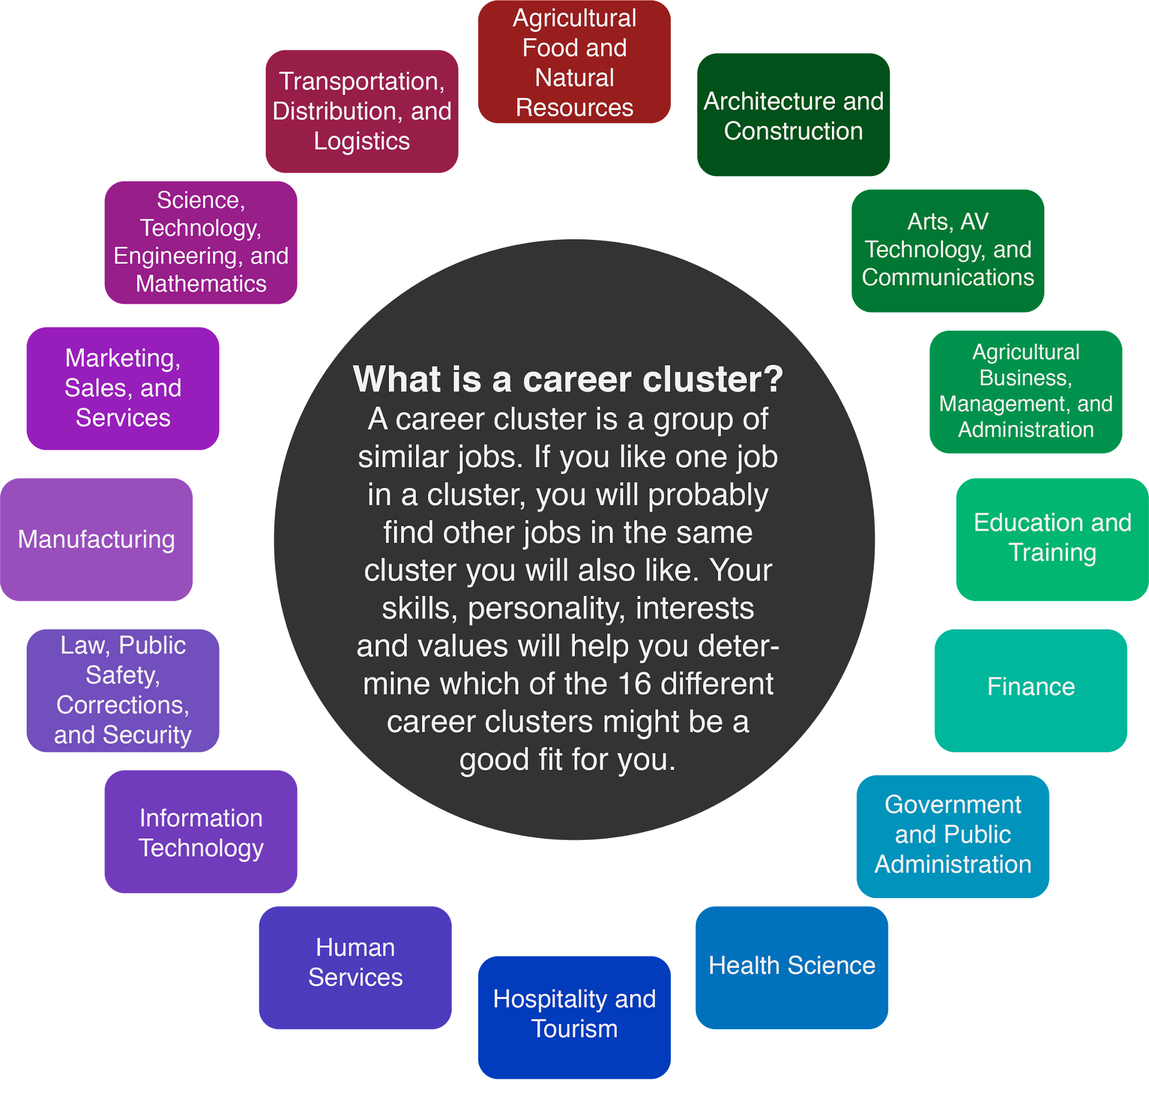
As you begin to watch Career Expo videos and complete the activities, remember to explore as many different careers and career clusters as you can. Look for careers you never thought about and see what happens—you might find a new passion to pursue! As you explore, remember that it is okay if you don’t know what you want to do when you are older. These activities are intended to start the conversation and help you begin to think about what your career choices might mean for you in the future.

Activities

Activity 1: Zoom Into Your Career Reflection Strategies

Overview
Virtual Career Explorations are a great way for you to explore a variety of interesting careers and learn about your career options. In each video, one of our professional volunteers shares their career story and answers students’ questions. If you’re eager to know more about a particular career, these talks are the perfect start for you!

What To Do
First, explore the five activity strategies below (“I Used to Think… But Now I Know,” “Preflections,” “Point of Most Significance,” “I Notice, I Wonder,” and “Color, Symbol, Image.”) Read each description and think about which strategies might help guide and frame your thinking. Then, click the link below and begin exploring different Zoom Into Your Career videos. For each video you watch, complete one of the below activities on your own, using one of the five activity strategies. You can use different strategies for different videos as you see fit. After you finish each activity, discuss it with a parent or guardian if possible.

Click here to explore the Zoom Into Your Career video playlist: https://tinyurl.com/K20VCEVideos

I Used to Think… But Now I Know
Before the video begins, draw a line down the center of a piece of paper. On the left, list the things you already know about this career. After the video is over, write down the new things that you learned about this career on the right.

Preflections
Before the video begins, make predictions about the learning you are about to engage in. For example, what is the topic? What will you learn? What will you be able to apply? After the video, reflect on and think about what you watched. Compare and contrast what you guessed at the beginning with what you learned by the end.

Point of Most Significance
After the video ends, think about the most important piece of information you learned. If you know others who watched the same video, talk with them about what you believe is the most important piece of information and why it was important to you.

I Notice, I Wonder
Before the video begins, draw a line down the center of a piece of paper. As you watch the video, use the left half of the paper to write a list of things that you notice about the career. Once the video is over, use the right side of the paper to make a new list of things that you still wonder about the career. This list of “I wonders” can help guide you in a direction to learn more about the career through online searches, group discussions, or additional career videos in the same cluster.

Color, Symbol, Image
After you have viewed the Career Expo video, choose a color, symbol, and image that you believe represents that career and your learning experience with the video. When you have finished, explain your color, symbol, and image to a family member or friend.

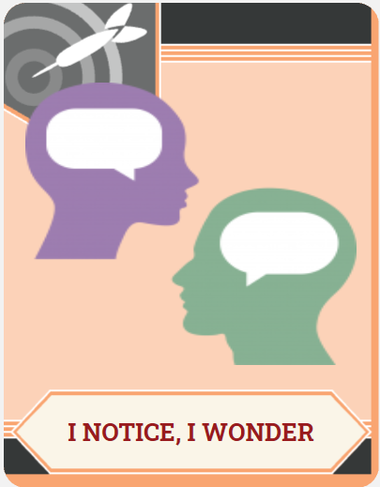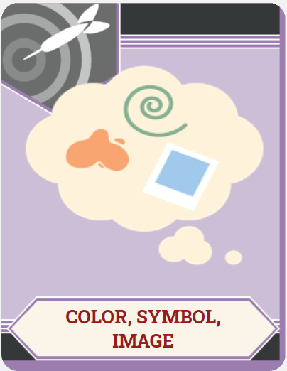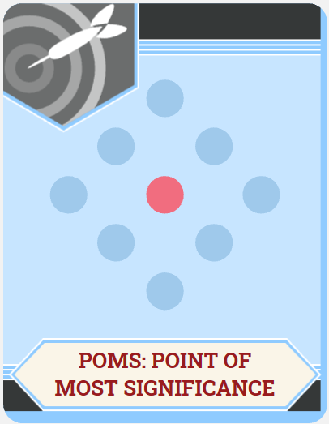

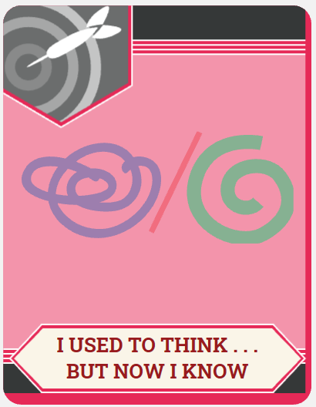

Activity 2: BINGO! I’ve Found My Career

Overview
Do you remember singing “And Bingo Was His Name-O!” when you were younger? This song helped you learn how to spell the farmer’s dog’s name. In this activity, we will use the Bingo game to learn about new career options. Learning about various careers now will help you decide which one interests you. Even if you already know what you want to be when you grow up, learning about career paths will help you plan your future.

The K20 Center has an online library of career exploration videos to help you discover careers you may not have considered before. You will use these videos to complete your Bingo activity while using college and career terms to fill your Bingo card.

Click here to explore the Zoom Into Your Career video playlist: https://tinyurl.com/K20VCEVideos

What To Do
Start by opening the Bingo card activity by clicking here.
Print as many Bingo cards as you like. These cards are found on pages 2–6 of the above link. Ask a family member for help with printing if you are not sure how to do so. Next, choose any Zoom Into Your Career video from the K20 YouTube playlist. Choose one of the Bingo cards you printed, and write the title of the video at the top of the page. Spend 1–2 minutes familiarizing yourself with the terms on the card. This will help you remember which terms to listen for as you watch the video. If you don’t understand what a term means, ask a parent or guardian to help you look up the definition.

Watch the video, and listen carefully. If you hear a word on your Bingo card mentioned, mark it off, pausing the video if necessary. You can earn a Bingo by completing a horizontal or vertical line, by forming a “T,” “U,” or square shape, or with a “blackout” (marking off ALL the terms).

After you finish your Bingo card, reflect on the video and activity by completing the 3-2-1 writing activity that follows. You can repeat this activity as much as you like with other videos by using one of the other filled Bingo cards or a blank template by clicking here. You can either print a blank Bingo card and write in the terms yourself, or cut out the terms from the list and paste them into the blank card. Have a parent or guardian help you with cutting and pasting if needed.

Activity 3: 16 Ways to Survey Your Career

Overview
Do you ever sit around and daydream about what career you will have when you are an adult? There are so many careers to choose from that sometimes thinking about future jobs can feel overwhelming. One fun way to help you consider your options is to take a career survey. The Career Cluster Survey is one such survey that helps you explore your skills, personality, and interests to identify which career clusters (or groups of similar jobs) might be a good fit for you. While your interests will likely change over the years, the Career Cluster Survey is a great place to begin your exploration!

After the activity, you will have an opportunity to further explore one of your top career clusters. Once you have an idea about what career cluster interests you, consider exploring the Zoom Into Your Career playlist by clicking here to learn more: https://tinyurl.com/K20VCEVideos

What To Do
Complete this survey to narrow down the career clusters for which you are most suited for right now. Keep in mind that the preferences and skills mentioned in this survey can always change. Begin by opening the first step of the Career Cluster Survey. Click here to do so: https://tinyurl.com/surveycards1. You can print the survey cards if you like, or you can use a blank sheet of paper to help you keep score. Follow the directions on the first page in the link to begin.

Once you have finished step 1, you will need a device with access to the Internet and your results from step 1 to complete the next step. Move on to step 2 by clicking here: https://tinyurl.com/clustercards2. Follow the directions on the first page in the link to begin. You will review descriptions and career options for each cluster, choose one of your Career Cluster Cards, and explore the cluster on https://www.mynextmove.org/.

Once you’ve finished step 2, move on to step 3 by clicking here: https://tinyurl.com/surveyactivity3. For this step, you will need to either copy the T-Chart provided or write on a blank sheet of paper. By following the “I Used to Think… But Now I Know” strategy, you will reflect on what you’ve learned and about how your preconceived thoughts on certain career clusters have changed.
