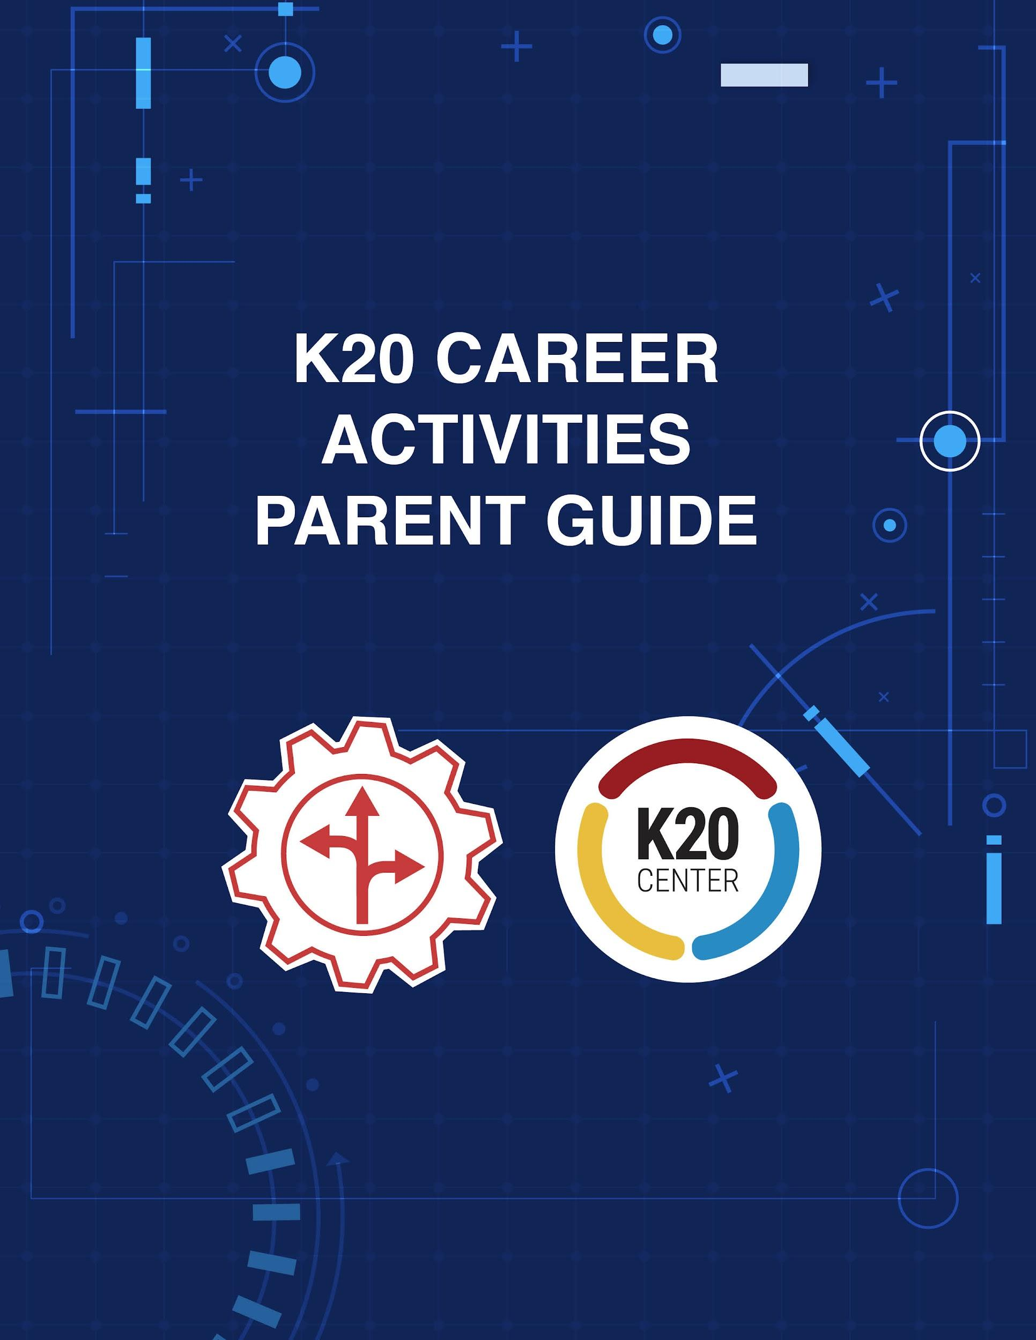

Contents
Overview ______________________________________________________________ | 3
Your Role as Family Support_______________________________________________ | 4
Activities ______________________________________________________________
Zoom Into Your Career Reflection Strategies ___________________________ | 5-6
BINGO! I’ve Found My Career _______________________________________ | 7
16 Ways to Survey Your Career ______________________________________ | 8-9

Overview
As you take on the role of family support in the following activities, you will act as a guide in encouraging your learner to have fun, in helping them think about careers they could pursue, and in facilitating conversations with them about their career options. Your support of your learner during their college and career exploration is very important for the following reasons:
- Family members have the greatest influence on their learner’s career choices.
- Family members know their learner better than anyone else.
- Family members have the most interest in helping their learner choose a rewarding career.
- Family members understand their learner’s future is too important to be left to luck or chance.

Your Role as Family Support
The K20 Mentoring Team has created a career exploration-based guide to help students learn about career options and opportunities through a variety of online and at-home activities. You can engage in the activities detailed by this guide alongside your learner to build their knowledge, understanding, and interest in a number of future career paths. Building early career awareness is important for your learner and helps them pursue aspirations related to the working world. Your learner may or may not know what they want to do when they grow up, and that's okay! No child’s future is completely mapped out. However, these activities provided by the K20 Center can help endow you and your learner with a better understanding of the careers they might be interested in. This guide for family support will assist you in supporting your learner as they explore possible college and career pathways. After your learner has completed each activity on their own, please refer to this guide for guided discussion questions and additional resources. These activities are part of the K20 Center’s online resources for career exploration. See more of these resources at https://tinyurl.com/k20resources.

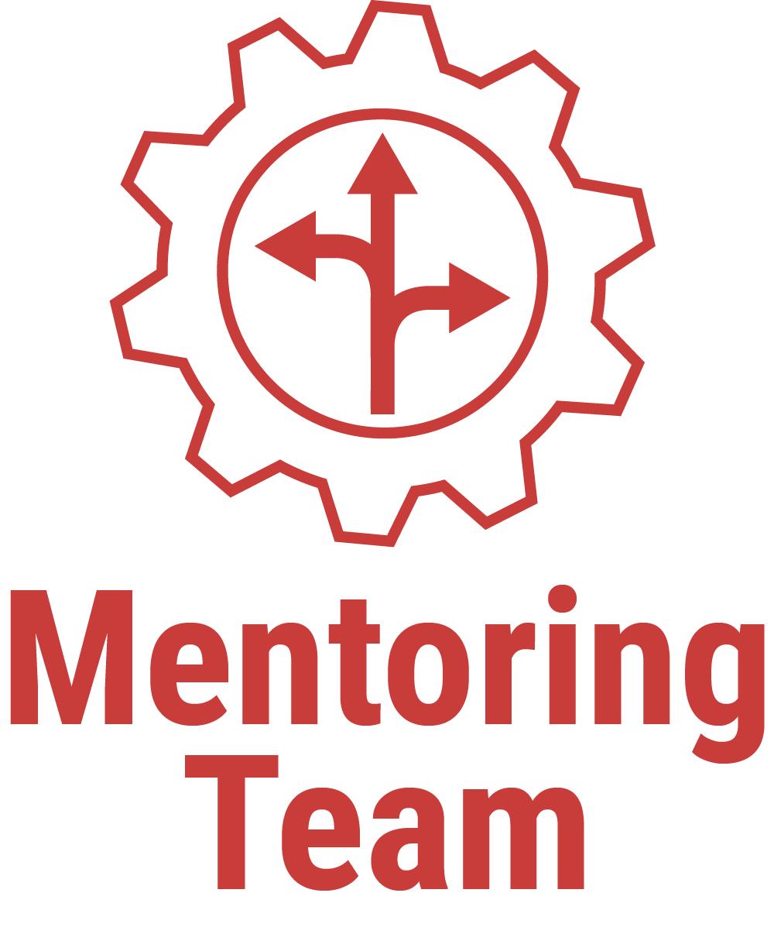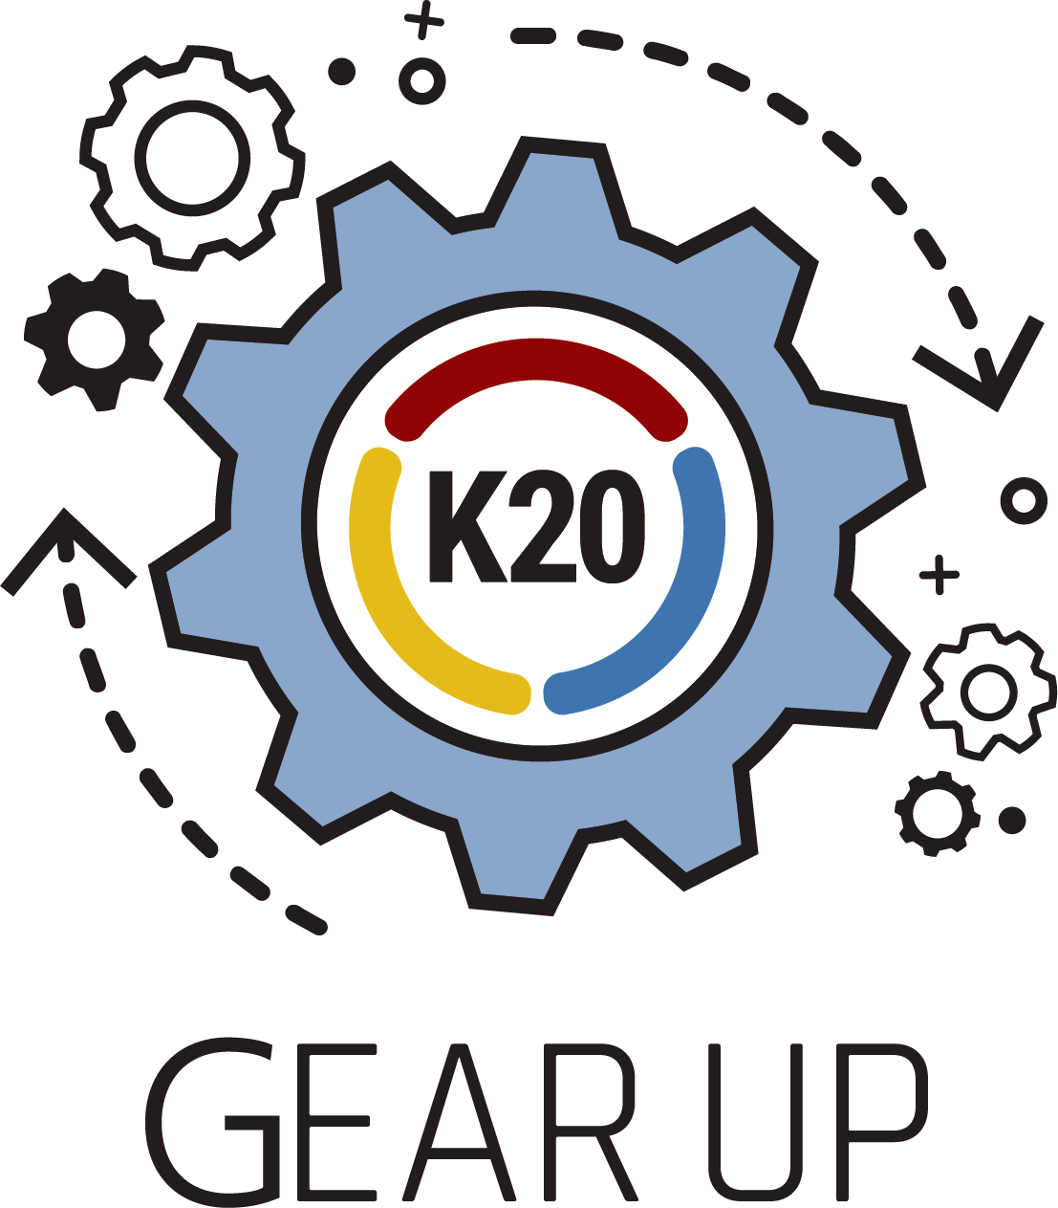

Why These Activities Are Important for Your Learner
Research shows parents are the most significant influence in their learner’s decision to continue their education after high school. GEAR UP, or Gaining Early Awareness and Readiness for Undergraduate Programs, is a federal grant program designed to increase the number of students who are prepared to enter and succeed in education after high school. Education after high school is commonly referred to as postsecondary education, and it includes pathways like a four-year bachelor’s degree, two-year associate's degree, career technical center-certificate, military education, and more. The K20 Center's GEAR UP grant is a partnership project between public schools, higher education, communities, and business organizations that work together to provide students and their families with a range of support services for college preparedness.

Activity Outline
Zoom Into Your Career Reflection Strategies are a great way for your learner to explore a variety of interesting careers. In each session, one of our professional volunteers shares their career stories and answers questions asked by learners just like yours. These career talks can help inspire your learner to pursue more learning about a particular career.
BINGO! I’ve Found My Career is an activity that aims to encourage learning more about careers about which your learner is interested. In this activity, your learner views several career videos and listens for key college- and career-inspired vocabulary words. Your learner tallies these words and uses them to try and score a BINGO!

16 Ways to Survey Your Career assists your learner in aligning their own skills, personality, and interests to specific career clusters that could be a good fit for them.

Activities

Zoom Into Your Career Reflection Strategies

Overview
In this first activity, your learner will explore a variety of careers and career options by engaging with interviews by career professionals. In these Zoom Into Your Career interviews, volunteers share their career paths and address commonly asked questions about their professions. While viewing the video, your learner chooses a learning strategy with which to organize and synthesize what they learn. Afterward, you and your learner should discuss what they explored.

The Zoom Into Your Career video playlist can be found at https://tinyurl.com/K20VCEVideos.

Family Support Role
Your learner will choose an activity to help guide and frame their thinking as they explore the Zoom into Your Career playlist. See the activity descriptions below and follow the directions stated to prepare your learner before they view videos and reflect afterward. After they complete an activity on their own, discuss with your learner the activity they completed. A few questions you might discuss include:

- What careers did you explore in the video?
- Did you learn anything new or surprising about this career?
- Do you still have questions about this career?
- Is this career one you might be interested in?

I Used to Think... But Now I Know
Before the video begins, have your learner draw a line down the center of a piece of paper. On the left, have them list the things they think are true (“I used to think”) about this career. After the video is over, have them write down new things that they learned (“but now I know”) about this career.

Preflections
Before the video begins, have your learner make a guess about what they expect to learn. After the video, have your learner reflect on and think about what they watched. Have them compare and contrast their initial expectations with what they learned by the end.

Point of Most Significance
Have your learner watch their choice of video. After the video ends, have your learner think about the most important piece of information they learned. If possible, invite your learner to have a discussion with other people who watched the same video. Have them talk about what they believe is the most important piece of information and why it was important to them.

I Notice, I Wonder
Before the video begins, have your learner draw a line down the center of a piece of paper. As your learner watches the video, have them write a list of true statements about the career (“I notice”) on the left side of the paper. Once the video is over, have them make a new list of questions and other “wonderings” about the career (“I wonder”) on the right side of the paper. This list of “wonderings” can help to guide your learner towards learning more about the career through online searches, group discussions, or additional career videos in the same cluster.

Color, Symbol, Image
Have your learner watch their choice of video. After your learner has finished watching, have them choose a color, symbol, and image that they believe represents the career they learned about and their learning experience with the video. When they finish, ask them to explain their color, symbol, and image to a family member or friend.

BINGO! I’ve Found My Career

Overview
During this activity, your learner engages in a game of BINGO that helps them learn more about careers they are interested in. Your learner watches career videos while they listen for vocabulary related to careers and college. Then, they reflect on what they learned in a 3-2-1 activity.

Family Support Role
Start by helping your learner locate the premade BINGO cards here (pages 2-6). Have your learner choose as many BINGO cards as they like. Consider printing out these cards, if possible. Spend 1-2 minutes with your learner reviewing the terms on the first card. If any term is unclear, look up the definition of the word together. This should help your learner gain a better understanding of each term’s meaning and should help them remember the terms. While your learner reviews the terms, access the K20 YouTube channel’s Zoom Into Your Career playlist: https://tinyurl.com/K20VCEVideos. Invite your learner to choose a video from the playlist based on which career video looks the most interesting to them. Have them write the title of the video at the top of the first BINGO card. Then, have your learner watch the video. While they watch, have them mark off any terms they hear. Your learner can earn a BINGO by completing a horizontal or vertical line, by forming a “T,” “U,” by forming a square shape with the border tiles, or with a blackout (marking off ALL the terms).
After your learner has finished the video, have them complete the 3-2-1 reflection activity that follows. Ask them to write down three things they learned, two questions they still have, and one thing they found interesting. This activity helps students summarize their understanding of the material and evaluate that understanding for gaps in knowledge.
Once they have completed the first video and activity, they can choose another career video and repeat the activity with another BINGO card. Additionally, your learner can customize the blank BINGO card located here. Terms to use are found on pages 3-5. Your learner can either print a blank BINGO card and write in the terms themselves, or cut out the terms from the list and paste them into the blank card with your help. Research shows that handwriting better facilitates comprehension (Duran & Fredrick, 2013).

16 Ways to Survey Your Career

Overview
This Career Cluster activity helps your learner think about their skills, personality, and interests to identify which clusters might be a good fit for them. Though their interests will likely change over time, this Career Cluster Survey is a great place to start exploring.

Family Support Role
Part 1:
For the first part of this activity, invite your learner to read statements from survey cards located here: https://tinyurl.com/surveycards1. After your learner reads each statement, ask them to decide whether they think the statement describes them. If so, they should add one point to a running total. Repeat this process for all 16 cards. Then, invite your student to determine what their three highest-scoring career clusters are.

Part 2:
Once your learner has finished the survey, invite them to open the Career Cluster Cards located here: https://tinyurl.com/clustercards2. Be sure your learner has access to an Internet-enabled device for this step. First, invite your learner to review the descriptions and career options on the career cards for their top three clusters. Next, invite your learner to visit https://www.mynextmove.org/ to further explore their three career clusters. They can also look through the K20 Center’s GEAR UP Zoom Into Your Career playlist and watch videos about careers that fit into their top three clusters: https://tinyurl.com/K20VCEVideos.

Part 3:
Now that your learner has completed the Career Cluster Survey, reviewed the descriptions of their top three career clusters, and explored one of the clusters further on www.mynextmove.org​, they should take a moment to reflect on what they’ve learned. Ask your learner to revisit their “I Used to Think... But Now I Know” T-Chart, adding more information based on what they’ve learned. Consider also discussing with your learner what they’ve learned in their exploration by asking questions like:
- What career cluster(s) did you explore?
- Did you learn anything new or interesting?
- Has your thinking changed regarding what careers or clusters you may be interested in?

Sources
Duran, K. S., & Fredrick, C. M. (2013). Information Comprehension: Handwritten vs. Typed Notes. Undergraduate Research Journal for the Human Sciences. 12(1).
My Next Move. (n.d.). What do you want to do for a living? Retrieved from https://www.mynextmove.org/

