K20 CAREER CLUSTER CARDS
The K20 Center’s GEAR UP program wants to help you explore career options! This Career Cluster activity will help you think about your skills, personality, and interests to identify which clusters might be a good fit for you. While your interests will likely change over the years, the Career Cluster Survey is a great place to begin your exploration, but the journey won’t end there. You can use what you learn in this survey and apply it to other career activities and exploration.

What is a career cluster? A career cluster is a group of similar jobs. If you like one job in a cluster, you will probably find other jobs in the same cluster you will also like.

Materials
- Your survey results from step 1
- A device with access to the internet (computer, smartphone, tablet, etc.)
Instructions
- Now that you have determined which three career clusters are your top matches, review the descriptions and career options below for each of these clusters.
- Choose one of your top three Career Cluster Cards and visit www.mynextmove.org to further explore this career cluster.
- Once you have explored one of the career clusters further, move on to the next step in this activity.

Career Clusters
Career Cluster Card 1 | Agricultural Food and Natural Resources
Career Cluster Card 2 | Architecture and Construction
Career Cluster Card 3 | Arts, AV Technology, and Communications
Career Cluster Card 4 | Business, Management, and Administration
Career Cluster Card 5 | Education and Training
Career Cluster Card 6 | Finance
Career Cluster Card 7 | Government and Public Administration
Career Cluster Card 8 | Health Science
Career Cluster Card 9 | Hospitality and Tourism
Career Cluster Card 10 | Human Services
Career Cluster Card 11 | Information Technology
Career Cluster Card 12 | Law, Public Safety, Corrections, and Security
Career Cluster Card 13 | Manufacturing
Career Cluster Card 14 | Marketing, Sales, and Services
Career Cluster Card 15 | Science, Technology, Engineering, and Mathematics
Career Cluster Card 16 | Transportation, Distribution, and Logistics

Cluster 1: Agriculture, Food, and Natural Resources
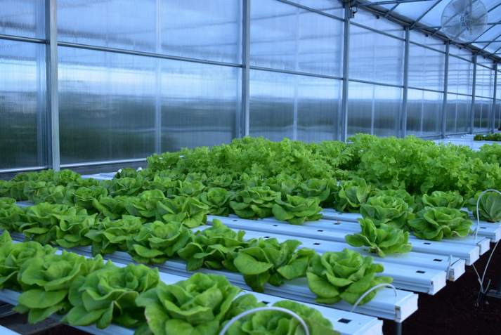
Thacker, Z. (2019). Ascension Island’s hydroponics lab is revitalizing life on the volcanic island. 45th Space Wing. Retrieved from https://www.patrick.af.mil/News/Photos/igphoto/2002187349/
Description
This career field is focused on the production, processing, marketing, distribution, financing, and development of agricultural commodities and resources. This includes food, fiber, wood products, natural resources, horticulture, and other plant and animal products.
- Agriculture Banker  - Commodity Trader  - Plant Pathologist  - Agronomist  - ARS Scientist  - Agriculture Mechanic  - Rancher  - Farmer  - Production Supervisor  - Natural Resource Specialist  - USDA Inspector | - Meat Processor  - Wholesale Food Purchaser  - Irrigation Specialist  - Landscaper  - Turf Manager  - Agriculture Education Teacher  - Forest Geneticist  - Extension Specialist  - Veterinarian  - Biochemist  - ESDA Grader

Cluster 2: Architecture and Construction
PXFuel. (n.d.). Worm. PxFuel. Retrieved from https://www.pxfuel.com/en/free-photo-oopgl
Description
This career cluster includes careers in designing, planning, managing, constructing, and maintaining built environments.
- Architectural and Civil Drafter or Engineer  - Environmental Designer  - Residential or Commercial Carpenter  - Construction Worker  - Systems Configuration Manager | - Electrical Design Engineer  - Electrician  - HVAC/HVACR Technician  - Building Services Technician  - Painter  - Sheet Metal Technician

Cluster 3: Arts, A/V Technology, and Communication
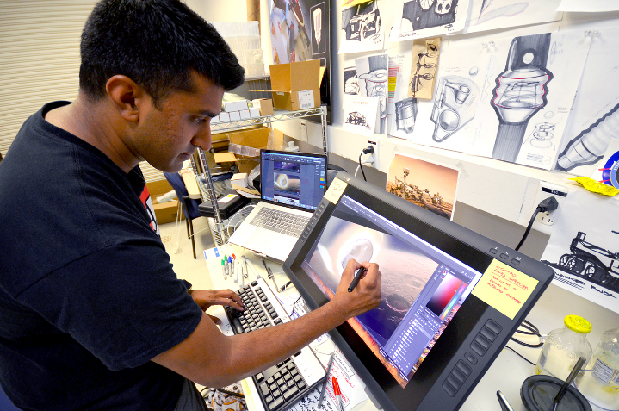
Tavernier, L., NASA, & JPL-Caltech. (2018). NASA. Retrieved from https://www.jpl.nasa.gov/edu/news/tag/Career+Guidance
Description
Careers in this field involve designing, producing, exhibiting, performing, writing, and publishing multimedia content. This includes visual and performing arts, design, journalism, and entertainment services.
- Video or Web Producer  - Film Maker  - Graphic Designer  - Television Studio Producer  - Stage Designer  - Publisher  - Costume Designer | - Radio Broadcaster  - Fashion/Apparel Designer or Illustrator  - Interior Designer  - Home Furnishing Coordinator  - Textile Designer or Chemist  - Curator or Gallery Manager

Cluster 4: Business, Management, and Administration
Lopez, M. (n.d.). Business charts presentation. Pexels. Retrieved from https://www.pexels.com/photo/business-charts-presentation-project-2399034/
Description
This career field includes careers in planning, organizing, directing, and evaluating business functions essential to efficient and productive business operations.
- Chief Executive Officer  - Entrepreneur  - Controller  - Adjuster  - Budget, Cost, or Systems Analyst  - Marketing Manager  - Bookkeeper  - Office Manager | - Human Resources Manager  - Training and Development Specialist  - Executive Assistant  - Wholesale or Retail Buyer  - Retail Salesperson  - Meeting and Convention Planner  - Receptionist

Cluster 5: Education and Training
Woodleywonderworks. (2011). Flickr. Retrieved from https://www.flickr.com/photos/wwworks/6233339252
Description
This career field includes jobs involved in planning, managing, and providing education and training services, as well as related learning support services.
- Superintendent, Principal, or Administrator  - Teacher or Instructor  - Preschool or Kindergarten Teacher  - Clinical, Developmental, or Social Psychologist  - Social Worker  - Counselor | - Teacher Assistant  - Parent Educator  - Child Care Worker  - Coach  - Recreation Worker  - Sign Language Interpreter

Cluster 6: Finance
StevePB. (2017). Savings. Pixabay. Retrieved from https://pixabay.com/photos/savings-budget-investment-money-2789112/
Description
This field includes careers involved with financial planning investment, including banking, insurance, and business financial management.
- Accountant  - Auditor  - Development Officer  - Financial Analyst  - Treasurer  - Controller  - Economist  - Budget Analyst | - Personal Financial Advisor  - Tax Preparer  - Investment Advisor  - Loan Officer  - Debt Counselor  - Actuary  - Underwriter  - Insurance Appraiser  - Bank Teller

Cluster 7: Government and Public Administration
Wikimedia Commons. (n.d.). Capitol building full view. Wikimedia Commons. Retrieved from https://en.wikipedia.org/wiki/File:Capitol_Building_Full_View.jpg
Description
This field includes careers involved in executing governmental functions. This includes careers in governance, national security, foreign service, planning, revenue and taxation, regulation, and management and administration at the local, state, and federal levels.
- Aviation Inspector  - Coroner  - Legislative Assistant  - Air Crew Member or Officer  - Radar and Sonar Technician | - Intelligence Analyst  - Diplomatic Officer  - Transportation Security Screener  - Court Administrator or Clerk  - Construction and Building Inspector

Cluster 8: Health Science
Joch, G. (2009). Science Careers in Search of Women. Flickr. Retrieved from https://www.flickr.com/photos/argonne/4534362371
Description
This career field includes jobs involved with planning, managing, and providing therapeutic services, diagnostic services, health informatics, support services, and biotechnology research and development.
- Athletic Trainer  - Dentist/Dental Hygienist  - Anesthesiologist  - Director of Nursing  - Admitting Clerk  - Health Educator  - Medical Biller  - Medical Transcriptionist | - Respiratory THerapist  - Pharmacist  - Paramedic  - Phlebotomist  - Medical Lab Technician  - Research Assistant  - Food Service Worker  - Data Entry Specialist

Cluster 9: Hospitality and Tourism
Hashoo Foundation USA. (2011). Hotel management trainee. Flickr. Retrieved from https://www.flickr.com/photos/hashoofoundation/8230136061
Description
Careers in this field involve the management, marketing, and operations of restaurants and other food services, as well as lodging, attractions, and recreation events and travel-related services.
- Restaurant Manager/Owner  - Hotel Front Desk Clerk  - Travel Agent  - Pastry Chef  - Room Service Attendant  - Catering and Banquets Manager  - Sales Professional  - Event Planner | - Museum/Zoo/Aquarium Exhibit Developer  - Interpreter  - Reservationist  - General Manager  - Executive Chef  - Tour Guide  - Parks and Garden Developer

Cluster 10: Human Services
SelFalko. (2007). Counseling Session or Salesman. Flickr. Retrieved from https://www.flickr.com/photos/safari_vacation/6351361924
Description
This career field includes jobs involving preparing individuals for employment in career pathways that relate to family and human needs.
- Psychologist  - Social Worker  - Hair Stylist/Barber  - Childcare Assistant/Worker/Director  - Parent Educator  - Community Service Director | - Funeral Director  - Cosmetologist  - Skin Care Specialist  - Certified Financial Planner  - Employee Benefits Representative  - Counselor

Cluster 11: Information Technology
Tstokes. (n.d.). Computers. Needpix. Retrieved from https://www.needpix.com/photo/1082776/computers-information-technology
Description
Careers in Information Technology (IT) involve designing, developing, managing and supporting hardware, software, multimedia, and systems integration services.
- Computer/Information Systems Manager  - Computer Engineer  - Computer Programmer  - Computer Security Specialist  - Computer Support Specialist | - Computer Systems  - Analyst Data  - Communications Analyst  - IT Mechanic

Cluster 12: Law, Public Safety, Corrections, and Security
Pickpik. (n.d). Hammer. Pickpik. Retrieved from https://www.pickpik.com/hammer-books-law-court-lawyer-paragraphs-10889
Description
Careers in this field include jobs that provide communities with legal, judicial, and protective services.
- Coroner  - Corrections Officer  - Court Clerk  - Detective and Investigator | - Judge Lawyer  - Lifeguard and Ski Patrolman  - Police Patrol Officer  - Firefighter

Cluster 13: Manufacturing
Pxfuel. (n.d). Robotic. Pxfuel. Retrieved from https://www.pxfuel.com/en/free-photo-oibxx
Description
This career field includes jobs in factories or industrial settings in which workers process materials for final products.
- Chemical Engineer  - Forklift Operator  - Gas and Oil Plant Operator  - Jeweler  - Locksmith Metal/Plastic Processing Worker | - Office Machine Repairer  - Power Plant Operator  - Shoe and Leather Worker  - Welder

Cluster 14: Marketing, Sales, and Services
Rawpixel. (2018). Achievement. Pxhere. https://pxhere.com/en/photo/1450669
Description
Careers in this field require workers to use their persuasive abilities to sell or promote products and services.
- Advertising Salesperson  - Buyer and Purchasing Agent  - Customer Service Representative  - Floral Designer  - Market Research Analyst | - Public Relations Specialist  - Real Estate Agent  - Sales Manager  - Telemarketer

Cluster 15: Science, Technology, Engineering, and Mathematics
Nyberg/USAID, R. (2014). Female scientists in USAID Partnerships for Enhanced Engagement in Research Science project. Flickr. Retrieved from https://www.flickr.com/photos/usaidasia/12626580724
Description
Careers in this field ask workers to provide research and services related to science, technology, engineering, and math. These services are provided by gathering and analyzing information, solving problems, and applying findings.
- Aerospace Engineer  - Biologist Chemist  - Electrical and Electronics Engineer  - Geographer | - Petroleum Engineer  - Mechanical Engineer  - Meteorologist  - Physicist Safety Engineer

Cluster 16: Transportation, Distribution, and Logistics
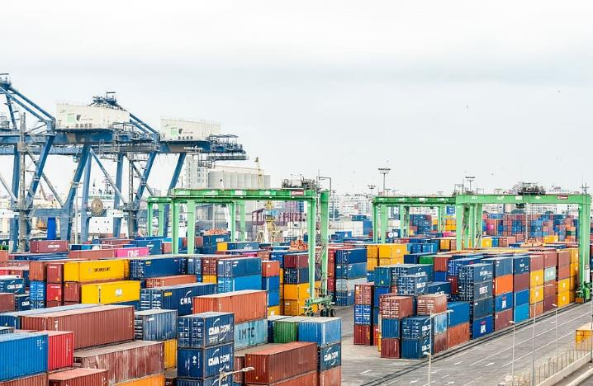
Pxfuel. (n.d.). Port. Pxfuel. Retrieved from https://www.pxfuel.com/en/free-photo-xdoob
Description
Careers in this field involve moving materials, goods, and people by road, air, pipeline, railroad, and water.
- Air Traffic Controller  - Airplane Pilot  - Automobile Mechanic  - Flight Attendant  - Motorboat Mechanic | - School Bus Driver  - Subway and Streetcar Operator  - Traffic Technician  - Transportation Agent

