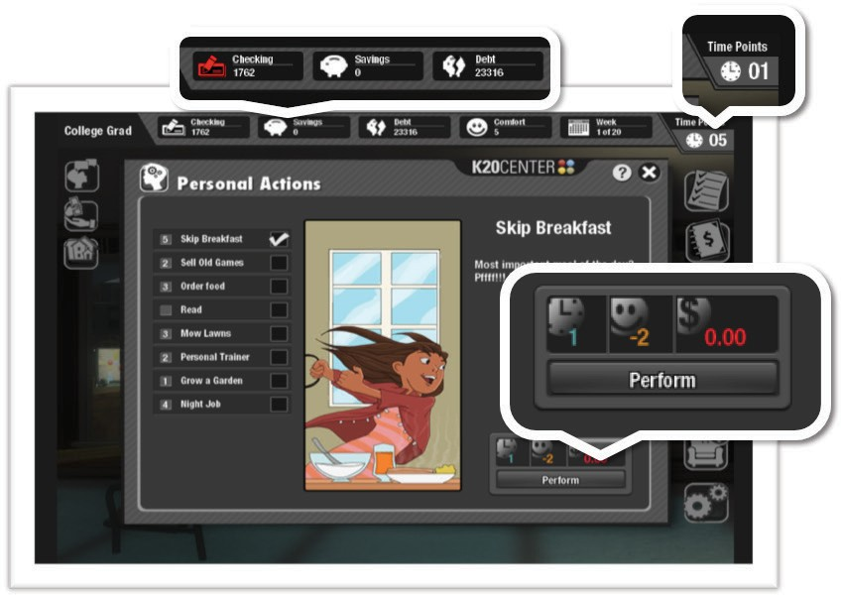

BASIC SCORE COMPONENTS
In each scenario, the player will earn a paycheck every four weeks. After they deposit their paycheck, they are prompted to set a budget for the next four weeks. Then they are free to determine how to spend their TIME,
COMFORT, and MONEY, by choosing from any of the options on the screen, from paying bills to going shopping.
Every action the player takes in the game will impact their score in one of these three areas. If the player does not have enough time, comfort, or
money to complete an action, the Perform button will be disabled. They will have to either choose a different action or perform an action that will give them enough resources to complete it.
Once the player has used all of the time points allotted for each four-week period, they will see a monthly summary, which provides feedback on their performance during that time. In order to win the game, the player must MEET OR EXCEED the minimum SAVINGS REQUIREMENTS, DEBT
REPAYMENT GOAL, and COMFORT LEVEL set out at the beginning of the scenario. Throughout the game, the player must strategically use their time, comfort and money in order to achieve and maintain the scenario goals.



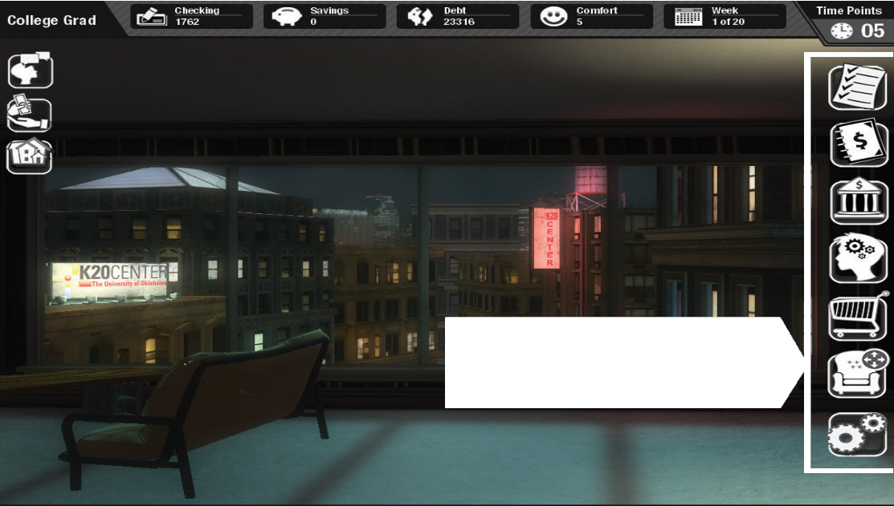



CHECKING: This display indicates the amount of money the player thinks they have available to spend. If the player does not put receipts into the ledger, the account balance will not update. That means that a player might believe they have more money than they actually have, causing them to overdraw on their account. The icon on the checking account display turns red if the ledger needs to be updated.
INTERFACE
SCORE: Here the player can find all of their scoring information.
EVENTS: These life events, bills and notifications will appear throughout the player’s turn.
ACTIONS: These are actions that the player can access at any time during the game.

SAVINGS: This display indicates the total amount of money held in the player’s savings account.
DEBT: This display indicates the player’s entire debt load, which may include credit card debt and any outstanding loan balances.



COMFORT: This display indicates the player’s general wellbeing.
Comfort points can be earned from performing fun actions such as playing video games and from purchasing better furniture. Meanwhile, they can be spent on actions that increase your time or
money, and lost when the player fails to maintain their budget or becomes overdrawn on their checking account.




WEEK COUNTER: This display indicates the number of weeks the player has completed and the number of weeks the player has remaining until the end of the game. It also helps the player determine how much time remains until their next pay period.

TIME POINTS: This display indicates the amount of time a player has remaining in any given week. Time points are reduced as a result of most actions taken during the game. When time points reach zero, they are reset and a new week begins. There are four weeks in every month.

 GAME GOALS: This icon opens the GOAL screen, providing the player
with information about the starting and win conditions for the scenario they are playing.


LEDGER: This icon opens the LEDGER screen, where the player can sort receipts, check their account balance, see how their spending compares to their budget, and view savings/debt history.


PERSONAL ACTIONS: This icon opens the personal ACTIONS screen where players can choose to call in sick, work overtime, hang out with friends and more.

 BANK: This icon opens the BANK screen, where the player can choose to transfer money, apply for a credit card or invest.

 SHOP: This icon opens the SHOP screen, where the player can choose
to buy furniture, remodel or sign up for a service.
 REARRANGE FURNITURE: This
icon opens a top-down view of the
apartment. Here the player will be able to move their furniture to their liking.

 SETTINGS: This icon opens the SETTINGS panel, where the player can choose the language and audio settings of the game. The player can
also quit the game from this panel.

 LIFE EVENT: This icon opens a life event panel. Life events are
unexpected events that arrive each week and the player must resolve them before they can proceed to the next week. Some life events require the player to make a decision and experience the consequences of those decisions by how they impact the player’s time, comfort or money.

 NOTIFICATIONS: This icon opens a notification panel. If the player has received a special message or
warning, a notification will arrive at the beginning of each week. Players must respond to all of their messages before they are allowed to proceed to the next week.




BILLS: Each of these icons opens a bill. Bills arrive every week and each bill has a unique icon. Depending on the scenario, the player could receive bills for rent, electricity, groceries, city services, taxes, cable/internet, credit card, insurance and loans.


GLOSSARY: This icon represents the Glossary. Every major panel of the game includes a glossary featuring key terms related to that panel, along with an explanation of the concepts.

