SHOW ME THE MONEY!
Financial Literacy Activity

CONTENTS
Personal Financial Adviser Overview _________________________________________ | 2
Materials
Instructions
Activity 1: Financial Literacy Reflection ________________________________________ | 4
Activity 2: Mind Your Own Budget ___________________________________________ | 6
Activity 3: Budget Basics ___________________________________________________ | 10
Activity 4: Practicing Financial Literacy ________________________________________ | 13
Extend _________________________________________________________________ | 16
Sources ________________________________________________________________ | 17

PERSONAL FINANCIAL ADVISOR OVERVIEW
Do you find that, when you’re hanging out with your friends, they are always asking you for advice on how to save their money or how to find the best deals on the things they like? If so, a career as a personal financial advisor may be the one for you! As a financial advisor, you can give advice to your clients every day on a variety of topics dealing with money. This career falls under the Finance career cluster.
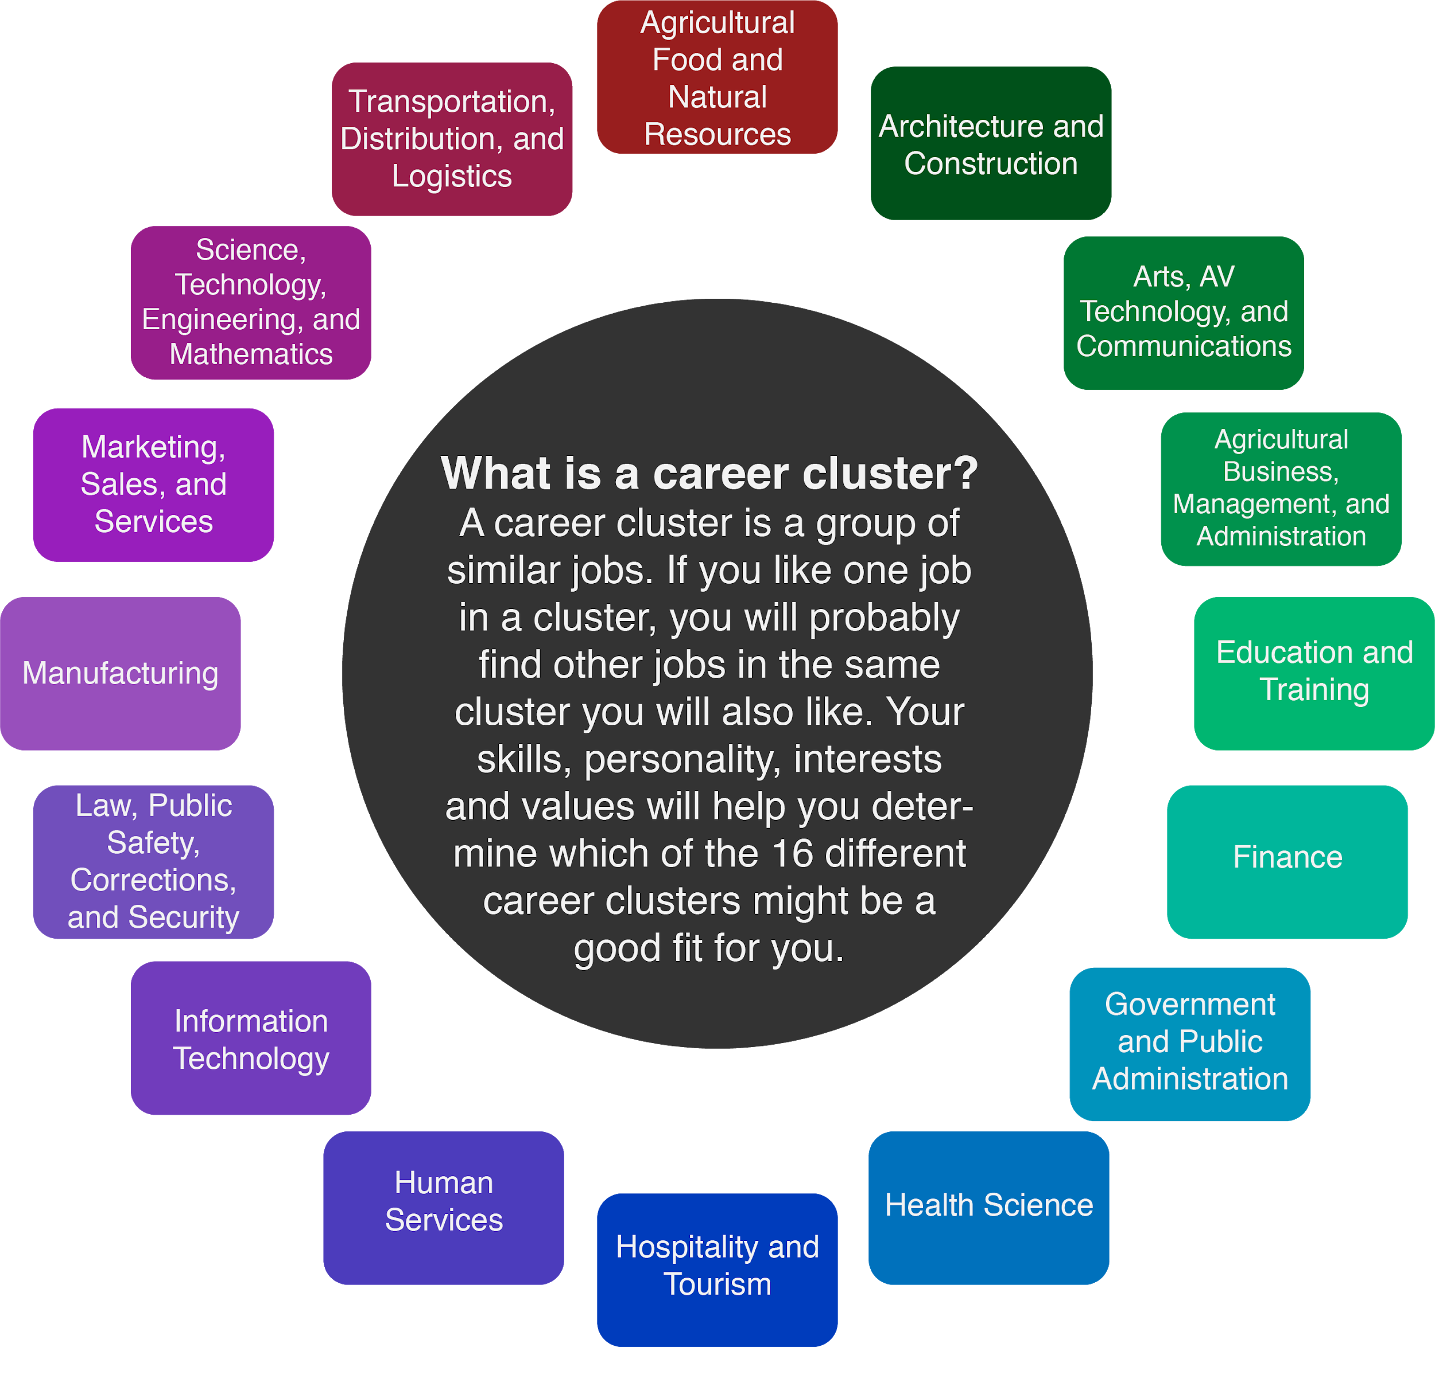
Financial advisers meet with people who want help with investing their money, have questions about tax laws, or need support making important decisions about insurance. They don’t just look at what a client needs for the short-term, they also help them make long-term financial decisions like expenses for education and retirement.
Each day, personal financial advisors use math to help them solve problems. They also use their communication skills—speaking and writing—to explain information to their clients. Being able to explain information in a way that the client can understand is an important part of the job. The average salary for a personal financial advisor is $87,850 but can range from $42,950 up to $208,000+ depending on postsecondary education and experience.

Personal financial advisors typically do the following:
- Meet with clients in person to talk about their financial or money goals.
- Explain the types of skills and financial services that they can use to help a client.
- Answer questions about money making options and the potential risks involved in each one to their clients.
- Recommend investments to clients.
- Select investments for their clients.
- Help clients plan for major events in their lives, such as education expenses or retirement.
- Keep track of their clients' accounts.
- Make decisions about clients’ accounts or investments if changes are needed.
- Research different and new investment opportunities.
Many financial advisors offer advice to their clients, and some specialize in areas like retirement. Once they invest money for a client, they report to the client about how the investment is doing. Together, the financial advisor and client talk about how the investment is going and what adjustments they might make.
Being dependable, having integrity, and paying close attention to detail are important qualities to have as a financial advisor, since you will be making decisions for other people about their money. It’s also important to have genuine concern for your clients so they know they can trust you.

Note: Accessing the Game “Mind Your Own Budget”
If you are a student, ask your teacher or guardian to request access to the game "Mind Your Own Budget" ahead of time. To do so, they must navigate to the following page: https://k20center.ou.edu/getgames/
Once your teacher or guardian has given you access to the game, you can play on your computer. If your teacher or guardian cannot request an account, you can instead play the game on an iPad by downloading the Mind Your Own Budget app. Find it here: Mind Your Own Budget on iOS (https://apps.apple.com/us/app/mind-your-own-budget/id721772106).

ACTIVITY 1: FINANCIAL LITERACY REFLECTION
Whether you realize it or not, you make financial decisions every day. Because of that, it’s important to be financially literate. But what does being financially literate actually mean?
In this activity, you will explore financial literacy through games, videos, and activities that simulate real-life scenarios you or your clients may face! To be a successful personal financial advisor, it is important that you are also successful in financial literacy.

Materials:
- Internet-enabled device
- Pencil or pen
Instructions:
- Watch Ryan Broyles, former NFL player, discuss financial decisions he made as a high school student here: MYOB: Ryan Broyles - High School (https://vimeo.com/161188298)
- Complete the financial literacy reflection on the next page.

Financial Literacy Reflection
Take some time to reflect on your own definition of "financial literacy" by answering the questions below. This is not a quiz, and there are no right or wrong answers. Instead, this is a place for you to start creating your own definition of financial literacy.
Financial Literacy Reflection
What does the term “financial literacy” mean to you?

Who are the people in your life that you think are financially literate?

Describe a situation in which one of the people you listed has acted in a financially responsible way.

ACTIVITY 2: MIND YOUR OWN BUDGET
Materials:
- Internet-enabled computer or iPad

Instructions:
- Watch the Mind Your Own Budget Training Video (https://youtu.be/QEW0prGx1Q8).
- Read “Mind Your Own Budget Goals” below.
- Review the “Playing the Game” guide on pages 7-9.
- Play “Mind Your Own Budget,” completing the unit. (See the note “Accessing the Game ‘Mind Your Own Budget’” in the Overview section for details on how to request access to play the game.)

Mind Your Own Budget Goals
- Save at least $1,000.00.
- Have less than $100.00 in debts.
- Have at least 5 comfort points.
This unit of the game gives you a theoretical three months to complete the goals above. You’ll have at least 5 time points per week with $2,070.00 per month to do so. This should take at least 1-2 class periods to play. Remember, your time points represent the time you have to spend! You start the game with 50 comfort points.

ACTIVITY 3: BUDGET BASICS

Materials:
- Pencil or pen
- Sample budget and budget template (pages 11-12)

Instructions:
- Read “Budget Basics” below to learn about key vocabulary such as income, expenses, budget, tracking, and current balance.
- Review the sample budget table.
- Use the budget template to create your own budget.

Budget Basics
Financial literacy begins with how much is coming into your pocket, or your income, and how much is going out, or your expenses. Income can be from many different sources—an allowance, a part-time job, chores, etc. In the video from Activity 1, Ryan Broyles mentioned that his income in high school came from a part-time job at Albertson's grocery store, refereeing sports events, and lawn mowing. How do you earn income?
Expenses are how you spend your money. Is it for food, gas, going to the movies, or monthly cell phone bills? If you pay for anything by yourself, it is considered an expense.
People who consider themselves financially literate usually maintain a budget, which is a basic financial literacy tool. They keep track of their money each week or each month so that they have more income saved than expenses. Keeping money you earn is never a bad idea, right?
On the following page is a simple budget template. Use it to think about how you earn and spend money.
The amount of money in your possession can be income earned from a job or chores. It can be given to you, as with an allowance. Income is money you receive periodically.
Once you know the amount of money in your possession, you can then determine how it will be spent. Is your priority to save as much as you can—maybe to save for something special—or just to spend your money wisely? By tracking your money, you can begin to see patterns of how your money is spent. For example, if you buy your friend a birthday present, you may wish to track the expense as “friends” or “social.” If you need school supplies, you might track that expense as “school” or “required.” The categories you use are up to you.

Here is an example of a simple budget:
Date | Income  (Money Earned) | Expenses  (Money Spent) | Category of Expenses | Current Balance
March 1 | $40.00 lawn mowing
March 2 |  | $5.00 poster board | School | $35.00
March 2 |  | $4.75 lunch | School | $30.25
March 5 |  | $10.25 movies | Friends | $20.00
March 5 | $20.00 allowance |  |  | $40.00
March 6 |  | $18.00 gas | School | $22.00

Using this type of budget, you can keep track of how much money you have left in the Current Balance column. Notice that there are many expenses related to school. If you do not wish to spend that much money for school, how can you save? Can you pack your lunch rather than spend $4.75? Can you ask friends for gas money if you are picking them up for school? These are questions only you can answer, and they are based upon choices about how you spend your money.

Now it’s your turn. What would be in your budget?
Date | Income  (Money Earned) | Expenses  (Money Spent) | Category of Expenses | Current Balance

ACTIVITY 4: PRACTICING FINANCIAL LITERACY

Materials:
- Pencil or pen

Instructions:
- Read “Practicing Financial Literacy” below.
- Read scenarios 1-6. Use the graphic organizer on page 15 to respond to each scenario, determining whether the student in each case is being financially literate and responsible.

Practicing Financial Literacy
By now, you have watched a few videos about financial literacy, played Mind Your Own Budget, and created a simple budget. You should have some idea of what it means to act financially literate and responsible with money. Below are some scenarios where students may or may not be acting financially literate. For each scenario, determine if the student is being financially literate or responsible. Justify your answer, including your reasoning, in the table provided.

Scenario #1
Sarah has a babysitting job and has earned $30.00 for babysitting for a family in her neighborhood. She would like to expand babysitting to other families in her neighborhood and is willing to spend $15.00 of her earnings to have flyers printed.
In spending half of her money on flyers, is Sarah being financially literate or not? Explain your reasoning.

Scenario #2
Brian is considering several colleges to attend after high school. He has saved some money, but knows he will need much more to make it through his first year of college. He is only researching local colleges that offer multiple scholarships or low tuition costs. He is also considering living at home his first year to save money.
Is Brian being financially literate or not? Explain your reasoning.

Scenario #3
Ellen receives a weekly allowance. Her parents have explained that this is the only money Ellen will receive for seven days (weekly). Her parents have determined her allowance on the cost of the food in the cafeteria ($35) along with some extra money for hanging out with her friends ($20). Ellen’s parents pay for her cell phone, her clothes, and school supplies. Ellen leaves campus every day for lunch with her friends, hangs out at the mall once a week, and contributes some gas money for her friend’s car for driving her around. Her money never lasts the entire week, so she is planning on asking her parents for more allowance money.
Is Ellen being financially literate or not? Explain your reasoning.

Scenario #4
Kristen’s mom set up a checking account with the bank for Kristen’s expenses. She has given gave Kristen a debit card to use. Kristen once overdrew her bank account, and her mother paid the penalty fees. She told Kristen that if she overdraws again, she will have the bank close the account. Kristen has decided to check her account online about every three days to see if her account balance is getting low.
Is Kristen being financially literate or not? Explain your reasoning.

Scenario #5
Mathias is saving for his first car, which he hopes to purchase within the next year. By Mathias’ calculations, if he saves all his money from his part-time job, he can pay for two-thirds of the car he wants. For the last third of his car payment, he plans to ask his parents to give him a loan, which he will pay back with 10% interest.
Is Mathias being financially literate or not? Explain your reasoning.

Scenario #6
Luke is in his first year of college. He is struggling to pay his bills and all the extra expenses that he was not prepared for. He has three credit cards. To cover all his expenses each month, he uses one of the credit cards so he won’t go in debt. He tries to rotate each credit card so there is not too much money on any one card. He is making the minimum payment on these cards.
Is Luke being financially literate or not? Explain your reasoning.

Scenario | What financial decision is the student making? | Is this decision financially literate? | Explain your reasoning.

#1

#2

#3

#4

#5

#6

Look back at your definition of financial literacy from page 5. Below, rewrite and add to this definition by including the knowledge you have learned here and through playing Mind Your Own Budget.

EXTEND: CAREER TALK
Interview with a Real-Life Banker
Cameron Brewer serves as vice president of BancFirst’s Commercial Capital division. Cameron brings over ten years of public, non-profit, and private sector experience to his position with BancFirst, where he started in May 2018. Cameron previously worked as vice president of the Center for Economic Development Law, developing financial scenarios for community revitalization plans across the state of Oklahoma. He received a master’s degree in public administration with a concentration in local government finance from The University of North Texas, as well as a Bachelor’s of Business Administration focused on entrepreneurship with a minor in architecture from the University of Oklahoma.
Watch the interview to learn more about what it’s like to be a full-time banker: Banking – Cameron Brewer – Zoom Into Your Career (https://youtu.be/myF01pusOi4)
After viewing Cameron’s career talk, reflect on the video by completing the 3-2-1 writing activity below.
3-2-1 Reflection
3 things about Cameron’s job that you found interesting:

2 new things you learned:

1 thing you’re still curious about:

SOURCES

All the sources that were linked throughout the activity are listed below. Providing a list of sources allows us to give credit for the work someone else made.
CareerExplorer. (2019, November 14). What does a financial advisor do? Retrieved December 15, 2020, from https://www.careerexplorer.com/careers/financial-advisor/
Hassan, M. (n.d.). Finance. Needpix. https://www.needpix.com/photo/download/1163985/finance-accountancy-savings-tax-financial-advisor-investment-tax-form-wages-business
NextThought. (2020, September 22). MYOB_04_Credit Crunch_v2. Retrieved December 15, 2020, from https://vimeo.com/168199149
NextThought. (2020, September 22). MYOB: Jay Hannah - 01. Retrieved December 15, 2020, from https://vimeo.com/161062326
NextThought. (2020, September 22). MYOB: Jay Hannah - 03. Retrieved December 15, 2020, from https://vimeo.com/164309016
NextThought. (2020, September 24). MYOB: Ryan Broyles - High School. Retrieved December 15, 2020, from https://vimeo.com/161188298

