PICTURE YOUR STARTUP

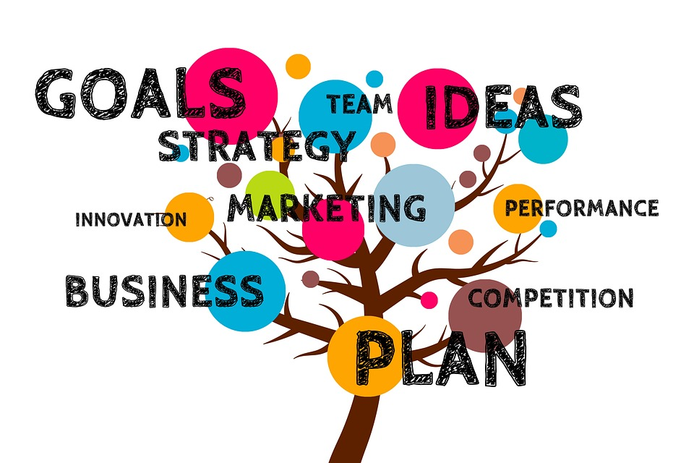
Geralt. (2017, December 1). Business Plan Tree [Digital image]. https://pixabay.com/illustrations/business-plan-tree-growth-grow-2987962/

CONTENTS
Picture Your Startup: Overview ____________________________________________ | 3
Materials
Instructions
Preflection: Circle Maps __________________________________________________ | 4
Activity #1: Picture Your Startup ____________________________________________ | 6
Activity #2: Make Your Pitch _______________________________________________ | 15
Extend: Triangle, Square, Circle _____________________________________________ | 16

PICTURE YOUR STARTUP: OVERVIEW
Have you ever thought about how cool it would be to run your own business? With creativity and drive, you can be an entrepreneur, a person who creates, organizes, or operates a business. Running a business can be enjoyable and rewarding, but it also requires lots of planning and hard work. Along with getting to do fun things like naming your company, picking out products, and possibly designing your business space, you also need a solid plan for how your business will succeed. With so many small businesses out there, you must decide what will make your company shine.
According to the United States’ Small Business Profile, there were 30.7 million small businesses in 2019. Because there are so many small businesses, starting a one that will last can be tricky. One of the most important aspects of starting a successful business is having a strong plan.
This activity will help you practice the skills needed to make a business plan. If you enjoy the process, you may turn your ideas into a business one day!

Materials:
- Picture Your Startup Student Guide
- Internet access
- Printed chart and task cards (optional)
- Two pieces of blank paper (optional)
- Something to write with (optional)

Instructions:
- Start with Circle Maps activity (page 4).
- Use that strategy to help you complete Activity #1: Picture Your Startup (page 6).
- Use your ideas from Activity #1 to complete Activity #2: Make Your Pitch (page 15).
- Complete the What? So What? Now What? Reflection strategy (page 3).
- Check out the videos and websites for further exploration Extend: Triangle, Square, Circle activity (page 16).

PREFLECTION: CIRCLE MAPS
Circle Maps is a brainstorming activity that will help you make connections between old ideas and new ones. For this activity, begin by thinking about your interests and use those to create new business ideas. By the time you have completed the activity, you should have several business ideas based on your knowledge about your interests.

Materials:
- Printed chart on the following page (optional) or a blank sheet of paper
- Pencil or pen

Instructions:
Step One:
Using either the chart provided or by drawing your own circles on a blank sheet of paper, start with the outer blue circle. List as many interests you can think of. For example, you could list things you like to do for fun: dance, paint, play basketball.
- What do you like doing in your free time?
- What school subjects do you like?
- What kind of work do you enjoy?

Step Two:
Once you are happy with your list of interests, move to the red circle in the middle. Here you pick one interest that stands out and make a list of skills or talents you have related to that interest. For example, if you choose art as your main interest, you could list what kinds of art you are good at: watercolors, sketching, landscapes.

Step Three:
Now that you have picked your favorite interest and listed your skills related to that interest, it’s time to think about what you could make or sell. Make a list of items in the yellow circle. For example, if in step two you listed the kinds of art you are good at, you could sell homemade bookmarks or art lessons.

Step Four:
Circle your favorite product idea from the yellow circle and get ready to use it in the following activities!

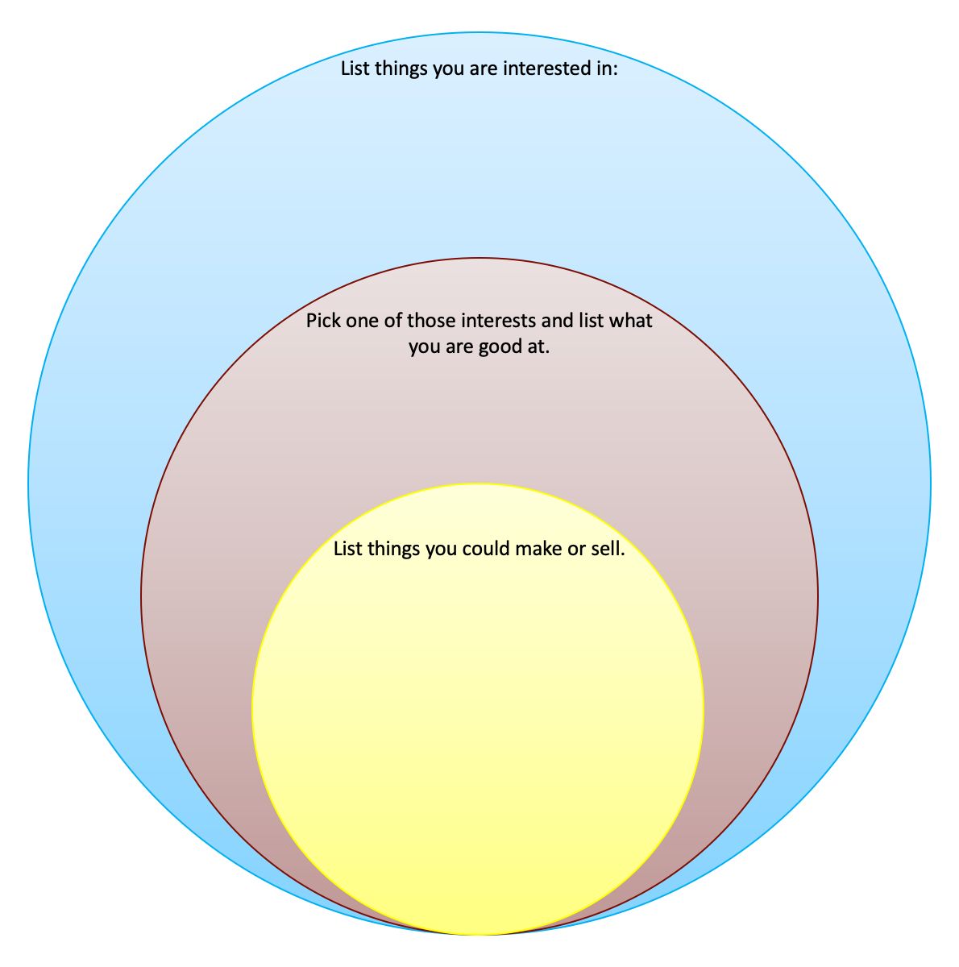

ACTIVITY #1: PICTURE YOUR STARTUP
During this activity, you will use the idea that you created using the Circle Maps Activity (or pick one of the ideas provided) and work through the beginning steps of creating your own business startup. The task cards in this activity are based on real questions people ask themselves when starting a new business.

Materials:
- Internet connection
- Printed cards on pages 8-14 (optional) or blank paper
- Pencil or pen

Instructions:
Step One:
Decide whether you want to use the idea you created above or select an idea from this list for your small business plan. Once you know what idea you want to use, write it at the top of your blank sheet of paper or on your printed cards.

Business Ideas
Write video game guides | Make bookmarks
Create greeting cards | Make homemade candles
Make homemade slime or playdough | Cook baked goods
Make jewelry | Make custom t-shirts
Make keychains | Create your own art/photography
Lawn care | Babysitting/pet sitting
Home organization/cleaning | Tech support
Product reviews | Tutoring

Step Two:
Use the task cards below to complete this part of the activity. You can either print the task cards or create your own using your blank sheet of paper. Note: Feel free to use the cards provided, but if you are tech savvy and want to use apps such as Canva, Pic Collage, or Google Slides, you are more than welcome to do so!

Step Three:
For each card, answer the question about your new business by providing a picture (or pictures) and a short description of why you drew or chose that picture.

Business Task Cards
Using the cards on the following pages, begin the first steps of planning your small business! For each card, answer the question by illustrating your answer. You can draw or find pictures that represent your answers, like the example pictures in the slides. Add a brief explanation of why you used those pictures.

Step Four:
Look back over all your cards and make sure you are happy with these first steps in your small business plan. Once you are ready, move to the next activity.

Task 1

What item of service will you sell to your customers?
Example picture of your product:  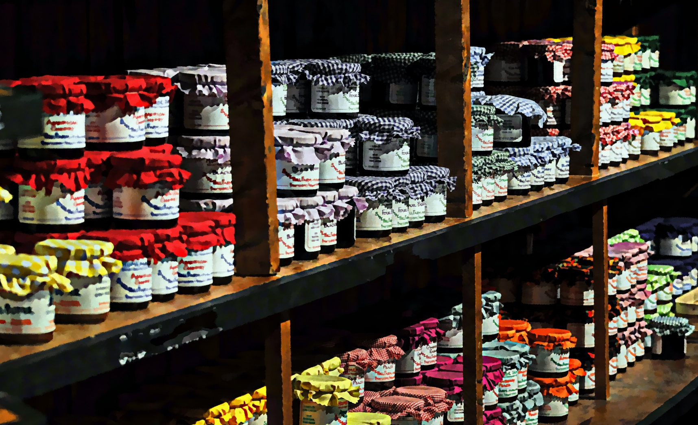  Needpix.(N.d). Jams Jams Jelly Free Photo [Image]. https://www.needpix.com/photo/1469949/jam-jams-jelly-homemade-sale-shop-artistic-painted-painterly | Picture(s) of your product:

Description of your product:
_______________________________________________________________________________________
_______________________________________________________________________________________
_______________________________________________________________________________________
_______________________________________________________________________________________
_______________________________________________________________________________________

Task 2

Who will be interested in buying your product or paying for your service?
Example picture of your potential customers:  Wallpaperflare (n.d.). Wallpaper buying, cheerful, customers, discount, diverse, diversity, downtown. [Image] https://www.wallpaperflare.com/buying-cheerful-customers-discount-diverse-diversity-downtown-wallpaper-aafmn | Picture(s) of your potential customers:

Description of your potential customers:
_______________________________________________________________________________________
_______________________________________________________________________________________
_______________________________________________________________________________________
_______________________________________________________________________________________
_______________________________________________________________________________________

Task 3

Why should people buy your product or service?
Example picture of why product is special:  Wallpaper Flare. (N.d). Field of blue spheres with one stand out in yellow. [Image] https://www.wallpaperflare.com/field-of-blue-spheres-with-one-stand-out-in-yellow-ball-bunch-wallpaper-aalez | Picture(s) of why your product is special:

Description of your why your product is special:
___________________________________________________________________________________________________________________________________________________________________________________________________________________________________________________________________________
_________________________________________________________________________________________
_________________________________________________________________________________________

Task 4

How will you sell your product or provide your service?
Example picture of how you will sell your product/service:  Hassan, Mohamad. (Dec. 19, 2017). Ecommerce, selling online, online sales [Image]. https://pixabay.com/illustrations/ecommerce-selling-online-3021581/ | Picture(s) of how you will sell your product/service:

Description of how you will sell your product/service:
_________________________________________________________________________________________
_________________________________________________________________________________________
_________________________________________________________________________________________
_________________________________________________________________________________________
_________________________________________________________________________________________

Task 5

How will you tell people about your product or service?
Example picture of how you will tell people:  Ogden, Lewis. (Sept. 7, 2018). Social Media Icons with paint splash effect. [Image] https://www.flickr.com/photos/bitsfrombytes/43617178595 | Picture(s) of how you will tell people:

Description of how you will tell people:
_________________________________________________________________________________________
_________________________________________________________________________________________
_________________________________________________________________________________________
_________________________________________________________________________________________
_________________________________________________________________________________________

Task 6

What materials will you need to make your product or provide your service?
Example picture of materials:  Pikrepo.(N.d). Assorted drawing materials. [Image]. https://www.pikrepo.com/fqkka/assorted-drawing-materials | Picture(s) of your materials:

Description of your materials:
________________________________________________________________________________________
________________________________________________________________________________________
________________________________________________________________________________________
________________________________________________________________________________________
________________________________________________________________________________________

Task 7

How will you make money off your product or service?
Example picture of making money off product:  Needpix. (N.d). Money green icon profit free photo. [Image] https://www.needpix.com/photo/1174183/money-green-icon-profit-free-vector-graphics | Picture(s) of how you will make money:

Description of how your will make money:
_________________________________________________________________________________________
_________________________________________________________________________________________
_________________________________________________________________________________________
_________________________________________________________________________________________
_________________________________________________________________________________________

ACTIVITY #2: MAKE YOUR PITCH
Now that you have some ideas for your business, it’s time to pitch those ideas to others for feedback and support! To “pitch” a business idea means you want to convince people that your business will be successful. Remember, when you start a business, even a small one, you often need to work with other people for help with money or product creation. You must convince them that your business idea is going to be successful.

Materials:
- Ideas from Picture Your Startup activity
- Internet connection
- Device to create business pitch (optional)

Instructions:
Step One:
Decide who you want to pitch your idea to and make sure they are willing to participate. Parents, guardians, family members, and friends are all great people to start with.

Step Two:
Decide how you would like to present your small business. Using the task cards you created in the above activity, make your business pitch. You can simply share these cards with your family by explaining the ideas for your business that each picture represents, or you can create your own PowerPoint presentation or Prezi (https://prezi.com/) to share.

Step Three:
Once you’ve shared your business pitch, ask your family for feedback.
- What did they like?
- What could be made better?
- Is there anything else you could add to the business plan?
Write down any points you think are helpful

EXTEND: TRIANGLE, SQUARE, CIRCLE
Materials:
- Blank sheet of paper or printed Triangle-Square-Circle graphic organizer on the following page (optional)
- Pen or pencil

Instructions:
The Triangle-Circle-Square strategy will help you reflect on what you have learned throughout the above activities.

Step One: Choose one of the two Career Talks linked below to watch. Both speakers turned their hobbies into businesses in some way.
- Professional Race Car Driver Justin Hutto
- Magician Joe Coover

Step Two: On a blank sheet of paper (or using the graphic organizer on the following page), draw a triangle. Inside that triangle, write three things you learned about creating a small business idea throughout these activities and from the career talk.

Step Three: Next, draw a square and write down the points from the activities that you agree are important to starting a small business—anything that “squares” with you—inside the square.

Step Four: Now draw a circle and write down any questions you still have about starting a business, or things that are “circling” in your mind.

What did you learn?
What did you strongly relate to or agree with?
What questions or thoughts do you still have?

SOURCES
All of the sources that were linked throughout the activity are listed below. Providing a list of resources allows us to give credit for the work someone else made.

Geralt. (2017, December 1). Business Plan Tree. [Digital image]. https://pixabay.com/illustrations/business-plan-tree-growth-grow-2987962/
Hassan, Mohamad. (Dec. 19, 2017). Ecommerce, selling online, online sales. [Digital image]. Pixabay. https://pixabay.com/illustrations/ecommerce-selling-online-3021581/

Needpix. (N.d). Jams Jams Jelly Free Photo. [Image] https://www.needpix.com/photo/1469949/jam-jams-jelly-homemade-sale-shop-artistic-painted-painterly

Needpix. (N.d). Money green icon profit free photo. [Image] Needpix. https://www.needpix.com/photo/1174183/money-green-icon-profit-free-vector-graphics

Ogden, Lewis. (Sept. 7, 2018). Social Media Icons with paint splash effect. [Image] https://www.flickr.com/photos/bitsfrombytes/43617178595

Pikrepo.(N.d). Assorted drawing materials. [Image] https://www.pikrepo.com/fqkka/assorted-drawing-materials

Pixabay. (N.d). Business, plan, tree. [Image] https://pixabay.com/illustrations/business-plan-tree-growth-grow-2987962/
U.S. Small Business Administration Office of Advocacy. (2019). United States Small Business Profile. https://cdn.advocacy.sba.gov/wp-content/uploads/2019/04/23142719/2019-Small-Business-Profiles-US.pdf
Wallpaper Flare. (N.d). Buying, cheerful, customers. [Image] https://www.wallpaperflare.com/buying-cheerful-customers-discount-diverse-diversity-downtown-wallpaper-aafmn

Wallpaper Flare. (N.d). Field of blue spheres with one stand out in yellow. [Image] https://www.wallpaperflare.com/field-of-blue-spheres-with-one-stand-out-in-yellow-ball-bunch-wallpaper-aalez

